Hufsa Haq

Candidate Number : #####

Centre Number: #####

####### School

WithiPro

Table of Contents

**Analysis** 3

Introduction 3

Initial Objectives 4

1ST Interview with Dr. Louise Terril - The Primary Client 4

Libraries for extracting PDFs 5

Obstacles 17

2nd interview with Client 18

Storing Images and Text in Database 19

Extraction of the Metadata 21

Entity Relationship Diagram 22

Question Booklets 26

Selecting Questions and Hiding Feature 26

3rd Interview with Client 28

User Rights 29

4th interview with Client 31

Website Interface Using Flask 33

Flow Diagram 34

Modelling 35

Final Objectives 55

**Design** 57

User Interface Design 57

Metadata extraction 58

IPSO Chart 60

Login Page 62

Teacher Home Page and Student Home Page 63

Search Page 65

Questions Page and Answers Page 69

Question Analytics Page 70

Delete PDF Page 71

Upload PDF Page 72

Text Page 73

Experiment Page 73

Show Images Page 75

Admin Home Page 77

Add user Page 78

Delete user Page 79

Show all users Page 80

Update user Page 80

User Input Table 82

Form Navigation Design 83

File Structure 84

Potential SQL Commands 85

Data Flow Diagram 87

Security Considerations 88

Modularisation 89

Testing Plan 90

**Testing** 98

**Coding** 108

HTML 135

Adding a user 135

Deleting a user 136

Showing list of users 137

Updating a user 138

Admin home 139

Base of Admin Sections 140

Layout 141

Login 143

Teacher Home 145

Student Home 148

Uploading a PDF 149

Experimenting with regex 150

Text from PDF 151

Showing Images 152

Search 154

Questions from Compile 156

Answers from Compile 157

Deleting PDFs 158

Question Analytics 159

**Evaluation** 160

Final Interview with Client 160

Improvements 161

# Analysis

# Introduction

The primary objective of this A-level project is to develop an innovative application that streamlines the management of exam papers. This application will provide a user-friendly interface for uploading exam papers, extracting individual questions, and organizing them efficiently within a database. Users, both students and teachers, will gain the capability to search for specific questions using keywords, compile question booklets, and maintain a comprehensive record of their question usage.

Existing solutions like Exampro impose limitations on schools and educators, including the following:

1. Current solutions like Exampro come at a significant financial expense, with fees often reaching above £100 per subject and level. This can be a considerable burden for educational institutions.
2. Exampro and similar tools may lack certain functionalities that educators and students require for effective question management and booklet creation, as they are not bespoke to the diverse needs of both groups.
3. These systems typically offer a finite number of questions, restricting the variety and diversity of questions available for creating exam papers or booklets. This limitation can hinder effective revision for students.
4. Many existing systems, including Exampro, only support questions from a single exam board in their booklets, which can be limiting for educators and students who wish to mix questions from different exam boards to enhance their revision experience.

Notably, students do not have access to Exampro, differentiating Withipro's user base from existing solutions.

In response to these challenges, my project aims to deliver a comprehensive solution that addresses these limitations:

1. Unlike limited question banks, my application will support a vast repository of questions, allowing educators and students to access a wider variety of questions for their revision needs.
2. My system will enable educators to mix and match questions from different exam boards and other sources, enabling flexibility in question selection.
3. I will implement a record-keeping feature that allows educators to keep track of previously used questions, streamlining question reuse and analysis.

# Initial Objectives

1. Develop an interface that allows users to upload exam papers in PDF format.

2. Implement a PDF processing module using libraries to extract questions from the uploaded papers.

3. Create a database to store individual questions along with relevant metadata such as year, subject, and mark scheme.

4. Enable users to search the database for specific questions using keywords.

5. Implement functionality to add questions the teacher has wants and compile question booklets.

## 1ST Interview with Dr. Louise Terril - The Primary Client

**Me:** To begin, could you describe how you currently go about setting questions for your classes?

**Dr. Louise Terril (LT):** We primarily rely on AQA's Exampro to select questions from past papers for our classes. Additionally, there are instances where we create questions ourselves using standard word processing tools.

**Me:** What do you consider as the key benefits of using the current system, Exampro, for question selection?

**LT:** The current system offers some notable advantages. Firstly, it provides a convenient interface for scrolling through lists of past questions. This feature allows us to easily filter questions by specific units, simplifying the process of selecting questions tailored to our teaching needs. Moreover, Exampro provides quick access to mark schemes, which is immensely valuable for assessing student responses.

**Me:** What drawbacks or limitations have you encountered while using Exampro for question selection?

**LT:** While Exampro serves its purpose well, it does have its limitations. One significant drawback is that it restricts us to one exam board when compiling questions. This limitation means there is no straightforward method for incorporating new questions into the system, hindering our ability to diversify question types or add unique questions that may better suit our teaching goals.

There are instances where we encounter a shortage of questions on specific topics, making it a challenge when we aim to compile revision booklets. And as students do not have access to Exampro, it increases our workload to provide revision materials around exam seasons.

# Libraries for extracting PDFs

In a recent discussion with the client there was a clear emphasis on developing a versatile educational tool that caters to the needs of both teachers and students from a spectrum of subjects and exam boards. I envision the tool providing students from various qualifications with a wealth of question types, allowing for an inclusive and adaptable learning environment. This necessitates that the extraction software be applicable to a range of differently formatted papers without compromising quality. Thus, my solution must be general and not depend on any of the characteristics of the PDF remaining constant.

I first considered PyPDF2 as the library that would allow me to extract individual images of each question part. During the research phase, I discovered that PDF processing using PyPDF2 has limitations. Certain PDF files, such as those with special encoding or encryption, may not be readable by the library. Additionally, PyPDF2 can only extract text from PDFs and cannot handle images or other media files.

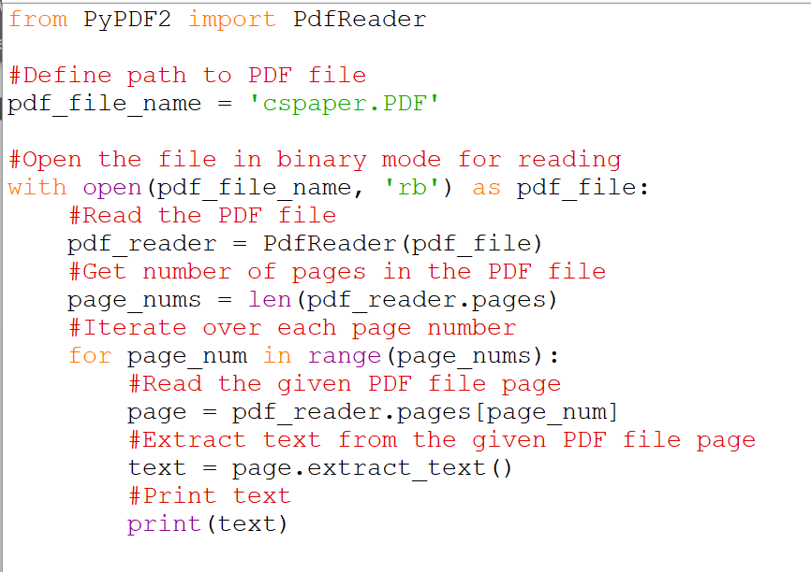

|  |
| --- |
| This program extracts all the text from the entire pdf using PyPDF2 |

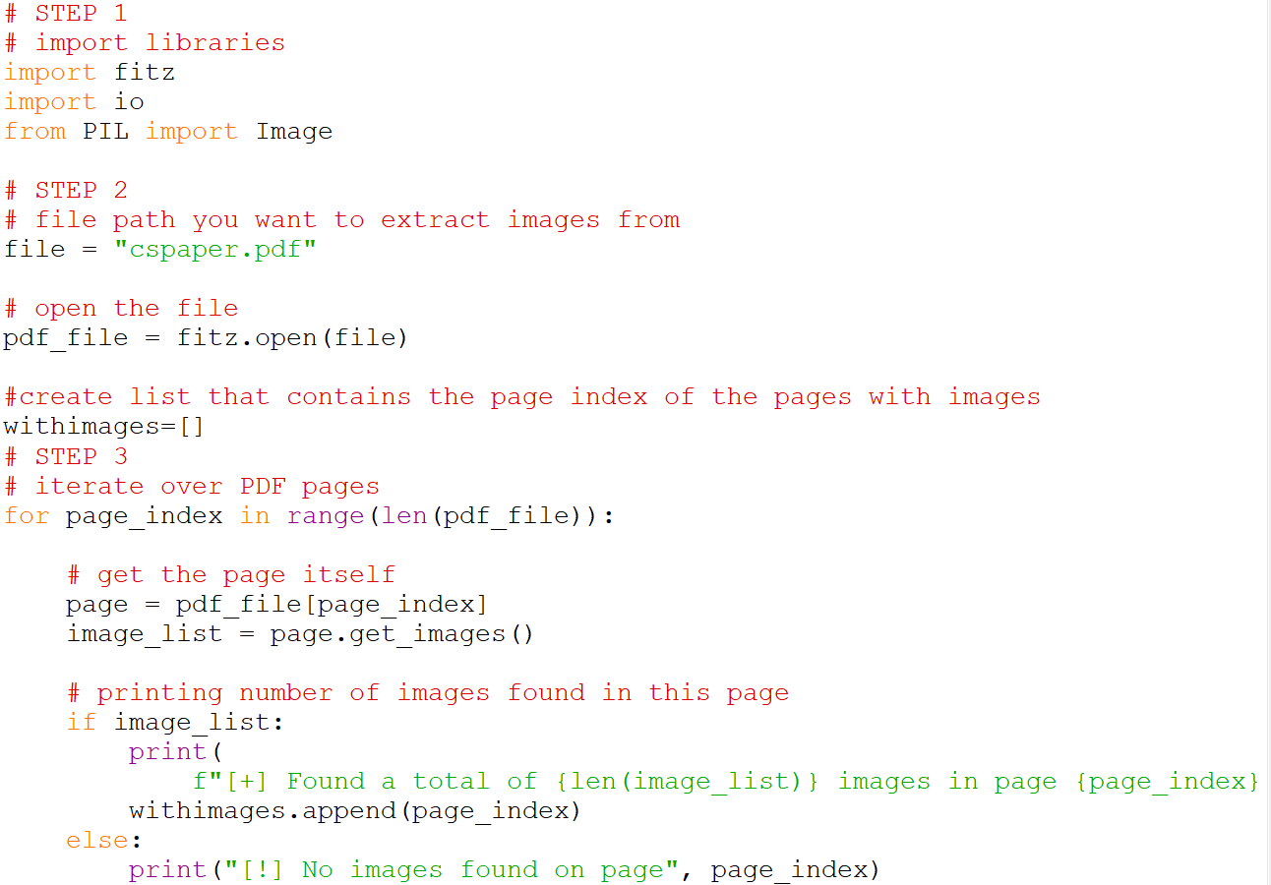As a result, an alternative approach was explored using the Fitz library in addition with the PIL library. This allowed for the extraction of both text and images from PDFs, enabling a more comprehensive analysis of the exam papers. My modified plan was for the extracted text and images to be recompiled to form individual questions.

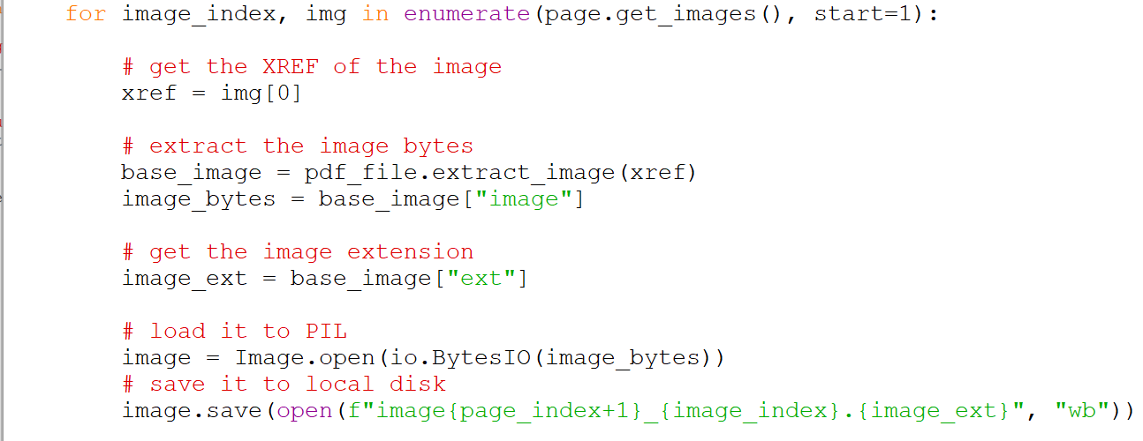

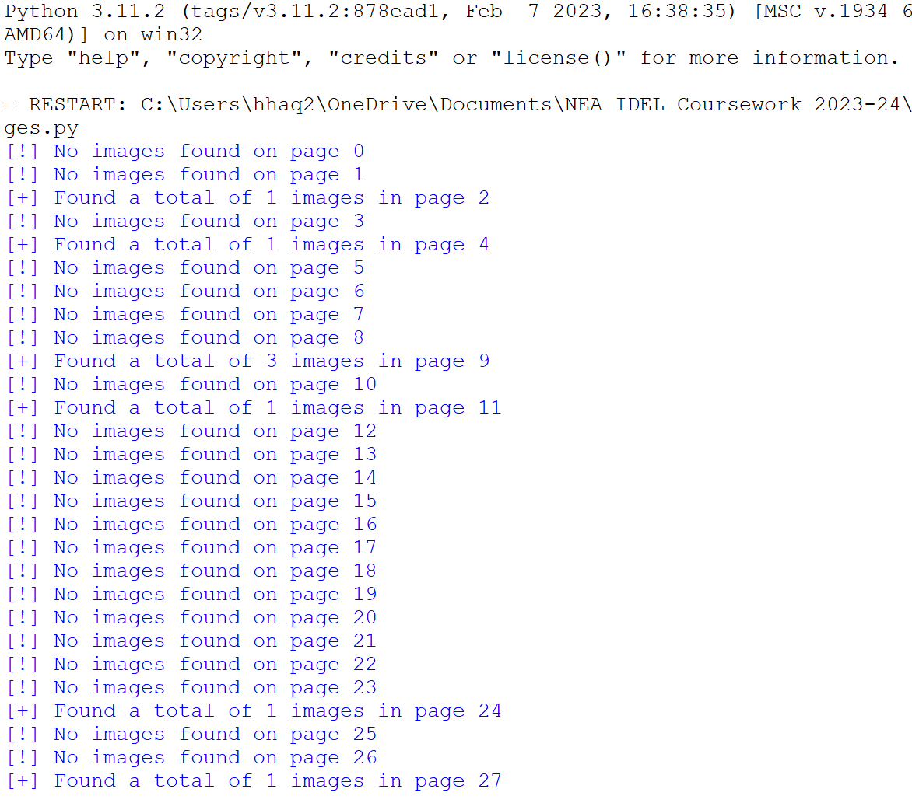

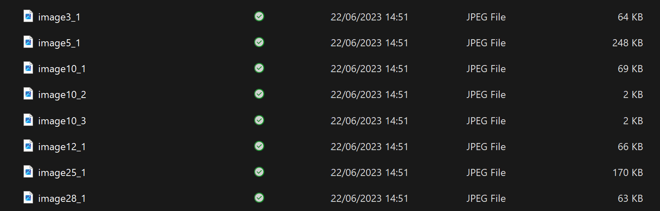

|  |
| --- |
| This uses the Fitz library in addition with the PIL library to extract images and save them to a desired location. However, many questions are a mixture of text and images which causes reconstruction of the questions impossible as there is no way to add markers of where the images were within the question and maintaining the structure and style of the question is integral. |

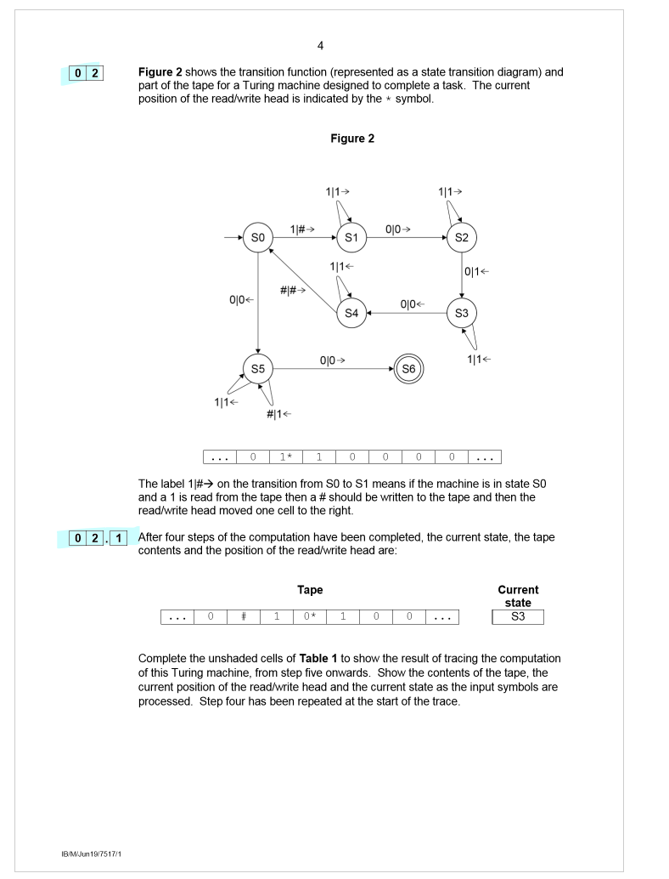

For example, for the question above the images extracted would be: 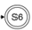, which is not representative of the data I am trying to extract and this is due to how the question was originally created with certain parts being images and other diagrams being made by text represntation. This method is very experimentative and will not provide consistant results. In addition, if the same question consisted of multiple images, idenifying the correct images would be an extensive issue.

After extensive research, I decided that this method was not feasible as I was unable to fuse these two parts.

Alternative methods were explored, including using ScraperWiki, urllib2, and BeautifulSoup to scrape data from web pages containing the exam papers. Scraper wiki is a Python library for scraping web pages and saving data. It is one of the easiest ways to save data – such as using the ScraperWiki platform, and it can also be used locally. This in combination with Beautiful Soup, would allow both access to the images and the text.

|  |
| --- |
| https://stackoverflow.com/questions/17098675/searching-text-in-a-pdf-using-python  <https://stackoverflow.com/questions/17098675/searching-text-in-a-pdf-using-python> |

ScraperWiki and BeautifulSoup are popular tools for web scraping and data extraction. When used together, they offer several advantages for extracting text and images from web pages to reconstruct questions. BeautifulSoup provides a simple interface for parsing HTML and XML documents, making it easy to locate and extract specific elements such as question text and image URLs. It supports various parsing strategies, allowing flexibility in handling different HTML structures. ScraperWiki, on the other hand, offers additional functionalities for data extraction and management, including the ability to store extracted data, schedule scraping tasks, and export data in different formats. This can be beneficial for organizing and processing many questions.

However, there are a few limitations to consider. The effectiveness of the extraction heavily relies on the structure and consistency of the web pages being scraped. If the structure varies across various sources, it may require additional adjustments to the scraping code. Moreover, handling complex scenarios like extracting images embedded within question text or capturing specific image regions can be challenging and may require additional image processing techniques. Overall, ScraperWiki and BeautifulSoup provide a solid foundation for text and image extraction, but after careful consideration, it will not create accurate and reliable reconstruction of questions.

|  |
| --- |
| References: <https://www.projectpro.io/article/python-libraries-for-web-scraping/625> - for details explaining the functionality of these programs |

Feedback from the client indicated that they preferred direct file upload rather than relying on web scraping as it required technical knowledge beyond the average teacher. Therefore, the approach using ScraperWiki and BeautifulSoup was deemed less desirable. Instead, I focused on enhancing the PDF processing capabilities by investigating libraries or approaches that can extract both text and images from PDF files.

After much trial and error, I decided to analyse the physical layout of the exam paper to identify how the structure changes when a new question starts. I noticed that the margins are more pronounced where the question numbers are. This will require a more complex approach. One approach could be to use pdfminer.six, a more low-level PDF parsing library, to analyse the layout and coordinates of text on the page. This library can provide information about the position of text elements, allowing me to infer changes in margins.

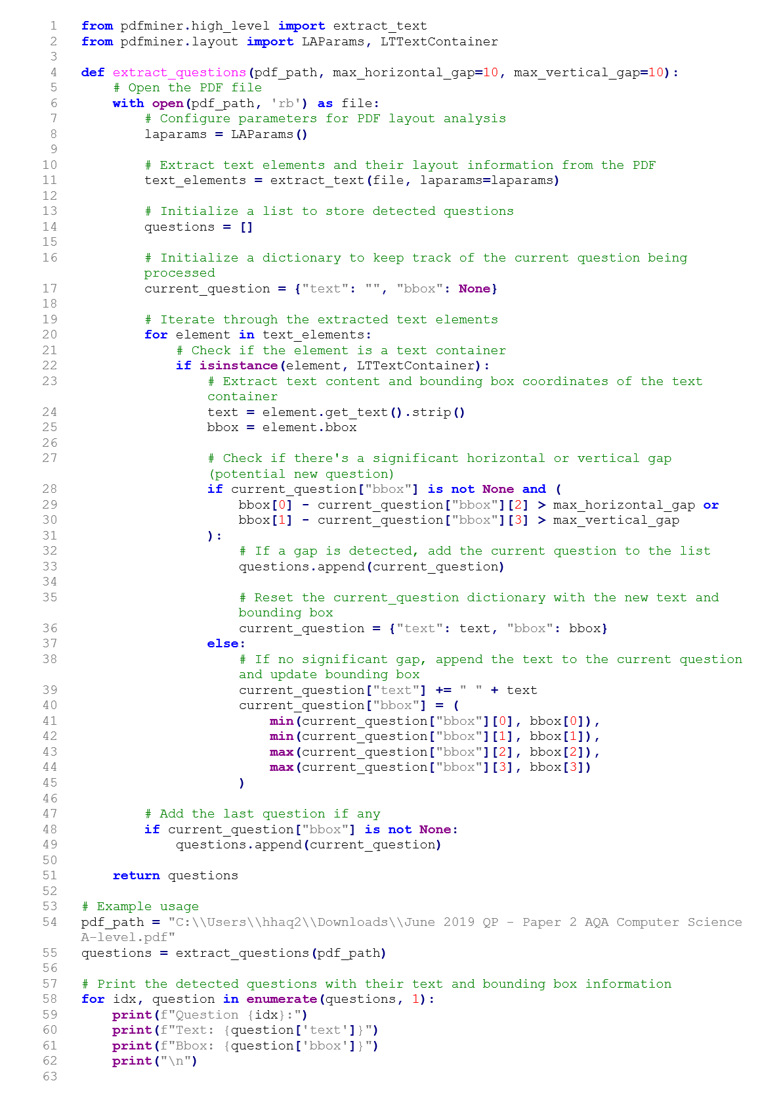



This Python code utilizes the PDFMiner library for extracting text elements and their layout information from PDF files. The extract_text function from Pdfminer.six interface is employed to obtain the raw text content of the PDF document, while the LTTextContainer class from the layout module allows access to detailed layout information, including bounding box coordinates and font sizes. The code aims to extract questions from papers, specifically targeting regions with larger font sizes, indicative of potential questions. It does so by iteratively analysing the text elements, checking for font size thresholds, and identifying significant vertical gaps between text elements, which may signify the start of a new question. The code maintains a record of each identified question along with its bounding box coordinates. This approach is particularly useful for distinguishing questions based on changes in margins and font sizes, enhancing the precision of the extraction process. The code outputs the text and bounding box information for each identified question.

This approach works very well for AQA papers but as I diversified my inputs by using different exam boards, the program was unable to pick up any potential questions. This can be explained by the modelling below and by the fact that it is difficult to identify margins accurately.

Here are a few extracts from several papers:

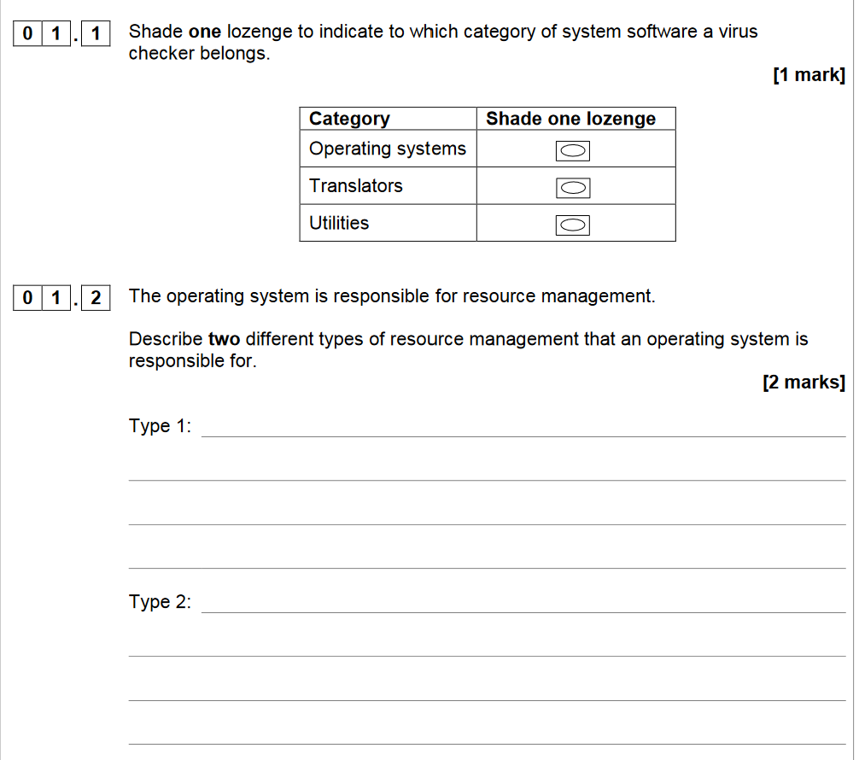

This is the ideal layout for this approach to form comprehensive results.

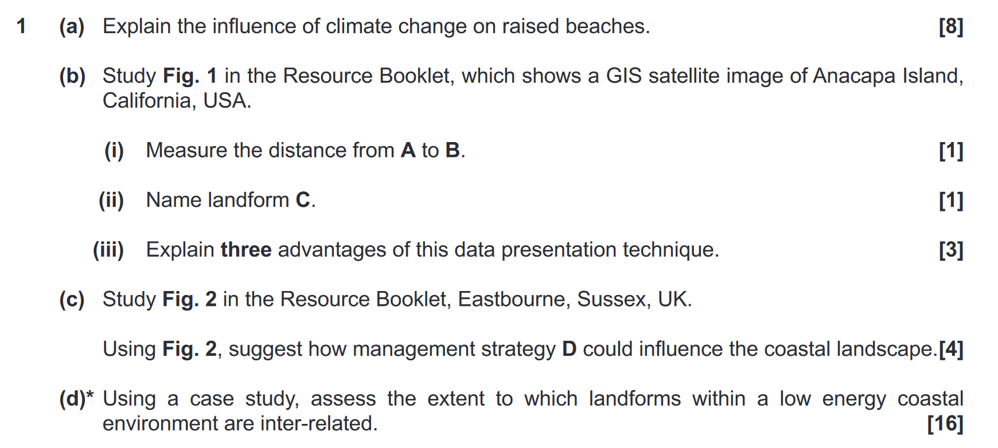

The margins do not change for parts of a question which does not allow me to extract individual parts.

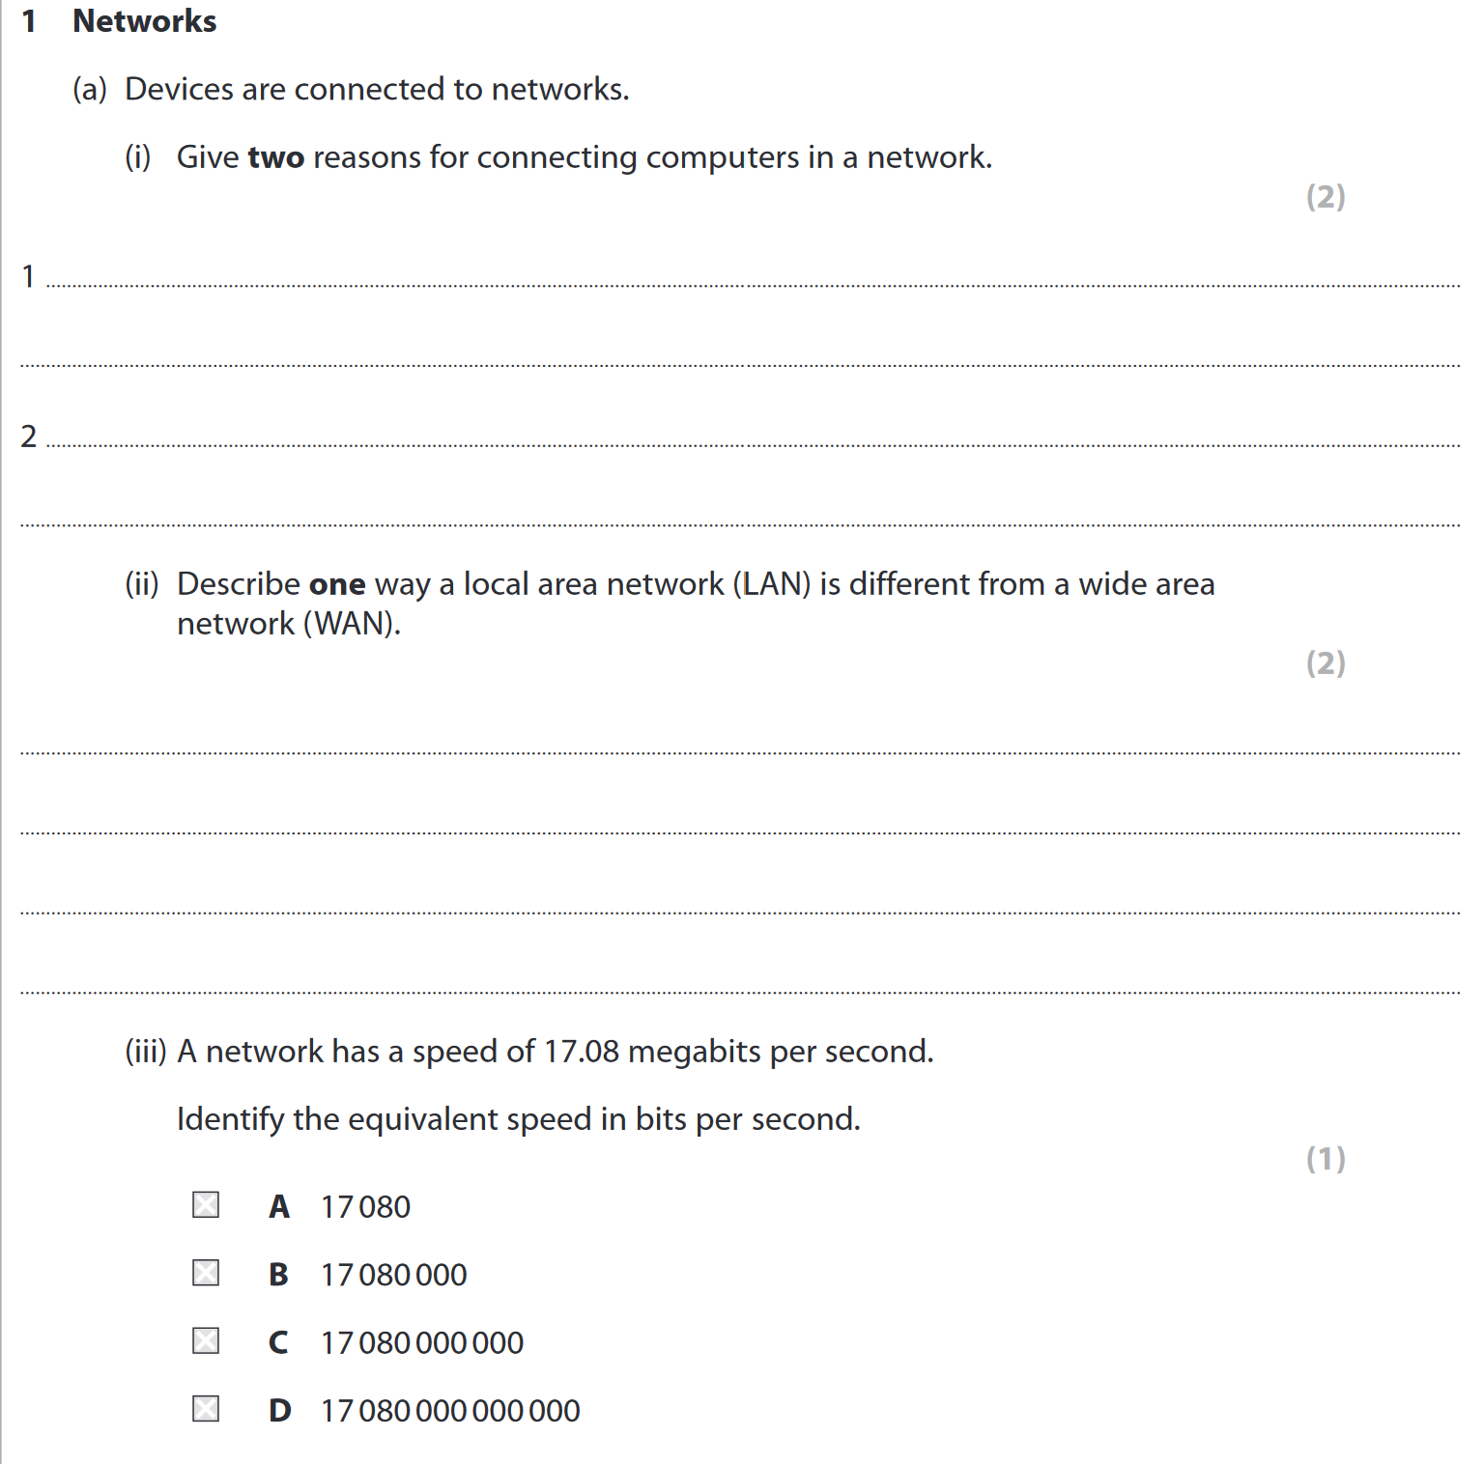

Here the margins do not have significance as the layout is not consistent for questions and the space for replies.

Whilst this was not a successful approach, I realised that analysing how the question numbers stand differently compared to the rest of the text was important. I have concluded that the using the Fitz library in conjunction with Regex and IRect will allow me to take ‘screenshots’ of the individual questions. The regex pattern will identify the question numbers as there are specific rules to writing a question number for example 9) a) i) has a number followed by two characters from the alphabet separated by a bracket. This data to be stored in a database, utilizing appropriate data structures and relational database techniques. The database will store individual questions along with metadata such as subject, year and mark scheme. This will hopefully allow efficient searching and retrieval of questions based on various criteria to fulfil the user’s needs.

1. **fitz (PyMuPDF) Library**:
   * Fitz provides comprehensive functionality for working with PDF files. I can load, read, modify, and extract information from PDF documents efficiently.
   * The library supports a wide range of PDF operations, including extracting text, images, and metadata, as well as annotating, merging, and splitting PDFs.
   * Fitz is a Python library compatible with various platforms, making it versatile.
2. **rect Library**:
   * rect is a utility library that simplifies the manipulation of rectangle coordinates. It provides a straightforward way to define and work with rectangles, which is especially useful for tasks such as cropping specific areas of a document.
   * The rect library reduces the complexity of working with rectangles.
   * The library supports different coordinate systems and provides methods to perform operations like intersection, union, scaling, and translation on rectangles.
3. **regex Library**:
   * The regex library offers advanced regular expression capabilities. It supports additional features and syntax, enabling more sophisticated pattern matching logic.
   * With regex, you can express complex patterns and rules more succinctly.

By leveraging these libraries, I can benefit from their extensive features. They enable me to handle PDF documents, manipulate rectangles, and perform advanced pattern matching operations, making it easier to extract specific content and capture snapshots of questions and mark schemes within documents.

After utilising these libraries, I was able to construct a program. The Python code employs the PyMuPDF library (fitz) and regular expressions (re) to automate the extraction and storage of questions from a PDF document. The process begins by opening the PDF file and iterating through each page. Text content is then extracted from each page, and a regular expression is applied to identify instances of the question number sequence, such as [0-9] [0-9] \n. The vertical coordinates of these identified patterns are stored to pinpoint the potential locations of questions. Duplicate coordinates are removed, and the list is sorted in ascending order. Subsequently, the script iterates through pairs of coordinates, extracts the corresponding question text, and saves it to a text file. Simultaneously, it defines a clipping region using Fitz Rect to capture the area between coordinates and saves the clipped portion of the page as a JPEG image. These steps collectively automate the extraction of questions from the PDF, saving both textual and visual representations, and the chosen libraries streamline PDF handling and pattern matching for efficient question identification and extraction.

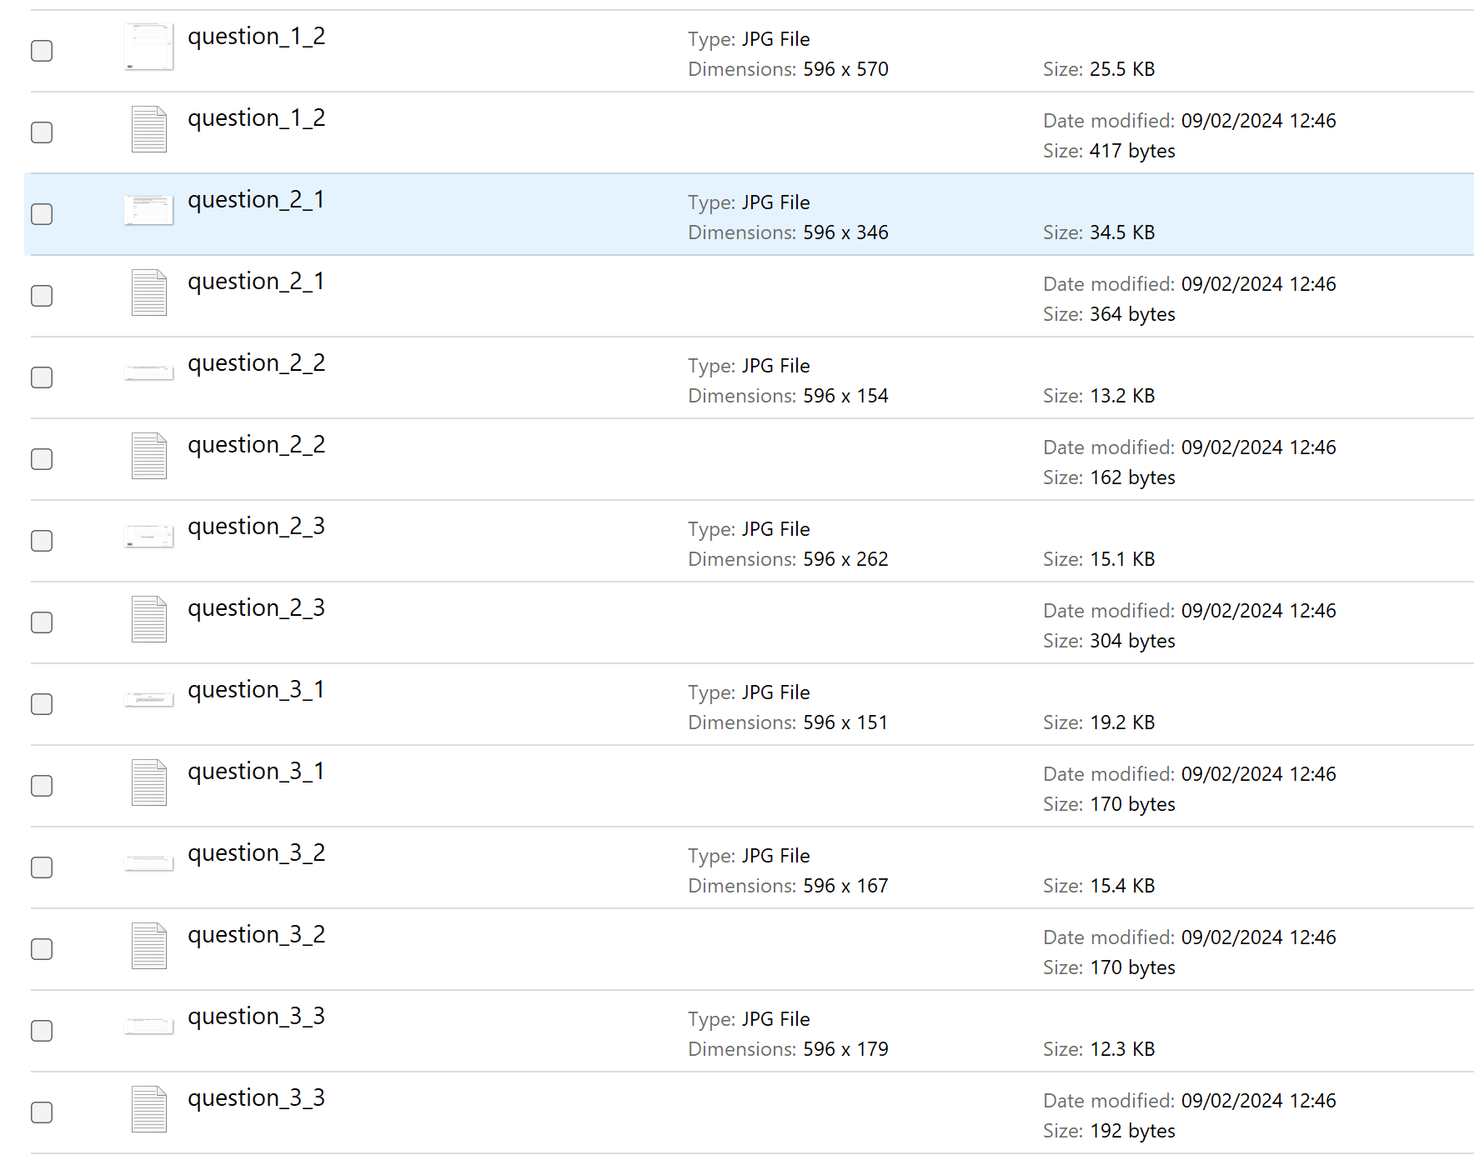

Here is an example image and text file:

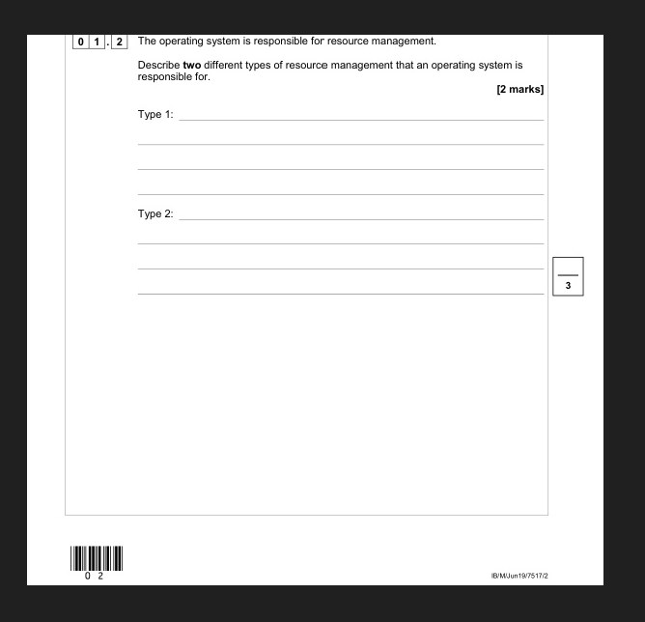

|  |
| --- |
| 0 1    . 2    The operating system is responsible for resource management.    Describe two different types of resource management that an operating system is  responsible for.  [2 marks]      Type 1:    Type 2:    Do not write  outside the  box |

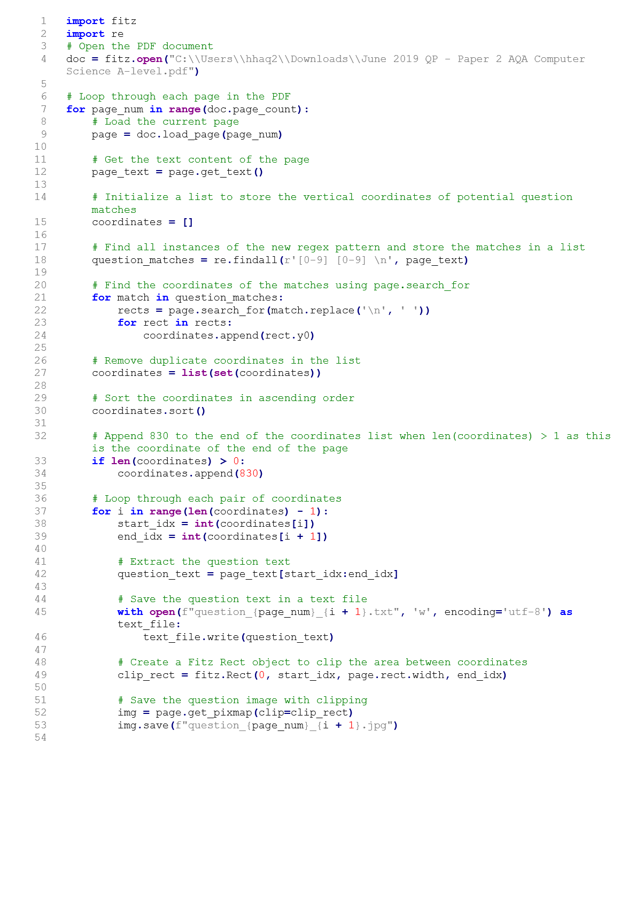

This program needs to be improved so that it fits my objectives by allowing the user to enter the pdf file and regex so that it is not hard coded. As per modelling, I need to improve the program so that if the first coordinates are much below the start of the page, then that must mean there is information above the first question on that page that needs to be saved. In addition, I need to change the program so that it does not save the question text and images to a file location but to be saved in a database. I will upload the PDF file to the computer, save the extracted images into the database, and subsequently delete the original. Once the images are successfully extracted and stored in the database, retaining the original file becomes unnecessary. It is a practical approach to save storage space. PDF files, especially those containing images, can be large. By deleting the original file after extraction, unnecessary data is removed, optimizing disk space. Choosing to overwrite the original file could lead to accumulating unnecessary data over time, especially if multiple extractions are performed on different PDFs in the future.

# Obstacles

When dealing with different exam papers, each paper possesses its own unique structure and formatting, making a single regex pattern insufficient for accurately extracting questions. This problem occurs for every subject, exam bord paper and year.

|  |
| --- |
| A screenshot of a computer  Description automatically generated with low confidence  AQA A-LEVEL COMPUTER SCIENCE Paper 1 |
| A picture containing text, screenshot, font, line  Description automatically generated  AQA AS MATHEMATICS Paper 1 |

To address this, I can allow users to enter a custom regex pattern that matches the question format of the specific paper they are uploading. Users can input the regex pattern through a user interface, and I will store these patterns in a database along with other metadata like subject, topic, year, or exam board.

When a user uploads an exam paper, the corresponding regex pattern will be retrieved and apply it to extract the questions based on the specified format. I will need to prioritize the retrieval of regex patterns based on the structure and text of the exam paper, ensuring the most appropriate pattern is used.

In cases where the pattern fails to accurately capture the questions, I will provide feedback to the user. This approach provides flexibility in handling the unique structure of each exam paper and allows users to adapt and refine the regex patterns as needed for accurate extraction.

After experimenting by putting the same paper but in different format types , I realised the results varied deeply and , using pdfs brought much more usable results. In order to maintain a standardized and consistent format, I have chosen to exclusively accept PDF file uploads. PDF (Portable Document Format) offers several advantages, including consistent formatting across different devices and operating systems, which ensures that uploaded documents are displayed uniformly for all users. Additionally, PDFs are widely accepted and compatible with various platforms, making them ideal. This decision aims to enhance document accessibility, and ensure consistent results.

# 2nd interview with Client

**Interviewer (Me):** Thank you for joining me today. I have been working diligently on the development, and I wanted to provide you with an update on the progress.

**Dr. Louise Terril (LT):** I appreciate that. Tell me about the latest developments.

**Me:** Initially, I explored PyPDF2 for extracting text and images from PDFs, but it had limitations. Instead, I turned to Fitz and PIL libraries, aiming to recompile extracted text and images to form individual questions.

**LT:** Interesting approach. How did that work out?

**Me:** Well, extracting images alongside text posed challenges, especially when dealing with questions that combine both elements. The method was not consistent, making accurate reconstruction difficult.

**LT:** I see. What alternatives did you consider?

**Me:** I explored web scraping using ScraperWiki and BeautifulSoup, but your feedback leaned towards direct file uploads. So, I delved deeper into PDF processing, leveraging Fitz to analyse the physical layout of exam papers.

**LT:** I appreciate your dedication. What is the new direction?

**Me:** I have shifted towards using Fitz, Regex, and IRect for a more precise 'screenshot' approach. Regex will identify question numbers based on specific rules, allowing me to capture individual questions.

**LT:** That sounds like a step in the right direction. What about handling the data?

**Me:** The extracted data, including questions and metadata, will be stored in a database for efficient searching and retrieval. It is a more structured and organized approach.

**LT:** Excellent. Please include a feature so that teachers delete specific questions and answers from a PDF later as regex patterns are new technology for us so being able to delete a previous attempt will be incredibly helpful.

**Me:** Absolutely. Ill design the system to accommodate that. It is user-friendly, allowing deletion based on user needs, especially considering the potential for evolving regex patterns.

**LT:** Perfect. We are beginners with regex, so having that flexibility is crucial. Great work so far!

**Me:** Thank you! I am committed to making this tool versatile and user-friendly. I will keep you posted on further developments.

# Storing Images and Text in Database

Storing the text in addition to other metadata within the database for each question in the exam paper management system serves several important purposes.

Storing the text allows for efficient searching and retrieval of questions based on keywords or phrases. By including the text content of the questions in the database, the system can quickly match user-provided search queries against the stored text, enabling users to find specific questions more easily. This feature enhances the usability of the system and saves users' time and effort in locating relevant questions.

With the text available in the database, statistical analysis or natural language processing techniques can be applied to gain deeper insights into the distribution of question types, topic frequencies, or the complexity of questions across different exams or subjects. This is something I want to incorporate in the future as it could streamline the development in applications such as this.

It ensures data integrity and consistency. As the text is an integral part of each question, storing it within the database prevents any mismatch or inconsistency between the metadata and the actual question content. This helps maintain the accuracy and reliability of the system, ensuring that users can trust the stored questions and associated information.

When it comes to storing images in a database, there are several approaches to consider, such as these images need to be able to be displayed onscreen on the website, for the user.

**Binary Encoding:**

*Pros:*

* Directly storing the binary representation of the image in the database allows for efficient storage and retrieval.
* It simplifies the handling of images as they are stored directly as raw binary data.

*Cons:*

* Displaying images on a website requires additional processing to convert the binary data to a format suitable for web display (e.g., converting to base64).
* Binary encoding can result in larger database sizes, potentially impacting storage requirements.
* Can cause fragmentation in the database file.

|  |
| --- |
| Reference: <https://sqldocs.org/sqlite/sqlite-blob/> - SQLite documentation on storing BLOBs (Binary Large Objects) |

**Base64 Encoding:**

*Pros:*

* Base64 encoding allows storing the image data as a string, which can be easily stored in a database.
* It simplifies the process of displaying images on a website since browsers can directly handle and display base64-encoded images.

*Cons:*

* Base64 encoding increases the size of the data by about 33%, potentially impacting storage requirements.
* Fetching base64-encoded images from the database may increase the server response time due to increased data size.

|  |
| --- |
| Reference : <https://medium.com/@shimonmoyal/a-dive-into-base64-and-its-significance-in-web-development-b6bd4427f61d> – for gauging comparisons between binary data and base 64 data |

**Hex Strings:**

*Pros:*

* Representing the image data as a hexadecimal string simplifies storage in a database, as it can be stored as a regular string.
* Hex strings are human-readable and can be easily understood and manipulated if necessary.

*Cons:*

* Hex strings can be significantly larger than the original binary data, resulting in increased storage requirements.
* Converting hex strings back to binary data for displaying images on a website adds extra processing.

**File Names:**

*Pros:*

* Storing images in the database by using file names allows for separation of image storage from the database, potentially reducing database size and improving performance.
* Retrieving and displaying images can be faster since direct file access is possible without the need for additional conversions.

*Cons:*

* Managing the relationship between the image files and database entries requires careful management to prevent inconsistencies.
* Additional considerations are needed for backup and data migration since image files are stored separately from the database.

While binary encoding or file names may be more efficient for large-scale storage and performance optimization, I have concluded that base64 encoding is the most suitable as simplicity and direct web display are crucial.

## Extraction of the Metadata

Extracting metadata from a PDF is crucial for several reasons, providing valuable information about the document's content and context.

1. **Document Classification:**
   * Metadata helps in categorizing and classifying documents based on information like the year, subject, level, exam code, and exam board.
2. **Search and Retrieval:**
   * Metadata enables efficient searching and retrieval of specific documents based on criteria such as subject, topic, or year.
3. **User Accessibility:**
   * Users can filter and access questions from documents based on their preferences.

I have researched several libraries that could help in extracting the PDF metadata:

1. **PyMuPDF (MuPDF):**
   * **Pros:**
     + Efficient rendering and extracting capabilities.
     + Good for extracting text and images from PDFs.
   * **Cons:**
     + Limited support for structured metadata extraction.
2. **PyPDF2:**
   * **Pros:**
     + Simple to use for basic PDF operations.
   * **Cons:**
     + Limited support for metadata extraction, especially for complex PDF structures.
3. **pdfminer.six:**
   * **Pros:**
     + Comprehensive library for PDF parsing, supporting structured metadata extraction.
     + Excellent for handling complex PDF structures.
   * **Cons:**
     + Might be considered more complex for basic operations compared to simpler libraries.

Considering the requirement that the program must have the ability to handle various PDF structures, pdfminer.six stands out as the most suitable library.

|  |
| --- |
| References : : <https://pythonhosted.org/PyPDF2/> - PyPDF2 documentation |

# Entity Relationship Diagram

1. **Users Table:**
   * user_id (Primary Key)
   * username
   * password
   * is_teacher (Boolean to distinguish between students and teachers)
2. **Questions Table:**
   * question_id (Primary Key)
   * pdf_id
   * question_text
   * question_image
   * question_number
   * usage count
   * is_hidden (Boolean to indicate whether the question is hidden)
3. **Answers Table:**
   * answer_id (Primary Key)
   * pdf_id
   * answer_text
   * answer_image
   * question_number
4. **Metadata Table:**
   * pdf_id (Primary Key)
   * year
   * subject
   * level
   * exam code
   * exam board
   * regex pattern
   * paper number
   * type
5. **Count Table**:
   * pdf count (this is what is used to generate the pdf ids so that there are no pdfs with the same id)

I will begin by using SQLite to create a normalized relational database for efficient PDF management, metadata extraction, and user administration within a web application. The process involves structuring tables with distinct purposes, such as "users," "metadata," "questions," "answers," and "count." Each table is carefully designed with appropriate data types and constraints. Primary and foreign key relationships are established, ensuring a cohesive database structure. The approach taken emphasizes the principles of normalization to mitigate data redundancy. PDF metadata, for instance, is centralized, and questions and answers are linked to their respective PDFs.

Firstly, the Users Table captures information about registered users. The user_id serves as a unique identifier, ensuring each user has a distinct reference. Usernames are unique and linked to the username column, while the password column stores the associated password securely. The Boolean is teacher flag differentiates between teacher and non-teacher accounts, enabling role-based access control.

Moving on to the Metadata Table, it accommodates PDF-specific information. The pdf_id acts as a primary key, uniquely identifying each metadata entry. Extracted details, including year, subject, level, exam_code, and exam_board, contribute to comprehensive metadata. The regex_pattern column stores regular expression patterns associated with the PDF, crucial for subsequent operations. Additionally, paper_number holds the extracted paper number, and type distinguishes between questions (QP) and answers (MS).

The Questions Table manages details related to individual questions. Each question is assigned a unique question_id, linked to its PDF through the pdf_id foreign key. The question_image column stores image data, while question_text holds textual content. The associated question_number aids in identifying the question, and usage_count tracks the frequency of use. Furthermore, the Boolean is_hidden flag indicates whether a question is hidden.

Similarly, the Answers Table maintains information about answers. An answer_id uniquely identifies each answer, and the pdf_id foreign key links it to the relevant PDF metadata. answer_image stores image data, answer_text holds textual content, and question_number associates the answer with its corresponding question.

Lastly, the Count Table serves a crucial role in tracking the count of PDF entries. The single column, pdf_count, helps manage and update the count efficiently.

These design decisions prioritize data integrity, minimize redundancy, and facilitate ease of maintenance. This normalized structure not only reflects the inherent relationships among entities but also supports efficient querying, scalability, and consistent data management.

The User’s Table does not have explicit relationships with other tables.

The Questions Table has a many-to-one relationship with Metadata Table through the pdf_id foreign key.

The Answers Table has a many-to-one Relationship with Metadata Table through the pdf_id foreign key and a one-to-one Relationship with Questions Table through the question_number foreign key.

Using [dbdiagram.io - Database Relationship Diagrams Design Tool](https://dbdiagram.io/home), I have created an entity diagram of my database.

KEY:

* <: one-to-many
* 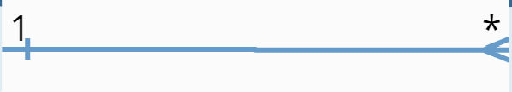
* >: many-to-one
* 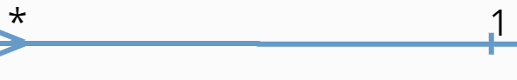
* -: one-to-one
* 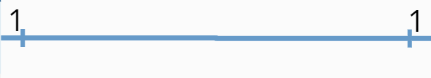
* <>: many-to-many

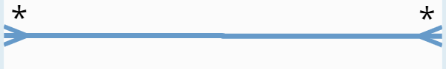

The key symbol means it is a primary key.

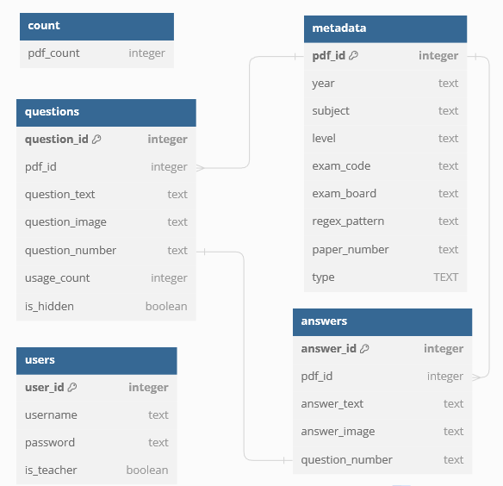

After further reading, I realised that it was more suilable to use the text data type compared to varchar for storing the base64 coding for the image.

1. **Variable Length:**
   * Varchar is a variable-length character data type with a specified maximum length. If I had a known limit on the size of the base64-encoded images, varchar could be appropriate. However, base64-encoded images can vary significantly in length based on factors such as image dimensions and quality.
2. **Base64 Image Size:**
   * Base64 encoding increases the size of the original binary image. The length of the base64-encoded string depends on the size of the binary image. As a result, it is challenging to predict a fixed maximum length for base64-encoded images.
3. **No Arbitrary Size Limitation:**
   * Text is a variable-length data type without a maximum size limit, making it more flexible for storing substantial amounts of text. Since the length of base64-encoded images can vary widely, using TEXT can accommodate a broader range of image sizes.
4. **Simplifies Database Schema:**
   * Using text for storing base64-encoded images simplifies the database schema by avoiding the need to define and manage a specific maximum length for the varchar field.

# Question Booklets

Another instrumental part of my application is the compiling of these question into booklets based on user preferences, which can be saved and reused. I have identified that there would be several steps I would need to complete to ensure that this feature is possible.

1. Retrieving Questions from the Database:

* Query the database based on user-selected criteria such as subject, topic, year, and exam board.
* Retrieve the relevant questions that match the specified criteria from the database using an appropriate library such as SQLite.

2. Filtering Questions:

* Allow the user to select the questions that they desire.

3. Delivering the Booklet:

* Open the questions and matching mark scheme in new webpages with no formatting, which can be printed from the browser.

## Selecting Questions and Hiding Feature

In more depth, I would need to consider how the user would select the questions to insert into the booklet. Additionally, after further discussion with the client, it has come to my attention that a button to hide certain results would be desirable. For example, the user may want to prevent the most recently released questions being accidently given to students so they may decide to hide such results until a more relevant stage in the school year.

Below I have outlined certain steps that would need to be considered:

Display Questions:

* Create a web page where users can view questions from the database.
* Display a list of questions in a user-friendly format, such as a table or a list.
* Each question should have a checkbox next to it to allow users to select or deselect questions.

Filter and Search Options:

* Include filtering and search options to help users narrow down their selection.
* Implement search bars that allow users to filter questions based on criteria like year, exam board, and paper.

Select/Deselect Questions:

* Allow users to manually select or deselect individual questions by checking or unchecking the checkboxes.

Compile Button:

* Include a "Compile" or "Add to Booklet" button that users can click after selecting their desired questions.

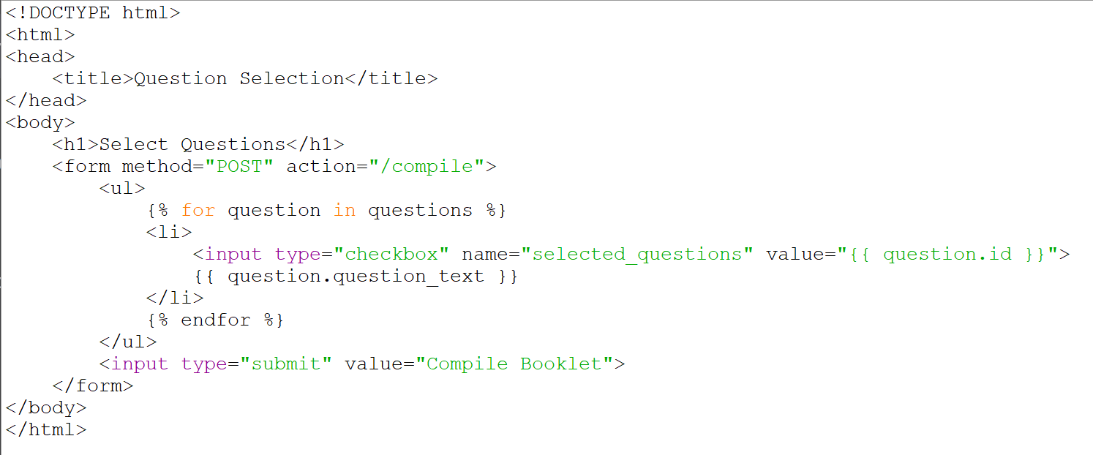

Hide Questions:

* To implement the feature to hide questions, I will include two more checkboxes which will show if that question is hidden or not. By switching the values of these checkboxes and then press the update button.

Validation:

* Implement validation to ensure that users cannot proceed to compile the booklet without selecting at least one question.

## 3rd Interview with Client

**Interviewer (Me):** As I work on my automated exam paper management system, I would love to hear your thoughts on what features and functionalities you would like to see on the website.

**Dr. Louise Terril:** To start, it is crucial for the website to cater to both teachers and students effectively.

**Me:** For teachers, what functionalities or features would you find most valuable?

**Dr. Louise Terril:** For teachers like me, ease of use and efficient question management are key. Here are some features I would appreciate:

1. A straightforward process for uploading exam papers and questions is crucial. It should be intuitive and not require too much technical expertise.
2. The ability to search and filter questions based on various criteria such as year, exam board, and paper is invaluable for creating tailored revision materials.
3. The option to hide/unhide questions, especially for questions from different exam boards, is beneficial. This way, I can create question sets that precisely match the topics I am teaching and prevent the use of newer, unreleased questions.
4. A feature for compiling custom booklets with selected questions, which can be saved and reused for different classes or years, would be a time-saver.

**Me:** Those are excellent points. Now, thinking about our student users, what features do you think would be most beneficial to them?

**Dr. Louise Terril:** For students, simplicity and accessibility are key. Here is what I believe would help them:

1. A robust search feature with keyword search and filters would enable students to quickly find relevant questions for their revision.
2. Like teachers, students should be able to create custom booklets for their revision. It is an excellent way for them to focus on specific topics.

**Me:** I will keep these features in mind to ensure it meets the needs of both user groups.

## User Rights

I recognize that students and teachers have distinct roles and responsibilities. To ensure a secure and user-friendly experience, I will implement different user rights and permissions tailored to each group:

**Teachers:**

1. Teachers have the privilege to upload exam papers to the system. They can provide valuable study materials for their students and fellow educators.
2. Teachers can hide or unhide questions from specific years, exam boards, or papers. This feature enables educators to curate question sets for different purposes and control which questions are visible to students.
3. Teachers have unrestricted access to the entire question database, including hidden questions. This access allows them to create custom booklets and perform comprehensive searches.
4. Teachers can delete exam paper and mark scheme images from a related pdf

**Students:**

1. Students can access the questions and answers available in the database but are limited to viewing questions that have not been hidden by teachers. This access promotes independent learning and revision.
2. Students can utilize the search functionality to find questions based on keywords, years, exam boards, or papers. This feature allows for targeted revision and exam preparation.
3. Students have the capability to compile custom question booklets for their revision needs. They can select questions from the visible question pool, arrange them, and create personalized booklets.
4. Students do not have the privilege to upload / delete exam papers. This limitation ensures that only authorized personnel (teachers) can contribute latest content to the system.

By implementing these distinct user rights and permissions, I aim to create a secure and productive environment where both teachers and students can benefit from my application. Teachers can effectively manage question databases and tailor content to their teaching objectives, while students can access, search, and compile questions to enhance their revision and learning experiences.

To ensure clarity and prevent confusion, I will implement a user authentication system that differentiates between teachers and students.

**Login Differentiation:**

1. **Teacher Home:**
   * Teachers will access a dedicated "Teacher Home" page after the application's login screen.
   * To log in as a teacher, users must provide their unique teacher credentials, which include a username and password associated with their teacher account.
   * The application will validate the teacher's credentials against a database of authorized teacher accounts.
2. **Student Login:**
   * Students will access a separate "Student Home" page after the application's login screen.
   * To log in as a student, users must provide their individual student credentials, typically a student ID or a username and password associated with their student account.
   * The application will validate the student's credentials against a database of registered student accounts.

**User Differentiation:**

1. **Authentication and Role Assignment:**
   * Upon successful login, the application will identify the user's role (teacher or student) based on their provided credentials.
   * The system will assign the appropriate role to the user's session, allowing them to access features and functionalities associated with their role.
2. **User Experience Customization:**
   * After login, the user interface will be customized based on the user's role. For example:
     + Teachers will see options and menus related to uploading papers, hiding/unhiding questions, and accessing the full question database.
     + Students will have access to options for viewing and searching questions, creating custom booklets, and accessing their own revision materials.
3. **Role-Based Permissions:**
   * Role-based permissions will be enforced throughout the application. Teachers will have the necessary permissions to perform actions like paper uploads and question management, while students will have a more restricted set of permissions.

# 4th interview with Client

Me: Hi there! I have extensively planned for differentiating user roles into students and teachers. Now, students and teachers have distinct functionalities. What are your thoughts on this so far?

Louis Terril (LT): That is a good start! I was thinking about extending the system with specific admin roles as well. I believe having dedicated admin features will enhance the overall management of the platform.

Me: Great idea! What kind of admin functionalities are you envisioning?

LT: Firstly, I would like a route to display all users. This will help admins view a list of all users in the system.

Me: Got it. What details should be included in the user display?

LT: We will need at least usernames, and any additional relevant information, in a simple table format.

Me: Perfect. What is next on the admin features list?

LT: I would like a route for admins to add new users. Admins should be able to input a username, password, and indicate whether the user is a teacher.

Me: Noted. What is the next admin functionality?

LT: We need a route for updating user information, like changing passwords. Admins should input a username and the new password.

Me: Understood. And finally?

LT: We should have a way to delete users as well.

Me: Perfect. I have a clear picture of the admin features now. Anything else or specific details you want to highlight?

LT: That covers the basics for now. Let us keep it simple and functional. We can always expand on these features later if needed.

Me: Absolutely. I will get to work on these admin routes, and I will keep you updated on the progress. Feel free to reach out if you have any additional thoughts or requirements.

LT: Sounds good. I am looking forward to seeing the admin features in action.

In my web application, the administrator, or admin, will be granted special privileges to perform various user management tasks. The show users route will allow the admin to view a list of all users in the system. The add users route will provide functionality for the admin to add new users by entering a username and password, with an option to designate the user as a teacher. The update user route enables the admin to update user information, and the delete user route will allow the admin to delete users by entering their usernames. These features empower the admin to maintain control over user accounts, ensuring efficient management and security within the system. Admins can easily navigate these routes to perform essential actions such as user listing, addition, modification, and deletion, thereby contributing to the overall administration and organization of the web application. They will also have their own designated home page.

# Website Interface Using Flask

Here are some essential elements and features of my web interface:

**User Authentication:** Implement user authentication and user roles (e.g., admin, teacher) to control access to different features and data.

**Dashboard:** Provide a dashboard or landing page where users can access the key features of my application.

**Upload Exam Papers:** Allow users to upload PDF exam papers. Provide feedback on successful uploads and handle errors gracefully.

**Extract Questions:** Offer a button or option to extract questions from uploaded exam papers. Display the extracted questions with relevant details (year, exam board, paper).

**Database Search:** Implement a search feature that lets users search for questions based on keywords, year, exam board, or paper. Use drop-down menus for exam boards as these can be hard coded as there is very few exam boards. Database interaction will form the core of the application's functionality. I will create functions for querying, updating, and deleting records while implementing data validation and error handling to maintain data integrity.

**Question Details:** Display detailed information about each question, including the question text, year, exam board, paper, and answers.

**Custom Booklet Creation:** Allow users to select questions and add them to a custom booklet.

**Record-Keeping:** Keep a record of questions that have been used in custom booklets. Provide insights or reports on question usage.

**Notifications and Alerts:** Implement notifications for successful actions or errors.

**Data Export/Download:** Allow users to export custom booklets as PDFs or download selected questions and answers.

**Responsive Design:** Ensure that the web interface is responsive and accessible on various devices (desktops, tablets, mobiles).

**Logout Option:** Provide a clear way for users to log out of their accounts.

**Error Handling:** Gracefully handle errors and display helpful error messages when something goes wrong.

**Navigation and Menus:** Design an intuitive navigation menu or sidebar for easy access to different sections of the application.

**Visual Design:** Attention to the overall visual design, including colours, typography, and layout, to make the interface aesthetically pleasing and easy to read.

# Flow Diagram

This is an initial modelling of how the program will flow.

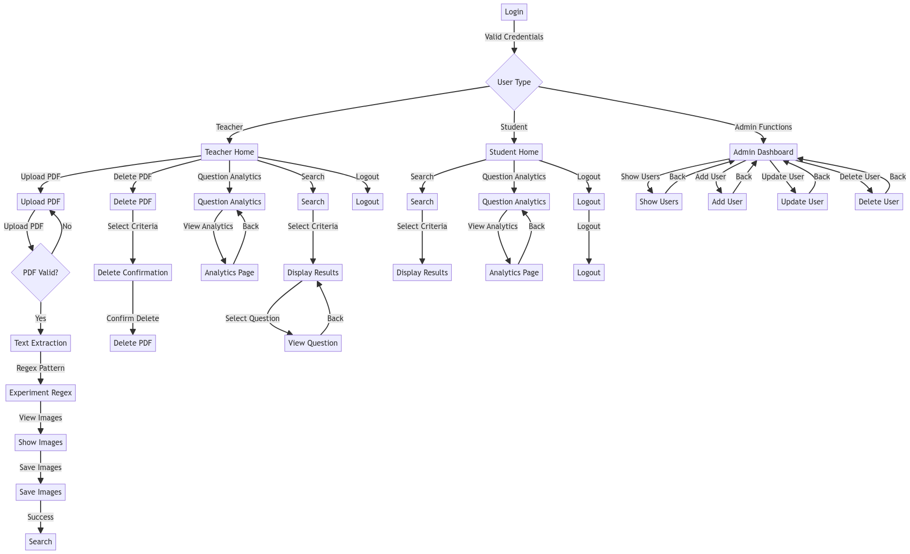

# 

# Modelling

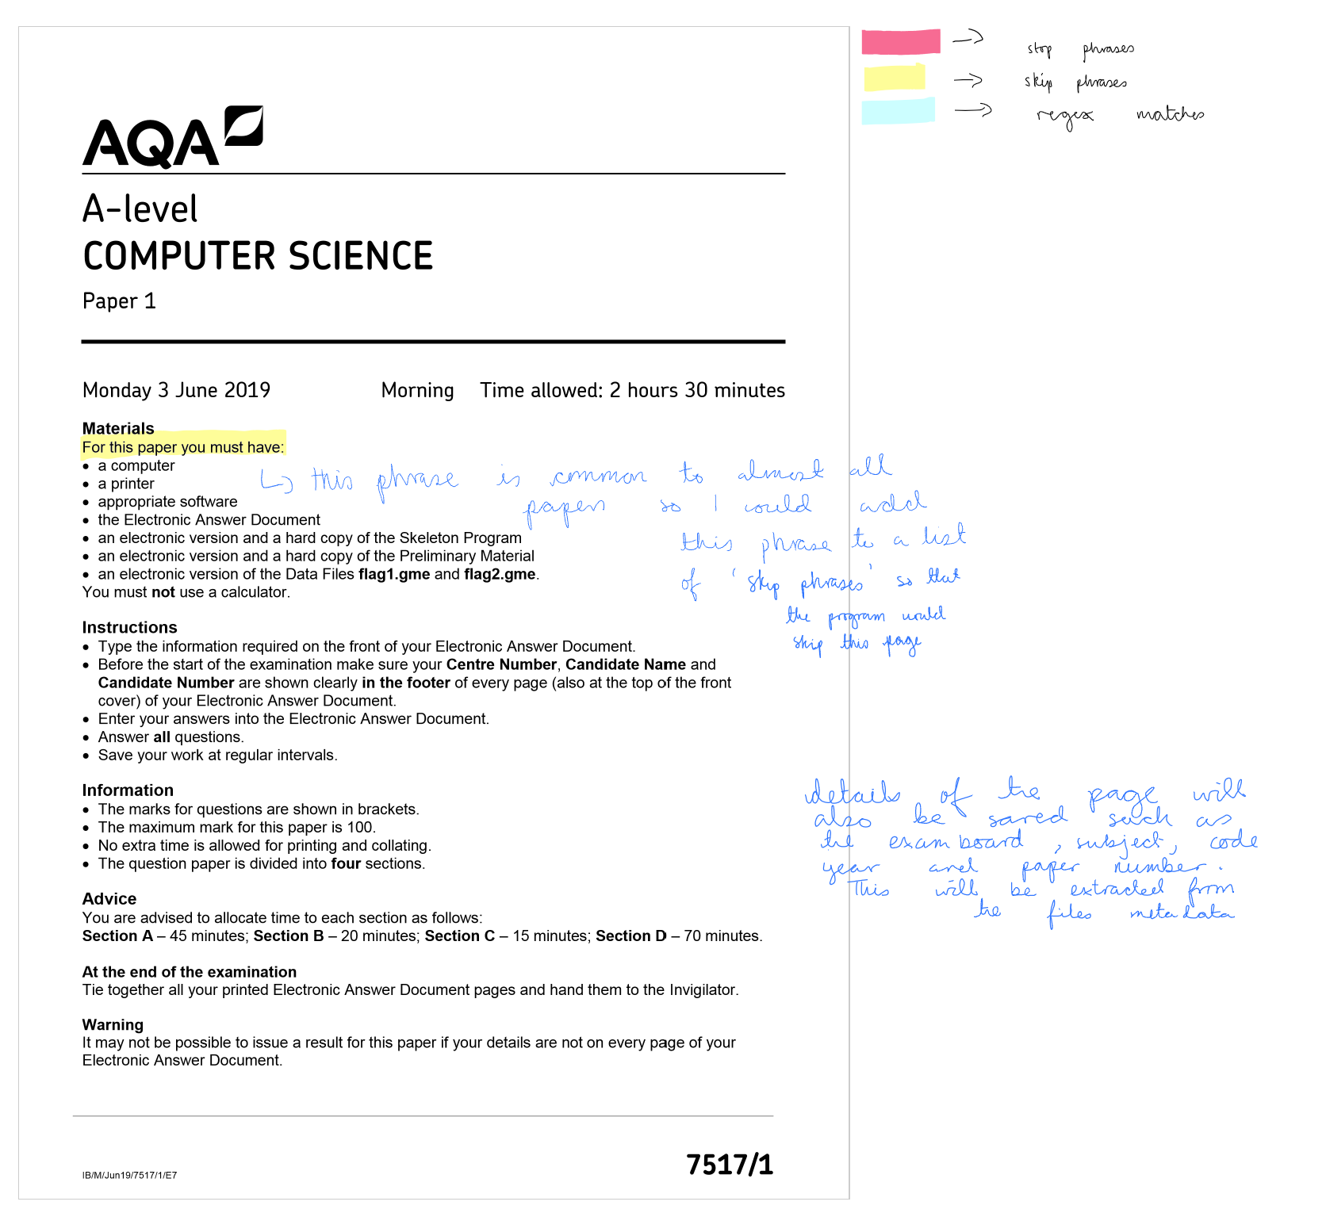

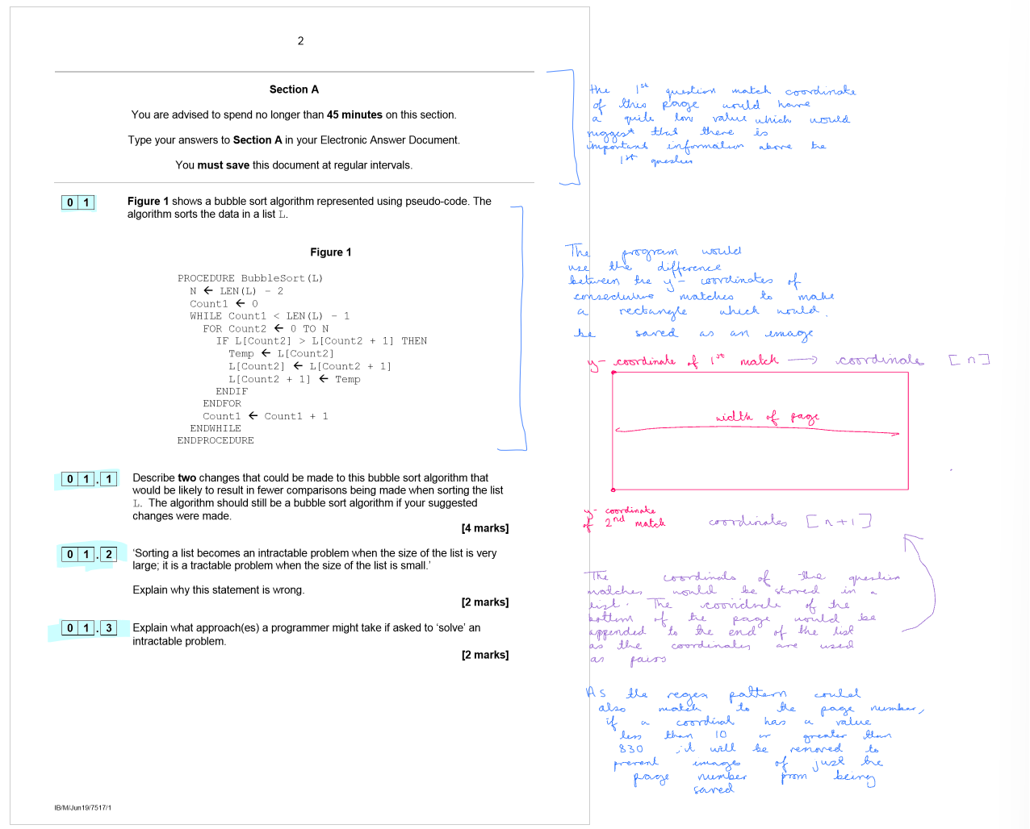

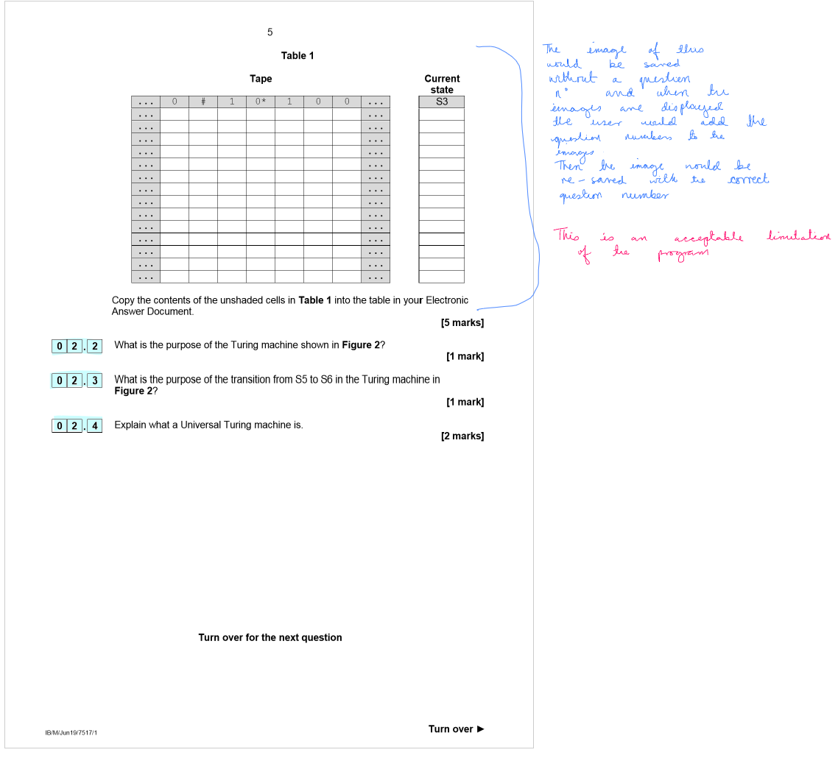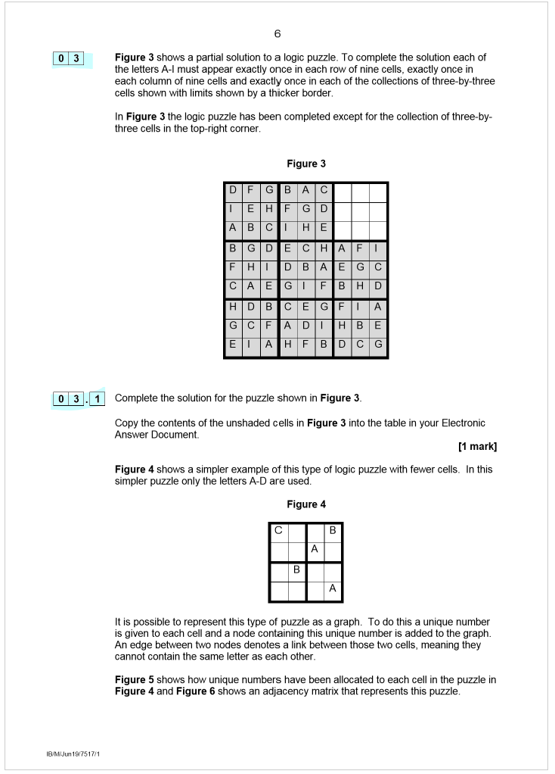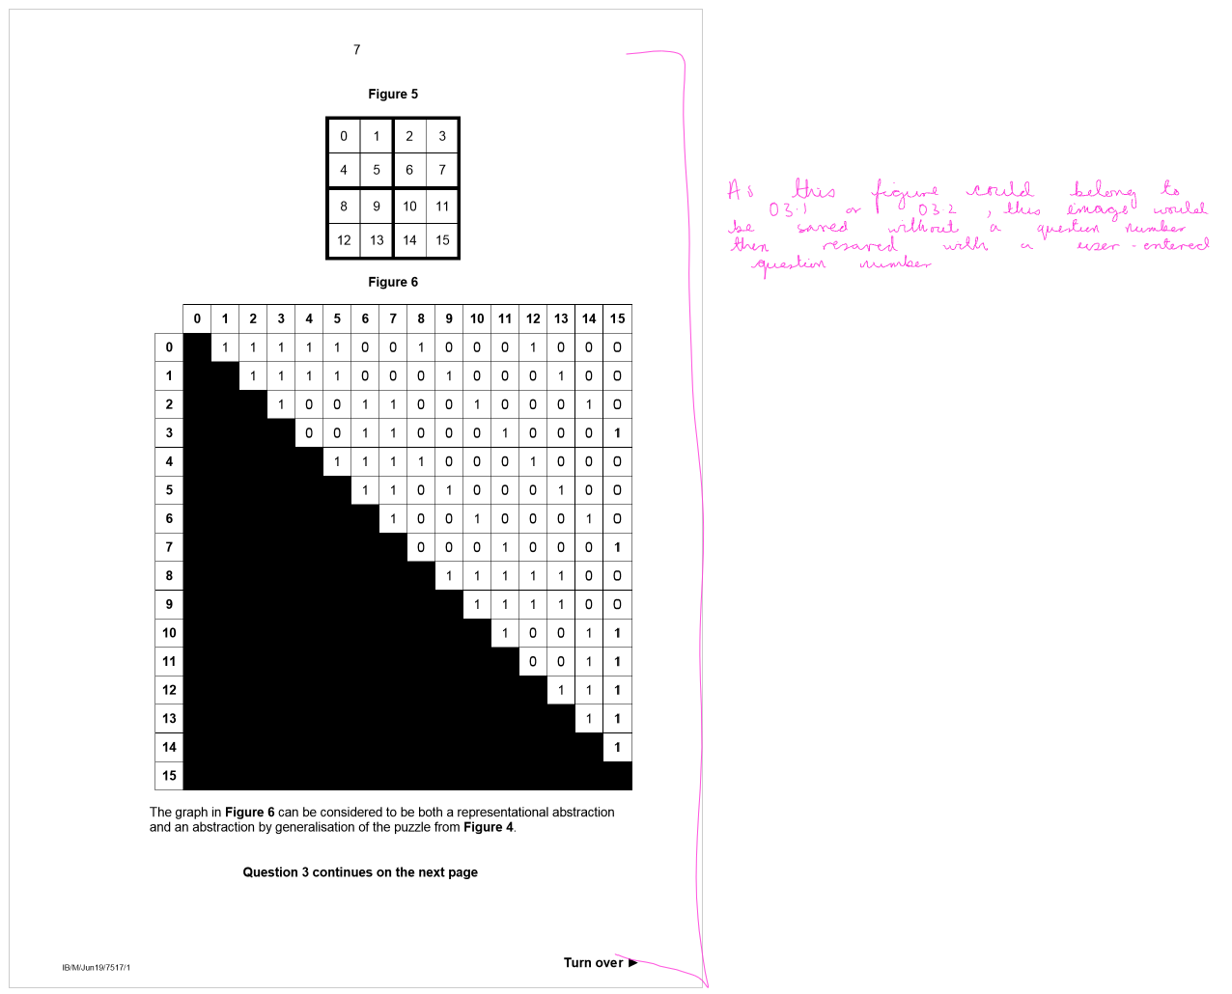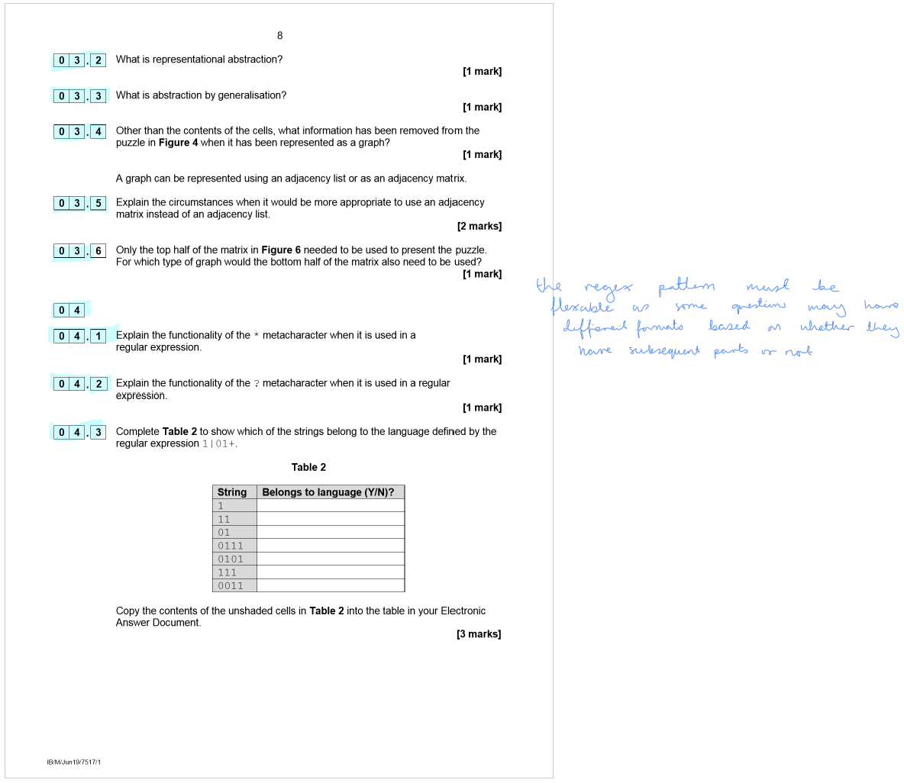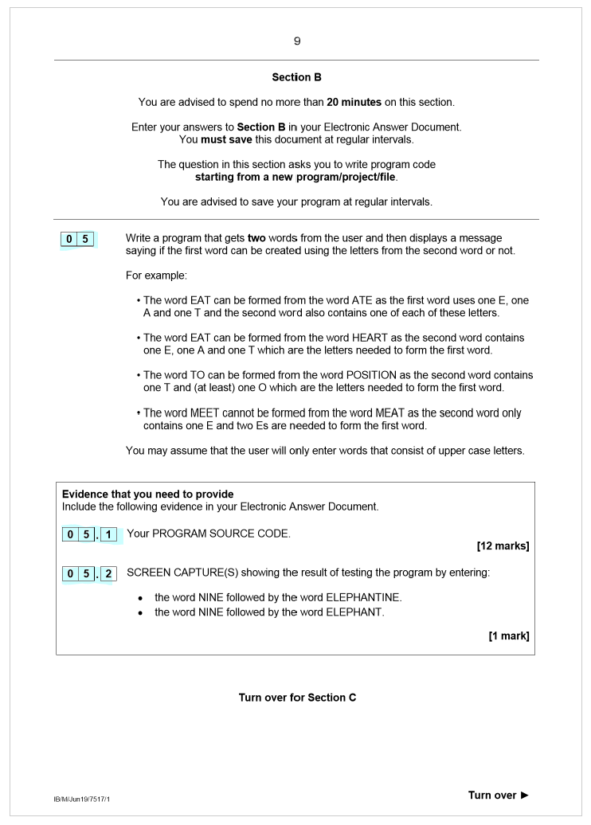

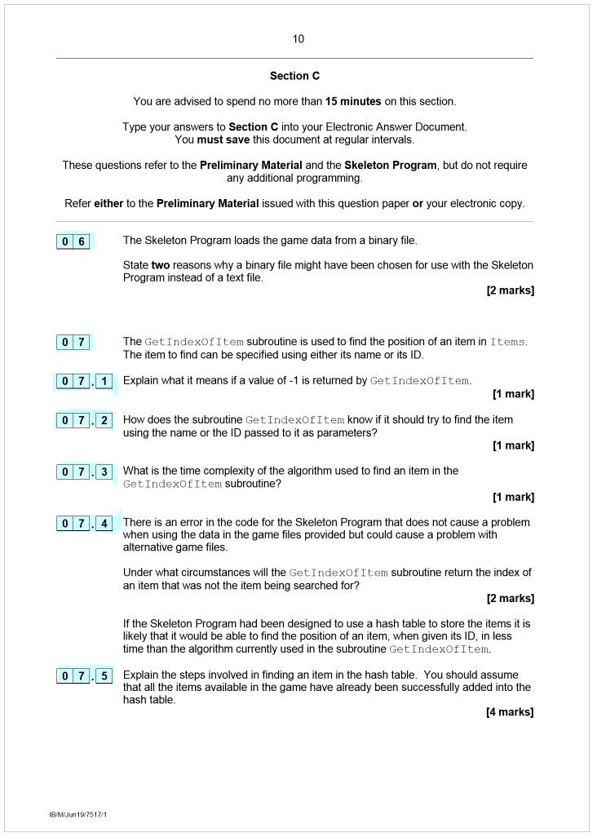

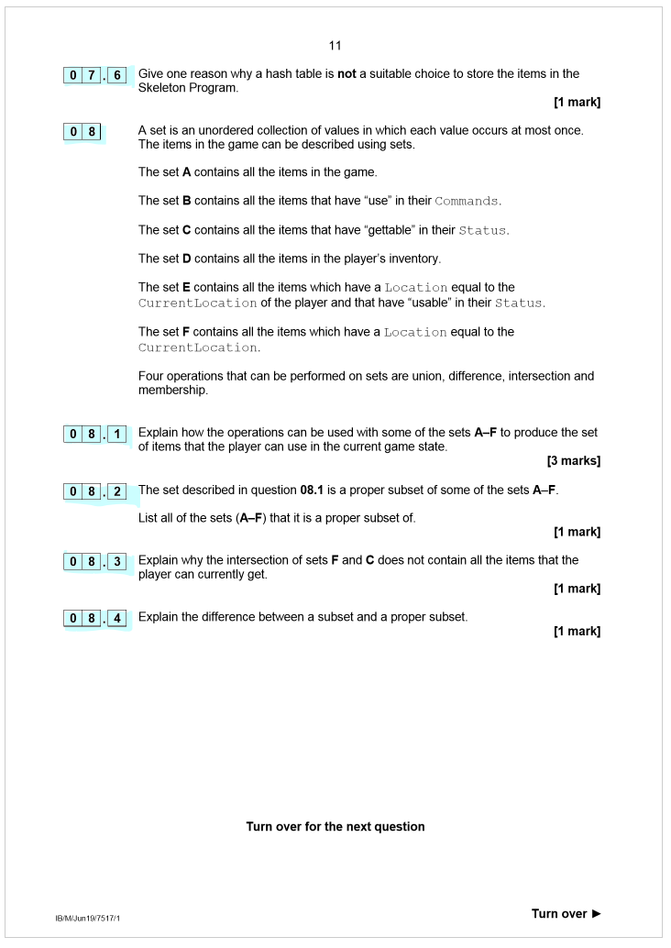

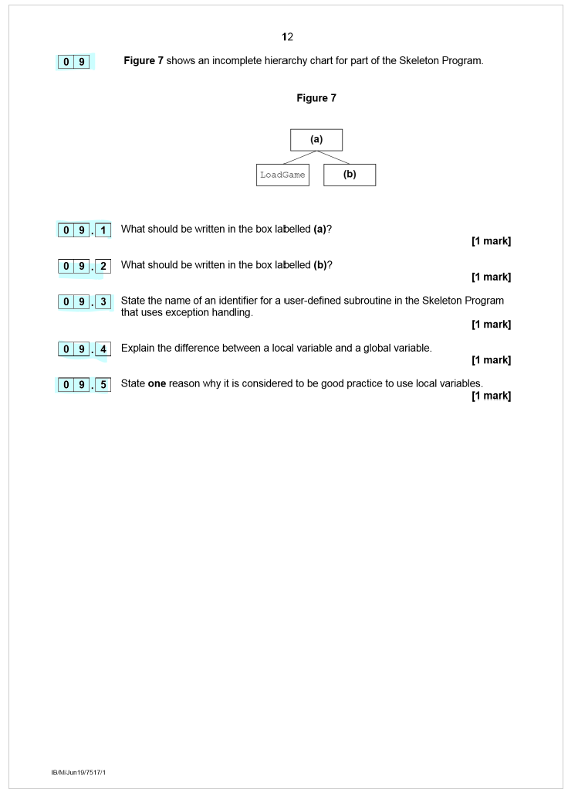

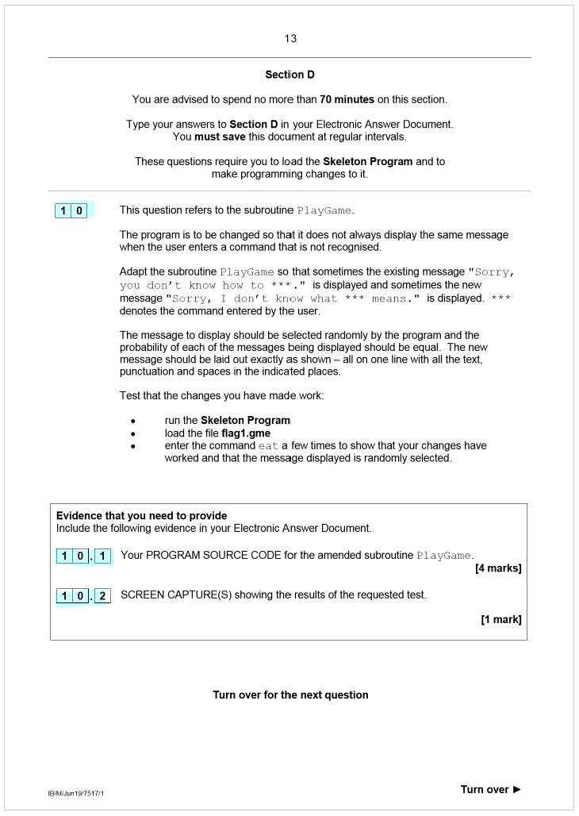

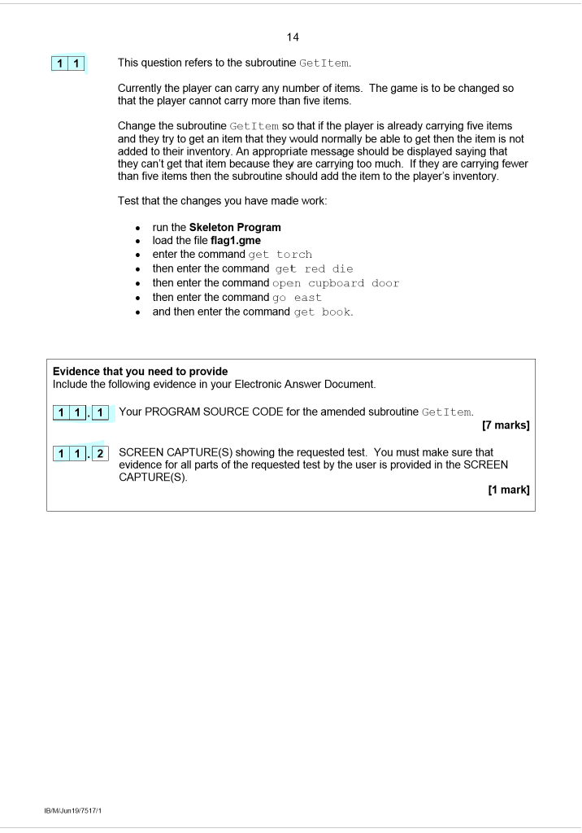

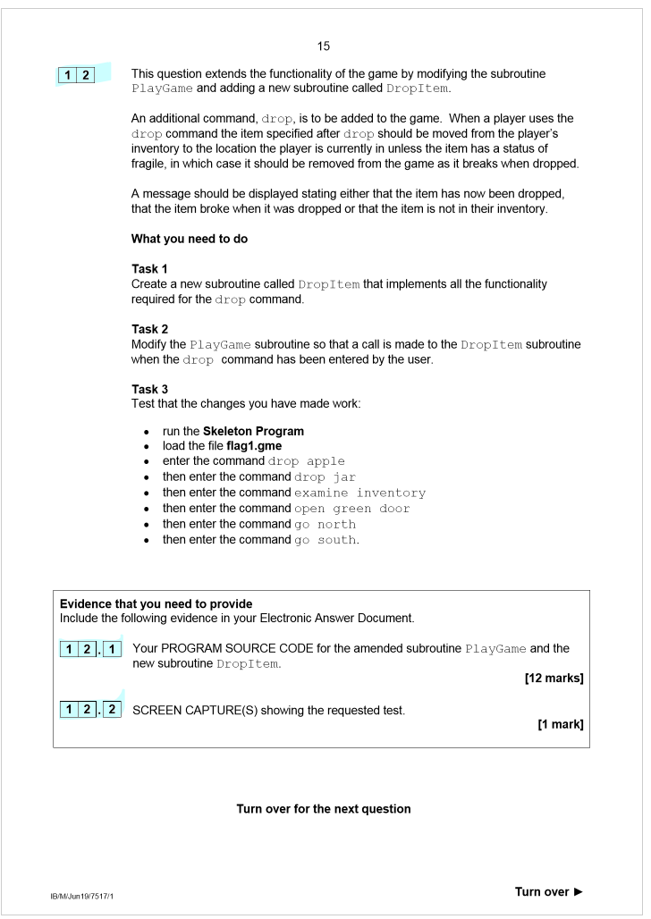

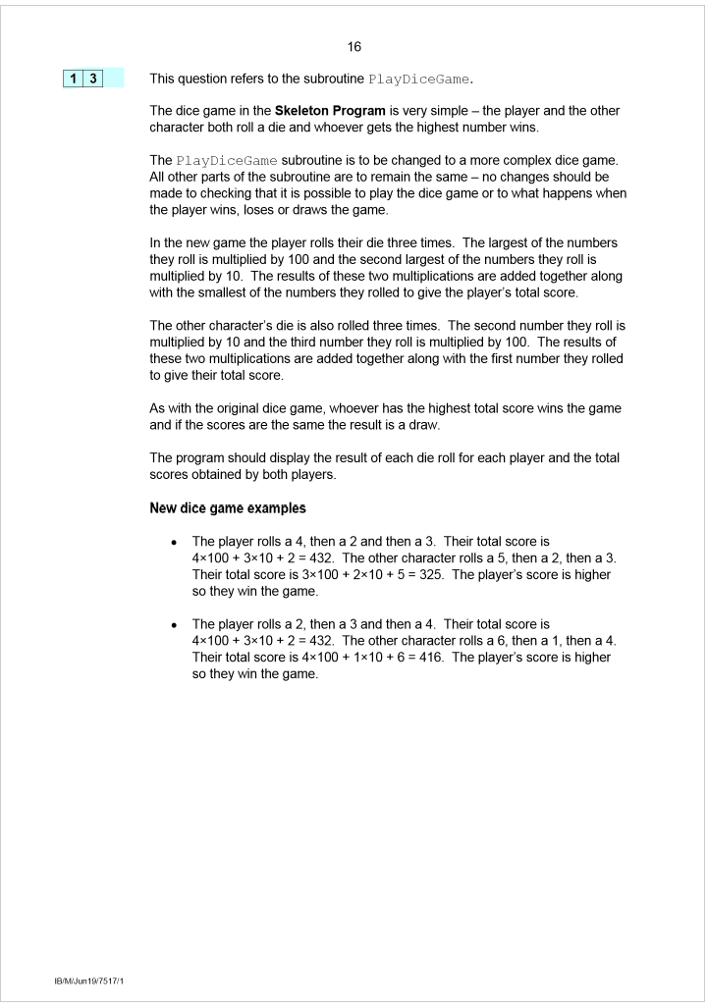

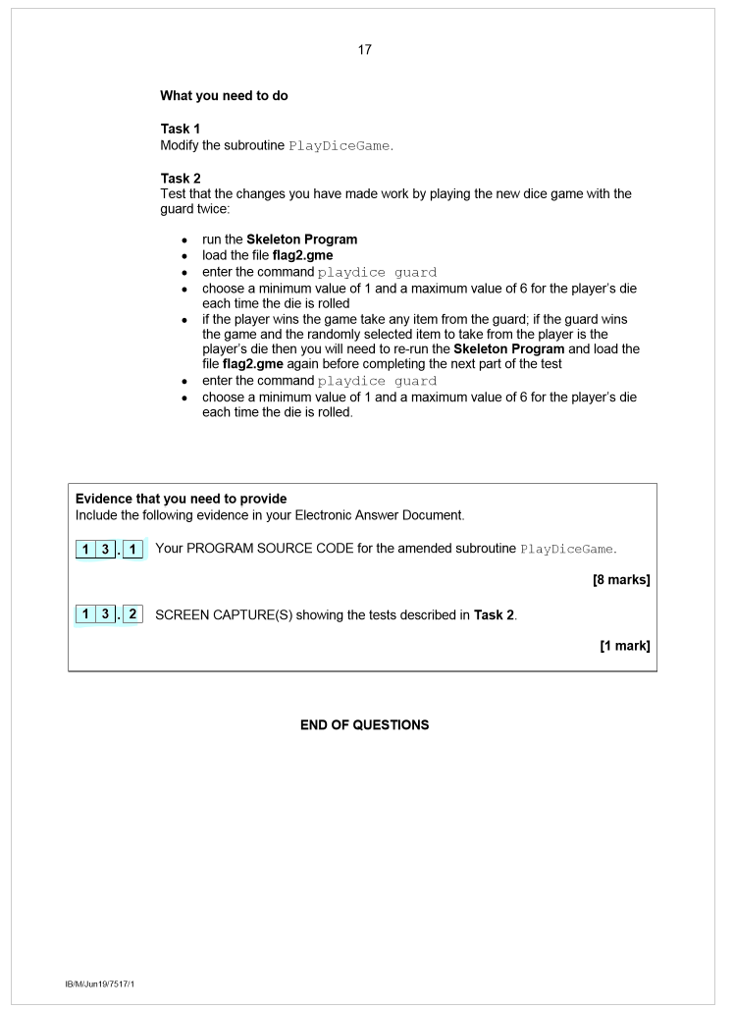

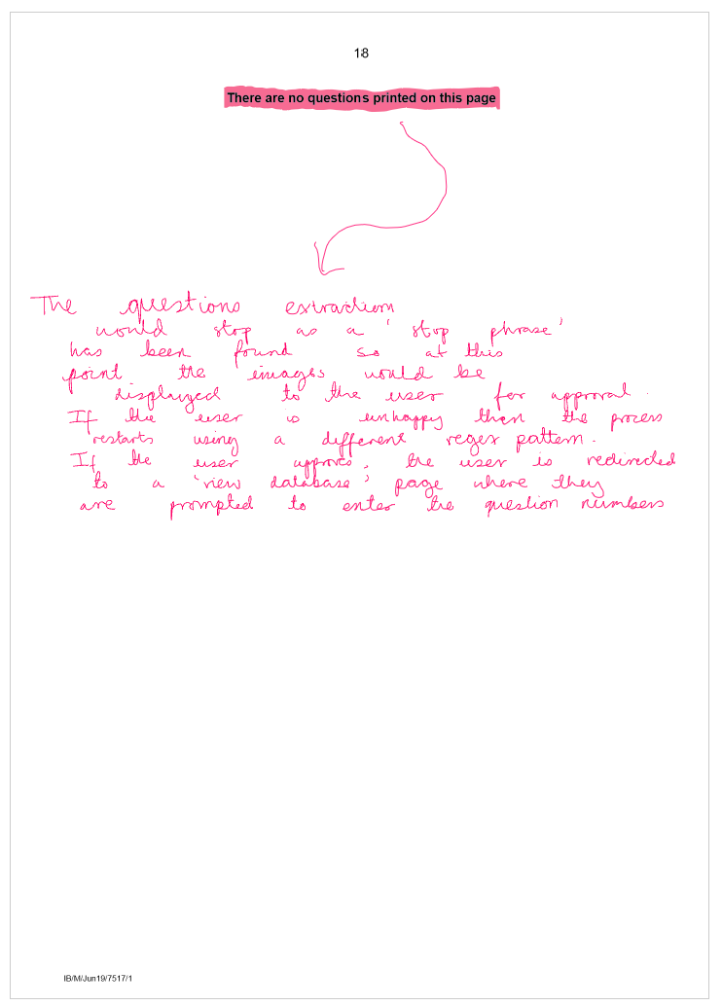





Final Objectives

1. **User Interface (UI):**
   * 1. Design a user-friendly interface for students, admins and teachers.
     2. Implement user authentication to distinguish between students and teachers.
     3. Create a page that displays the top 10 used questions
     4. Add buttons that will redirect the user to the correct feature: search, delete pdf, upload pdf and question analytics.
     5. Limit the access that students have to certain features.
     6. Integrate features for admin users.
2. **PDF Processing:**
   * 1. Implement a function that accepts the PDF file path and regex pattern and extracts images and text of individual questions and returns this as a list.
     2. This will use fitz (PyMuPDF) and IRect.
     3. The data structure used for storing question information in the provided code is a list of lists. Each inner list will contain two elements:
        1. The question text (extracted from the PDF).
        2. The question image, represented as a base64-encoded string.
     4. Implement logic to identify if the next image is a part of the previous question.
     5. Implement skip and stop phrases to decrease processing time by skipping certain pages in a pdf.
3. **User Uploading:**
   * 1. Include a page of extracted text from the first ten page of the pdf to allow the user to form the regex pattern.
     2. Include a page that will allow the user to enter a regex pattern and see example images to allow the user to refine their regex pattern.
     3. Include a page that will allow the user to enter the question numbers and approve the metadata of the PDF
4. **Database Design:**
   * 1. Design a database to store the extracted question information, along with the question image.
     2. Design a function to extract the subject, level, years, exam board and exam code by analysing the metadata of the pdf using PDFMiner library.
     3. Create a metadata table to represent the subject, level, years, exam board and exam code with the pdf id.
     4. Add a function that encrypts the image in base64.
     5. Design tables to store the question and mark scheme details, including the text, image, question number, pdf id and question id and a flag to see if the question is hidden.
     6. Design table to store user details.
5. **Database Integration:**
   * 1. Connect the application to a suitable database system (SQLite).
     2. Implement functions to insert the exam paper details and question details into the database.
     3. Implement logic to update the hidden status of questions by teachers.
6. **Retrieving and Displaying Questions:**
   * 1. Implement a search feature to retrieve questions based on various criteria like subject, topic, year, and exam board.
     2. Write a generalised database queries to fetch questions and their associated information from the database.
     3. Display the retrieved questions to the user.
     4. Ensure that students can only view non-hidden questions.
     5. Add checkboxes to allow the user to select the questions they want to compile.
     6. Add radios to show the hidden status of each question.
7. **User Management (Admin):**
   * 1. Allow admin users to add new users with appropriate permissions.
     2. Enable admin users to delete existing users from the system.
     3. Implement the ability for admin users to update user information.
     4. Provide a feature for admin users to view the list of all users in the system.
8. **Additional Features:**
   * 1. Add a to do list which displays question papers that have mark scheme that are yet to be uploaded and vice versa.
     2. Implement file validation to ensure that only PDF files, the standard format for exam papers, are accepted

# Design

# User Interface Design

Having my project as a website rather than an app provides several advantages in terms of accessibility and user engagement. A website, being accessible through standard web browsers, ensures that users can easily access without the need for downloading or installing additional software. This eliminates the barriers associated with app downloads, making my project instantly available to a broader audience across various devices, including desktops, laptops, tablets, and smartphones.

Websites allow users to access seamlessly regardless of their operating system. This cross-compatibility enhances the user experience and eliminates the need for separate development efforts for different platforms. Moreover, the web-based nature enables users to interact with it instantly, fostering a user-friendly experience without the constraints of app store regulations or approval processes.

Websites are also easier to update and maintain, as changes can be implemented on the server-side without requiring users to download updates. This agility ensures that users always have access to the latest features and improvements. Additionally, websites benefit from easier discoverability through search engines, contributing to a higher potential for user growth.

Opting for a website-based project over an app not only enhances accessibility but also eliminates the additional steps and complexities associated with app distribution. If my project were an app, users would need to navigate to an app store, to download and install the application. This process involves searching for the app, confirming compatibility with the user's device, and waiting for the download and installation to complete.

Furthermore, app distribution requires adherence to strict guidelines and approval processes imposed by app store platforms. Developers need to ensure their apps comply with these regulations, which may involve additional time and resources for testing, adjustments, and resubmissions. The distribution process for apps also involves periodic updates, each requiring user action to download and install. Users may face challenges if they have limited storage space on their devices or if they are in an area with slow internet connectivity.

While apps may offer advantages like offline functionality and direct access to device features, a website's accessibility, reach, and ease of maintenance make it a superior choice for projects aiming for widespread availability and seamless user interaction.

## Metadata extraction

I will need to see if the library will extract the correct components for pdfs from different exam boards and subjects. To do this, I will need to test code utilising the PDFMiner library by sending the function multiple pdfs of different origin.

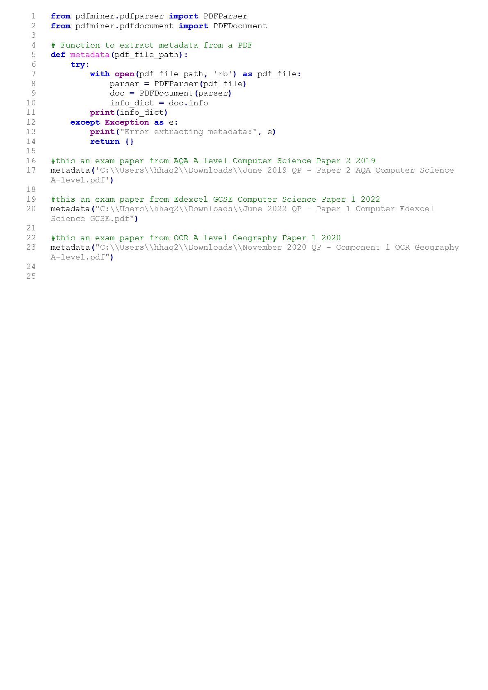

From the AQA paper the output looked like this:

[{'Author': b'AQA', 'CompDisplayName': b'Paper 2', 'CompFacet': b'Paper 2', 'CompName': b'A-level', 'Component': b'75172', 'CreationDate': b"D:20210620224650+01'00'", 'ExamSeriesFacet': b'June 2019', 'Important': b'', 'Keywords': b'', 'ModDate': b'D:20230117104355Z', 'OptionFacet': b'', 'PrintSizeFacet': b'', 'PublishedWhen': b'01/07/2021', 'PublishedYear': b'', 'QualFacet': b'A-level', 'ResourceFacet': b'Question papers', 'ResourceType': b'Question paper', 'SeriesMonth': b'June', 'SeriesYear': b'2019', 'Spec': b'7517', 'SpecFacet': b'Computer Science 7517', 'SubCategoryFacet': b'Sample papers and mark schemes', 'SubTypeCode': b'QP', 'Subject': b'Computer Science', 'Subtitle': b'', 'Title': b'June 2019 QP - Paper 2 AQA Computer Science A-level.PDF', 'TitleName': b'Question paper', 'TopicDisplayName': b'', 'TopicFacet': b'', 'TypeCode': b'QP', 'TypeName': b'Paper 2', 'dam-category': b'assess', 'dam-resource-id': b'', 'dam-spec-id': b'00053147-DB', 'dam-topic-id': b'', 'grouping': b''}]

From the Edexcel paper the output looked like this:

[{'CreationDate': b'D:20211123100632Z', 'Creator': b'Adobe InDesign 17.0 (Windows)', 'ModDate': b"D:20220509111611+01'00'", 'Producer': b'Adobe PDF Library 16.0.3', 'Trapped': /'False'}]

From the OCR paper the output looked like this:

[{'Author': b'OCR', 'CreationDate': b'D:20200220111903Z', 'Creator': b'Adobe InDesign CC 2015 (Macintosh)', 'GTS_PDFXConformance': b'PDF/X-1a:2001', 'GTS_PDFXVersion': b'PDF/X-1:2001', 'Keywords': b'Geography,Physical systems', 'ModDate': b'D:20211206171018Z', 'Producer': b'Adobe PDF Library 15.0', 'Subject': b'Geography', 'Title': b'A Level Geography H481/01 June 2020 Paper A', 'Trapped': /'False'}]

From this test using pdf miner to extract the metadata to accurately define each paper is not a comprehensive solution as some exam papers do not have the desired components stored. My solution to this is to build on the page where the user will enter their question numbers that will allow the teacher to fill in the missing components when saving. I will have theses preloaded with the values from the extracting metadata function to reduce time for teachers.

The PDFMiner function may be viewed as extra processing as for exam boards other than AQA the teacher will have to manually enter the year, subject, level, exam code, exam board and paper number. However, 92% of UK schools enter qualifications with AQA and 98% of students in England take AQA qualifications, so the PDFMiner function will save time for a large majority of the clients and it is not specific to the UK as AQA works in more than eighty countries. These statistics have been retrieved from the AQA official website: <https://www.aqa.org.uk/about-us/who-we-are/aqa-in-numbers> .

# IPSO Chart

I have modelled how I would like the program to flow however this will develop as I design a greater percentage of the program.

Below is a IPSO chart for the extraction process only available to a teacher:

|  |  |  |  |
| --- | --- | --- | --- |
| Input | Process | Storage | Output |
| User uploads an exam paper or a mark scheme.  User enters a regular expression (regex) pattern.  User would be able to confirm whether they want to use this regex pattern based on example images. | Metadata is extracted from the file, including author, component, series year, comp facet, and spec facet.  The system extracts questions/answers based on the given regex pattern.  Images are encoded using base64. | n/a | The system redirects the user to the 'Show Images' HTML page.  The 'Show Images' page displays all the captured images.  . |
| User fills in the input boxes for the metadata.  User enters question numbers of each image | Images and text are stored in a database with relevant data.  Questions and answers are linked through similar fields | Metadata, images, and text are saved in appropriate tables with other relevant data | Will be redirected to Search page when the save button is pressed. |

Here is an IPSO chart for the searching of the database and the compilation of custom booklets, available to both users and teachers:

|  |  |  |
| --- | --- | --- |
| Input | Process | Output |
| User enters search criteria (year, exam board, subject, paper number, keywords). | The program executes a database query based on the provided search criteria.  The database query retrieves relevant metadata and associated images. | The system displays search results, showing question images based on the user's search criteria.  If the user is a teacher, a "Hide" button is available for selected questions. |
| User selects the check boxes of the questions wanted.  Presses Compile Button | The program gets the pdf id and question number of the selected image and returns the base 64 encrypted image data for that question.  The matching images in the answers table will be retrieved using the pdf id and question number. | The program would display the selected images in a new tab. |
| Teacher only:  User selects the check boxes of the questions they want to hide/show.  Presses Hide Button | The program gets the pdf id and question number of the selected image and runs tan SQL command updating the is_hidden value for that question. | The radio buttons will reflect this change, students will no longer be able to see that question. |

Here is an IPO chart that outlines process behind the question analytics program:

|  |  |  |
| --- | --- | --- |
| Input | Process | Output |
| User accesses the Question Analytics page. | The application executes an SQL query to retrieve the top ten most used questions and their usage counts.  The application fetches the data from the database.  The usage count of a question is incremented by one when a question is selected to be compiled in a custom booklet. | The application generates an HTML page to display the question analytics. |

Here is an IPO chart that outlines process behind the delete pdf program:

|  |  |  |
| --- | --- | --- |
| Input | Process | Output |
| User provides input for parameters like year, exam board, level, subject, paper number and exam code. | The application executes an SQL query to select the pdf id with the matching year, exam board, level, subject, paper number and exam code. The program would then delete any record from the question , answers then the metadata table with the matching pdf id. | The application generates a confirmation message indicating the successful deletion of the selected exam papers.  If no matching exam papers are found, the application provides a message stating that no records were deleted. |

## Login Page

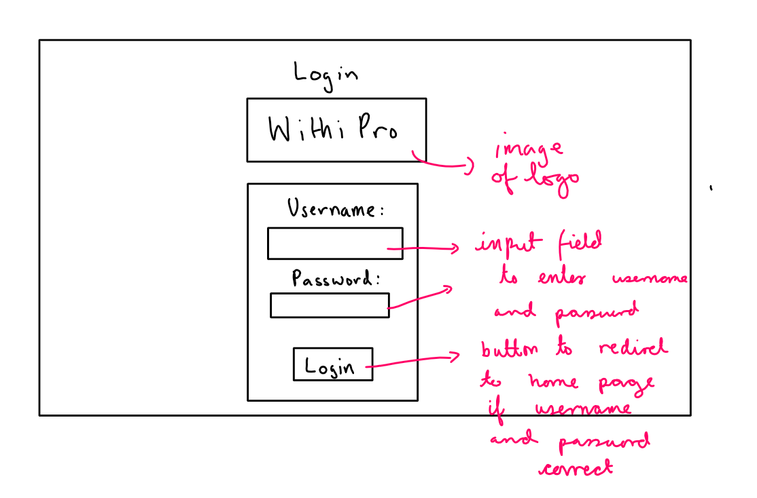

The login page is designed to provide a user-friendly authentication for users. It will have several features that enhance functionality and usability.

Utilizing the W3.CSS framework, the page will be responsive, ensuring a user experience across various devices and screen sizes. This responsiveness enhances accessibility, allowing users to log in from desktops, laptops, tablets, or smartphones.

The login form will employ the POST method to securely transmit user credentials (username and password) to the server. This ensures that sensitive information is not exposed in the URL and mitigates potential security risks associated with using the GET method.

Both the username and password fields will include the "required" attribute, prompting users to fill in these fields before submitting the form. This client-side validation enhances user experience by providing immediate feedback and preventing unnecessary form submissions with missing information.

**Inputs**

The login form consists of two primary inputs: a text input for the username with attributes including type, ID (username), name (username), and a requirement for entry; and a password input with attributes such as type, ID (password), name (password), and a mandatory entry requirement.

**Outputs**

Upon successful login, the user is redirected to the index page with a personalized welcome message. If login credentials are incorrect, an error message is displayed, notifying the user of the authentication failure.

In the future, this design could potentially incorporate additional features, such as multi-factor authentication, social login options, and personalized user profiles, further enhancing the overall user experience and security.

## Teacher Home Page and Student Home Page

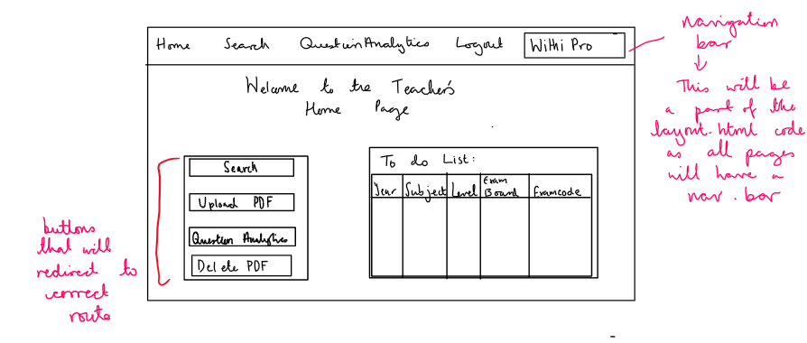

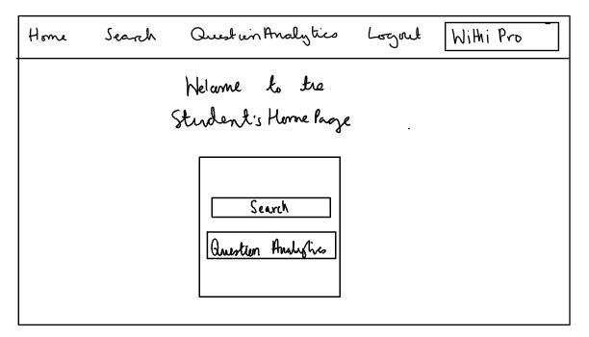

The teacher home page is designed to offer a straightforward and clear navigation experience. Four prominent buttons - Search, Upload PDF, Question Analytics and Delete PDF - serve as quick access points to key features. This ensures that teachers can easily navigate to the desired functionality. The student home page is designed to have two buttons: Search and Question Analytics.

Flexbox will be employed to structure the button container, ensuring a responsive and visually pleasing layout.

The logo will use absolute positioning to ensure that it remains visible and does not interfere with the main content. The width and height will be set to maintain a balanced aspect ratio.

There will be an additional property of the teacher home page. It will feature a to do list which will return a list of pdfs that need to be uploaded as their mark scheme / question paper are already in the database but cannot be utilised until both the questions and answers are present. Items in the to-do list are color-coded for easy identification. Question Papers (QP) are highlighted in light green, and Mark Schemes (MS) are highlighted in light red. I have included this as it allows teachers who are in charge of uploading papers to have a clear record of what they need to complete.

The code will include 2 SQL commands. The purpose of these queries is to identify and retrieve information about question papers (QP) and mark schemes (MS) that are missing their corresponding counterpart in a database. In these queries, aliases will be used to create temporary names for the tables in the FROM and JOIN clauses. The purpose of aliases is to provide shorthand notation for table names, making the SQL code more concise and readable. q is a shorthand alias used throughout the query to refer to the metadata table when it represents question papers. a is an alias for the same metadata table, but it is used to represent mark schemes or answers.

1. **Select Question Papers Without Mark schemes:** The first query will retrieve information about question papers (metadata records with type 'QP') that do not have a corresponding mark scheme. It will use a LEFT JOIN operation between the metadata table aliased as 'q' (for question papers) and 'a' (for answers or mark schemes). The condition for the join includes matching years, subjects, levels, exam boards, and exam codes. The query will look for records where the type is 'QP' (question paper) and the corresponding mark scheme does not exist (marked by the condition a.type = 'MS' being NULL). The result is a list of question papers without associated mark schemes.
2. **Select Mark schemes Without Question Papers:** The second query will do the reverse and identifies mark schemes (metadata records with type 'MS') that lack a corresponding question paper. Similar to the first query, it will use a LEFT JOIN operation between 'a' (mark schemes) and 'q' (question papers), checking for matching attributes and ensuring that the corresponding question paper's type is 'QP'. The query will retrieve records where the type is 'MS' and the associated question paper does not exist (marked by the condition q.type = 'QP' being NULL).

**In the case that both lists are empty the message “No items in the to-do list” will be displayed.**

The Python code within the Flask route checks whether the user is logged in and is a teacher before rendering the teacher home page. If not, it redirects the user to the login page. This ensures that only authorized users access the teacher-specific features.

The HTML code will use Jinja2 templating for dynamic content, enhancing the integration with Flask. Improvements could be incorporated based on teacher feedback, such as personalized dashboards, analytics summaries, or notifications.

## Search Page

Old design

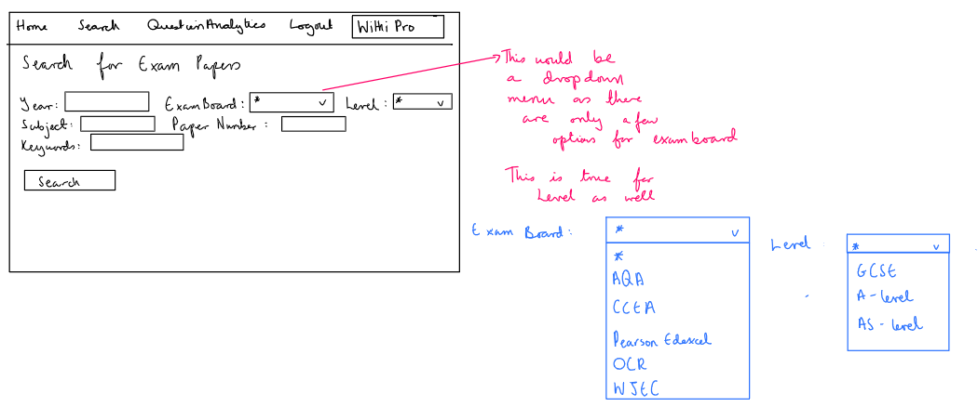

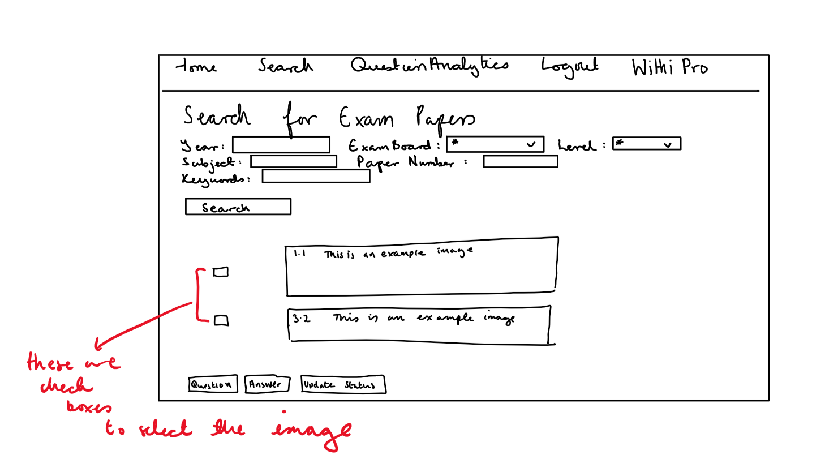

After reviewing this design I realized that my program cannot be fully utilised in making mock exam papers so I will extend this search function to allow for multiple examboards to be searched for and to increase the amount of keywords that can be entered as the former design was better for just topic tests but not general holistic papers. In addition, this design did not align with my objectives as there is no way for teachers to identify which questions are hidden.

New design

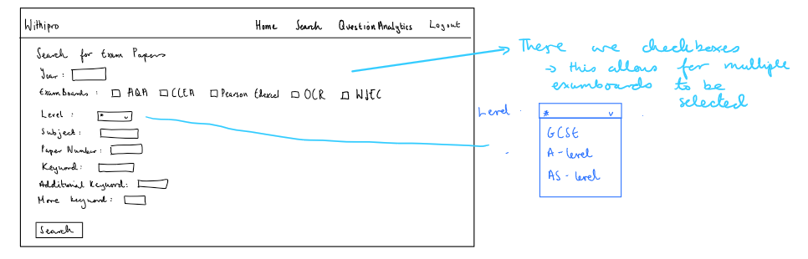

For teachers, the results would look like this:

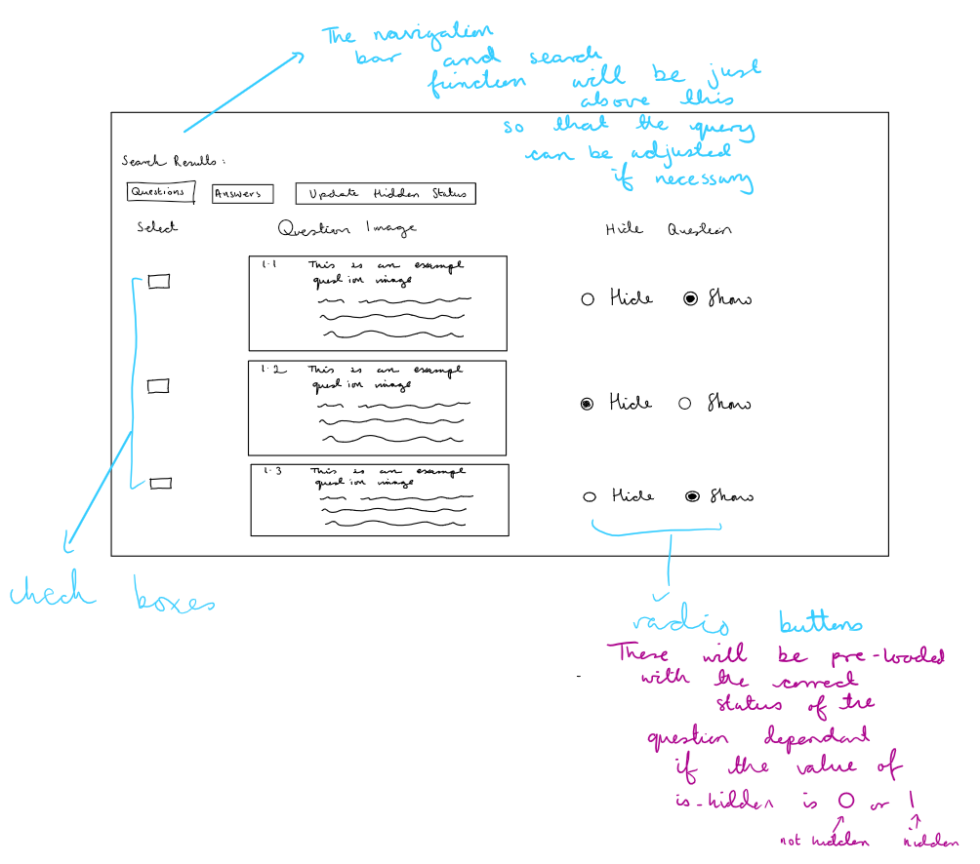

In a short interview with the client, I described the proceess of hiding the question and I was advised to add a note on the page guiding the teacher as they may not be certain on what need to be changed and which buttons need to be pressed. I will include this in the final product:” **Teacher Note:** If you wish to update the hidden status of a question, select that question, then change the Show/Hide value, and proceed to press the "Update Hidden Status" button.” Additionally, I will move the Questions /Answers /Update Hidden Status buttons to the top of the page as there can be many results returned based on the query.

For students, the results will look like this:

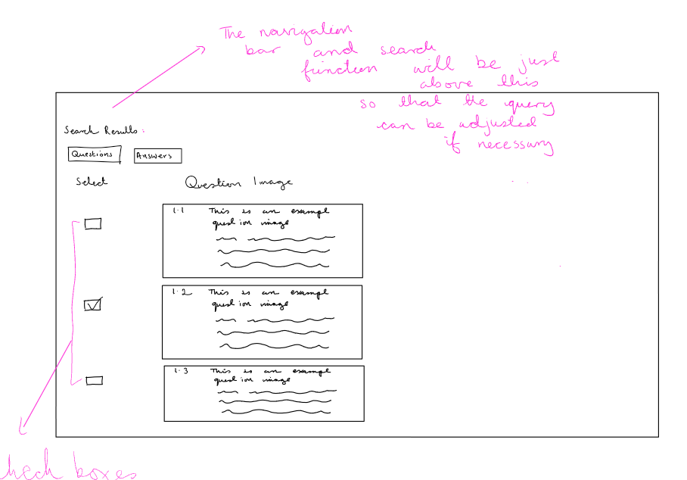

The Search page provides a dynamic search form allowing users to filter exam papers based on various criteria such as year, exam board, level, subject, paper number, and keywords. This flexibility ensures users can tailor their searches to specific needs.

The inclusion of a keyword search allows users to search for exam papers based on specific terms present in the regex patterns or question texts. The keyword search supports multiple keywords and utilizes SQL's LIKE operator for a more comprehensive search.

The search results will be presented in an organized table. Each result will include a visual preview, aiding users in quickly identifying relevant questions. For teachers, an additional column will indicate whether a question is hidden, providing valuable insights into the question status.

Conditional buttons are included based on the user's role (teacher or non-teacher). Teachers have additional options to "Update Hidden Status", providing extended functionality for managing and organizing exam papers.

The use of if statements in building the SQL query will be essential for several reasons:

1. If statements allow the inclusion of conditions based on user input. This ensures that only relevant conditions are added to the query, preventing unnecessary constraints when certain filters are not applied.
2. Building the query incrementally using if statements enhance code readability. Each condition is added in a structured manner, making it easier to understand and maintain the code over time.
3. If statements make the query adaptable to future changes or additions to the search criteria. New filters or options can be incorporated without restructuring the entire query.

Inputs:

1. Year(s) (Text): Users will be able to input one or multiple years (comma-separated) as text to filter exam papers based on the specified year(s).
2. Exam Boards (Checkbox Values): Users will select one or more exam boards (AQA, CCEA, Edexcel, OCR, WJEC) as checkbox values to narrow down the search based on the chosen boards.
3. Level (Dropdown Selection): Users will choose the academic level (GCSE, A-level, AS) from the dropdown menu as a text input to filter papers accordingly.
4. Subject (Text): Users will input the subject as text to find exam papers related to a specific subject.
5. Paper Number (Text): Users will input the paper number as text to search for papers with a particular identification number.
6. Keywords (Text): Users will input keywords as text for a more comprehensive search. The keyword search will support up to three keywords, allowing users to search based on specific terms present in regex patterns or question texts.
7. Search Button:
   * Type: Submit
   * Value: Search
   * User clicks this button to submit the search form.

The default value for all these fields is *.

Outputs:

Search Results: The results will be displayed in a clear and organized table format.

* + There will be a column of checkboxes used to select the questions.
  + Each row will represent a matching exam paper based on the search criteria.
  + For teachers, an additional column may indicate whether a question is hidden.

Action Buttons: The user will have the option to perform various actions based on their role:

* + Questions Button (Submit Form): Will generate a new page displaying question images for the selected exam papers.
  + Answers Button (Submit Form): Will generate a new page displaying answer images for the selected exam papers.
  + Update Hidden Status Button (Submit Form - For Teachers Only): Will allow teachers to update the hidden status of selected questions.

Teacher Note (Text - For Teachers Only): A note will be displayed to guide teachers on updating the hidden status of questions.

## Questions Page and Answers Page

These pages will have no formatting and will just display the images.

After reviewing the previously done modelling, I realised that questions may require previously mentioned information and figures to be solved so that when a user selects a question to be compiled the entirety of the question must be compiled.

1. **Retrieving Parts of the Selected Question:** To retrieve all parts of the selected question, I would need to identify each part based on the question number. For example, if the question number follows a specific pattern where the first two characters represent the entire question number , I can use these characters to fetch other parts. For example if the question number of the selected image is 01.2 then I must select all questions starting with 01 from that pdf. This involves constructing SQL queries to retrieve the question image and related metadata based on the PDF ID and question number. I will need to ensure that the SQL queries are parameterized to prevent SQL injection vulnerabilities.
2. **No Formatting for Printability:** To ensure the printed exam paper has no formatting issues, I should present the content in a clean and simple format. Embedding question images directly into the HTML using base64 encoding will eliminate external dependencies. This allows users to print the exam paper directly from the web page without worrying about image files or formatting discrepancies. Additionally, in the future I will consider providing a print-friendly CSS stylesheet to optimize the layout for printing.
3. **Pre-loaded Radio Buttons for Hidden Status:** Implementing pre-loaded radio buttons involves dynamically generating HTML elements based on the data fetched from the database. For each displayed question, I would create a set of radio buttons with predefined values representing the "Show" and "Hide" options. The radio buttons should be associated with each question, and their initial state (checked or unchecked) should reflect the current hidden status.
4. **Changing the Hidden Status:** To change the hidden status of questions, I will associate 0 and 1 values to the radio buttons, and this would be sent to the flask function and an SQL query will update this by using the question number, pdf id and the new value for is_hidden.

When the "Questions" or "Answers" button is clicked, the form will submit the selected data to the 'compile' route using the POST method. The `formtarget="_blank"` code in the html will ensure that the results open in a new browser tab. This design provides a user-friendly experience, allowing users to view search results in a separate tab without losing the context of the search form. It is particularly useful when dealing with a large set of search results or when comparing multiple sets of data simultaneously.

Initially, the design of the application aimed to display both the question and answers images on the same page after a search. However, after a constructive conversation with the client, it was brought to my attention that providing the flexibility for teachers to view the question and answers on separate pages would offer greater control over the layout. The client emphasized the importance of customization, acknowledging that teachers may have specific preferences regarding the arrangement of question booklets and answers. By opting for separate pages, teachers have the autonomy to decide whether they want the answers attached to the question booklet or presented in a distinct layout.

## Question Analytics Page

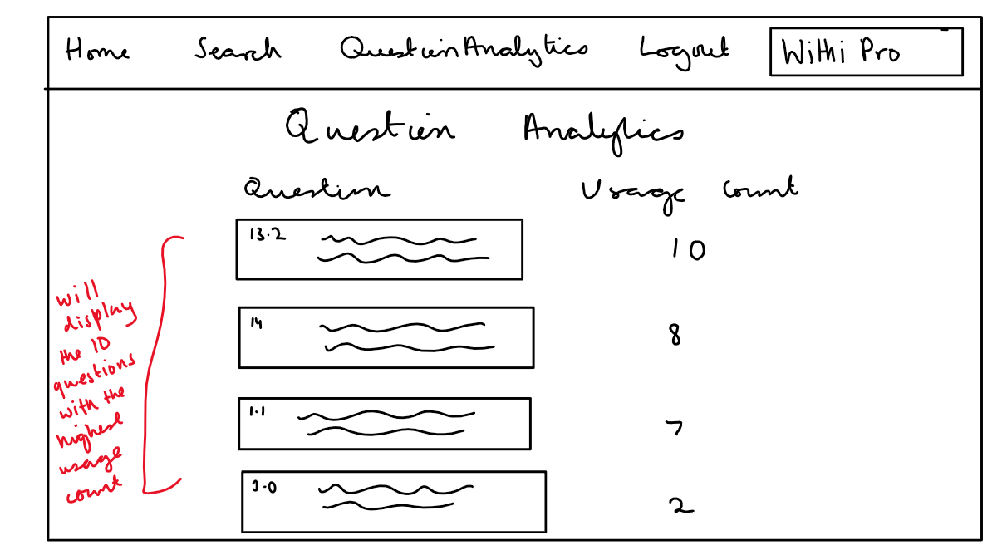

The code will fetch data from the questions table in the SQLite database. Specifically, it will retrieve the question images and their corresponding usage_count. The SQL query sorts the results by usage_count in descending order and limits the output to the top ten questions. the usage count will be updated within the compile route when the user selects a set of questions for compilation. The trigger for updating the usage count is the selection of a question by the user for compilation, indicated by the checkbox being checked. Once a question is selected, its usage count is incremented by one. This ensures that the system keeps track of how frequently each question is being utilized. The update is performed by fetching the current usage_count from the database, incrementing it by one, and then updating the database with the new count. This mechanism allows for the effective monitoring of question usage patterns, providing valuable insights into the relevance and popularity of individual questions within the application.

## Delete PDF Page

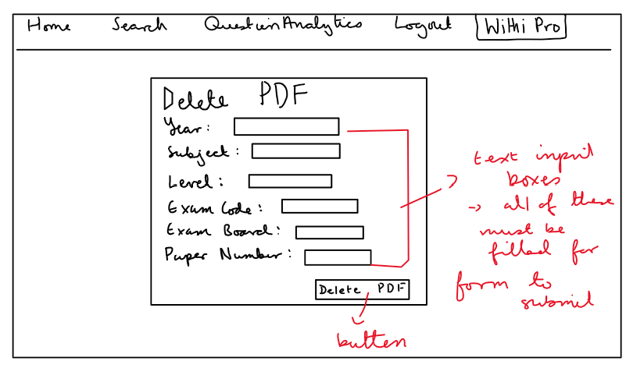

The code will check if the HTTP method used in the request is POST. This is important to ensure that the form data submitted by the user is processed when they attempt to delete a PDF. If the method is indeed POST, the code proceeds to extract the user input from the form. The input includes the year, subject, level, exam code, exam board, and paper number of the PDF the user wants to delete.

After extracting the user input, the code will validate whether all the required fields are filled. If any field is missing, an error message will be returned, and the user is redirected back to the "delete_pdf" page.

The application will generate a confirmation message in green indicating the successful deletion of the selected exam papers. If no matching exam papers are found, the application will provide a message in red stating that no records were deleted. The colour representation in the message display is crucial for the client as it provides immediate and visually intuitive feedback on the outcome of their actions. The use of green for messages indicating successful operations and red for error messages serves as a quick and effective visual cue. This design choice enhances the user experience by allowing the client to easily distinguish between positive and negative outcomes, facilitating prompt identification of the status of their requests.

The code then queries the metadata table to retrieve the PDF IDs matching the user's input. If no matching PDFs are found, the user is redirected back to the "delete_pdf" page.

If matching PDFs are found, the code will proceed to delete associated records. For each PDF ID, the code will delete corresponding questions, answers, metadata, and the PDF file from the server, using SQL DELETE statements.

## Upload PDF Page

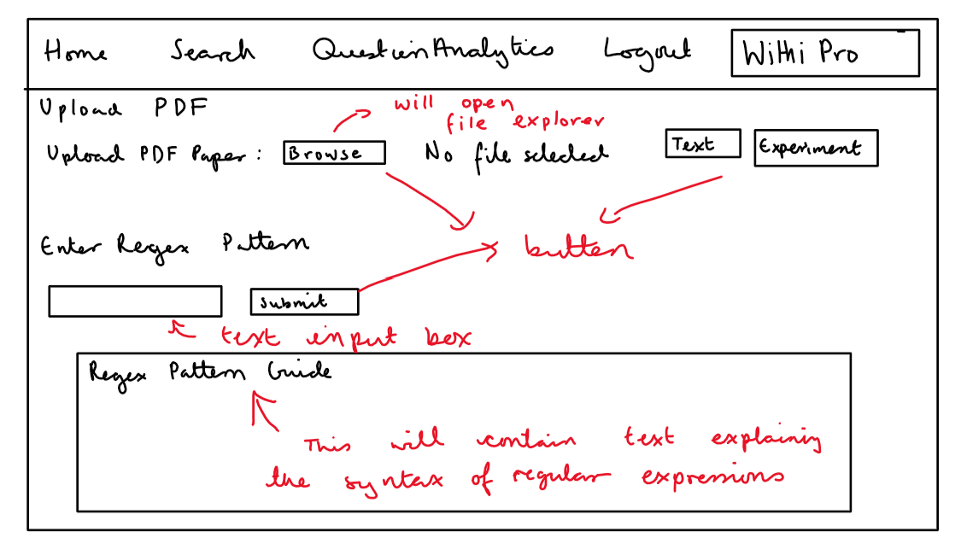

The web interface will comprise a form with the following inputs: a file upload field for the PDF, buttons for initiating text extraction and an experimental regex operation, an input field for entering a regex pattern, and a final submit button. The deliberate inclusion of a regex pattern guide aims to assist teachers in crafting accurate and effective regex patterns. The text extraction and an experimental regex will not work unless a file is uploaded.

Upon selecting a PDF file and clicking the "Text" or "Experiment" button, the flask code will process the uploaded PDF. Additionally, the PDF metadata, such as year, subject, level, exam code, exam board, and paper number, is extracted.

Teachers have the option to experiment with regex patterns, redirecting them to a separate route for further exploration. The inclusion of a regex pattern guide within the HTML aims to provide clear instructions and examples, supporting teachers in constructing appropriate patterns.

The "Submit" button triggers the submission of the PDF for processing. Before submission, the teacher will enter a regex pattern relevant to the PDF content. The backend code will check if the same metadata and regex pattern combination already exists in the database. If so, a pop-up message alerts the teacher, providing them with the existing type of paper (e.g., "question" or "answer"). This will serve as a precautionary step to prevent duplicate entries.

If the teacher chooses to continue, the program will save the PDF file to the designated folder, and the regex pattern is stored in the session. The teacher is then redirected to a route for displaying images extracted from the PDF that match the specified regex pattern.

The HTML template includes a section for a regex pattern guide, presenting information on various regex constructs. This educational component aims to allow teachers to construct effective patterns for their specific needs. Additionally, the template provides feedback messages to inform teachers about the success or potential issues during the upload process.

The overall design emphasizes user-friendliness, informative guidance, and seamless integration with the Flask framework to enhance the teacher's experience in uploading and processing PDF question papers.

## Text Page

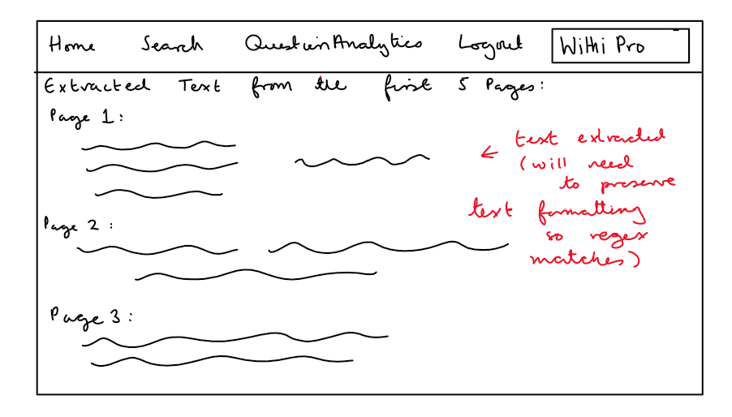

The PDF text is extracted from the first ten pages and displayed to the teacher. This allows them to preview the content before proceeding. To preserve the formatting of the extracted text from the PDF and ensure that the regex pattern applies correctly, will wrap the text output in appropriate HTML <pre> tag which is ideal for maintaining the original spacing and line breaks. This will ensure the regular expression will match.

## Experiment Page

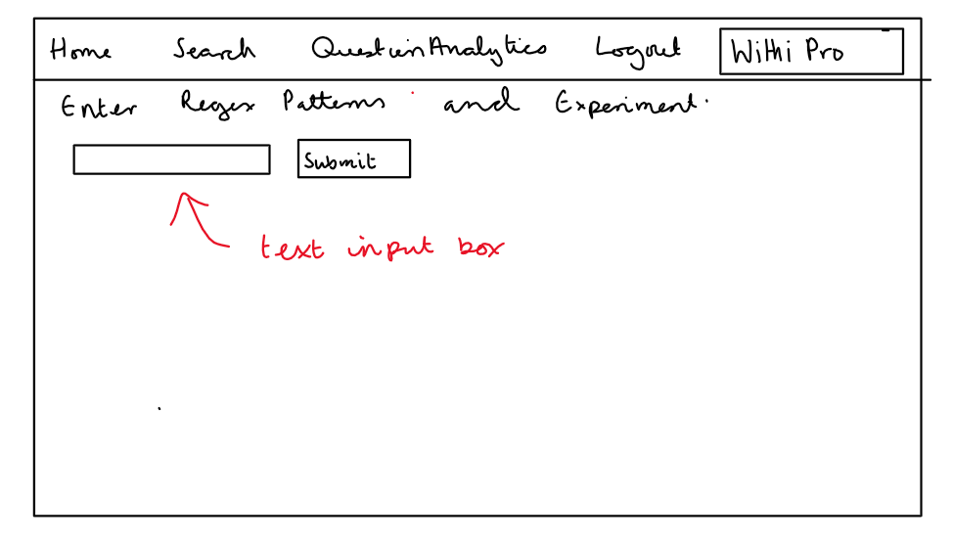

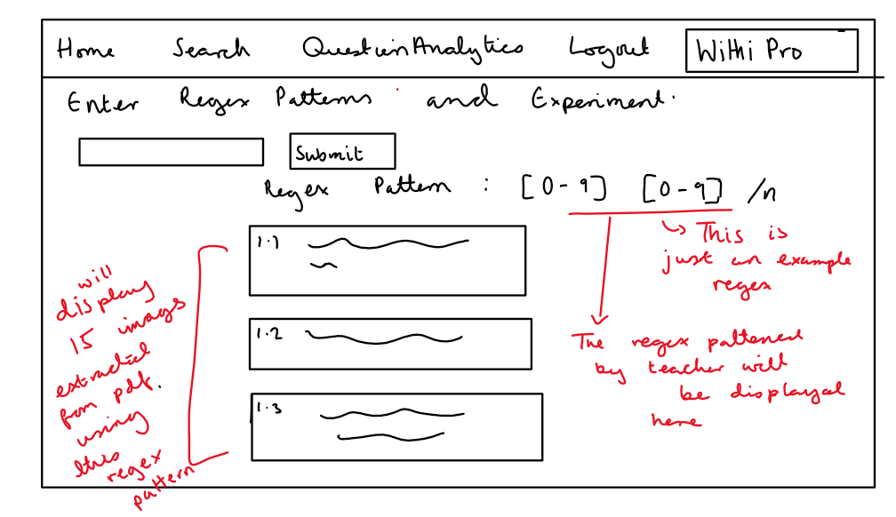

In the Flask route, an error message will serve as a fallback visual representation in case no images are extracted for a specific regex pattern. This design decision ensures that teachers receive feedback even when the regex pattern does not yield any matching images.

The mechanism involves checking if there are images corresponding to the entered regex pattern. If no images are available, the route will display an error message to provide a visual placeholder.

The route expects input from teachers in the form of a regex pattern they want to experiment with. Teachers will enter a regex pattern in the provided form and submit it. The backend will then extract images from the PDF corresponding to the entered pattern. The route will display these images, providing visual feedback to teachers about the matching results. Teachers can continue experimenting with multiple regex patterns, creating an interactive exploration of the PDF content. There will be 30 images outputted in the case of a successful regex pattern as there might be a lot of arbitrary images if the regex pattern isn’t optimised so seeing a large number like thirty will allow them to easily pinpoint how the regex can be optimized as they have more examples.

## Show Images Page

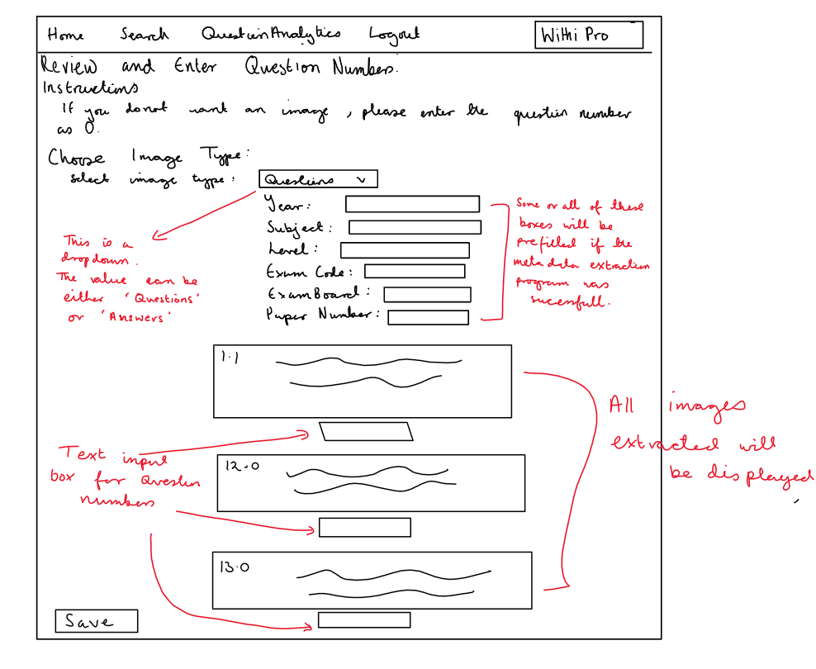

The web interface will present teachers with a visual representation of images extracted from a PDF based on a specific regex pattern. The inputs for this route include the regex pattern and the PDF file. The code uses the extract_images_from_pdf function to obtain a list of image data associated with the entered regex pattern. The images are then displayed on the web interface.

In the case where no images are extracted, a default image is utilized to ensure a visually consistent and informative display. This default image acts as a placeholder and communicates to the teacher that the regex pattern did not produce any matching images. This design decision aims to provide clarity and guidance to the teacher during the image review process.

The teacher will be presented with a set of instructions, including guidance on entering question numbers. The HTML template will dynamically render the images and provides input fields for the teacher to assign question numbers to each image. The teacher can choose the image type (either "Questions" or "Answers") and enter metadata such as year, subject, level, exam code, exam board, and paper number. These inputs for the metadata may be prefilled based on whether there was any extractable information in the files metadata.

Upon submitting the form, the save function will handle the saving of images and associated metadata into the database. It will need to perform necessary validations, checks for existing metadata, and executes SQL statements to store the information.

1. Instructions Section:
   * The template includes an "Instructions" section that provides guidance to the teacher on how to handle situations where they do not want certain images. It advises them to use "0" as the question number, which will be removed later.
2. Choose Image Type:
   * The template includes a dropdown menu labelled "Choose Image Type" that allows the teacher to specify whether the images are associated with questions or answers. This information is crucial for organizing and storing the data in the database.
3. Metadata Input Fields:
   * Input fields for metadata such as year, subject, level, exam code, exam board, and paper number are presented to the teacher. These fields are essential for categorizing and cataloguing the extracted images accurately.
4. Image Display:
   * The template dynamically displays the extracted images in a visually appealing manner. Images are presented in a row, each accompanied by an input field for entering the corresponding question number.
5. Default Image:
   * In case no images are extracted based on the provided regex pattern, a default image is displayed. This serves as a visual cue to the teacher that the current regex pattern did not produce any matching images.

Regarding how metadata is preloaded with information extracted using the pdf miner library, this process is handled by extracting the metadata using the extract_pdf_metadata.html

This will be broken into the individual components: year, subject, exam board, exam code, level, and paper number. This will be sent to the web form and these values will be resent to the flask route when the save button is pressed so that the updated values are saved into the database.

This can be done by:

<input type="text" class="form-control" name="metadata[year]" id="metadata_year" value="{{metadata.year }}" required>

<! -- Similar lines for other metadata fields -->

By assigning the extracted metadata values to the value attribute of the input fields, the template ensures that the teacher sees the relevant information already filled in. This reduces manual data entry and improves the efficiency of the data submission process.

## Admin Home Page

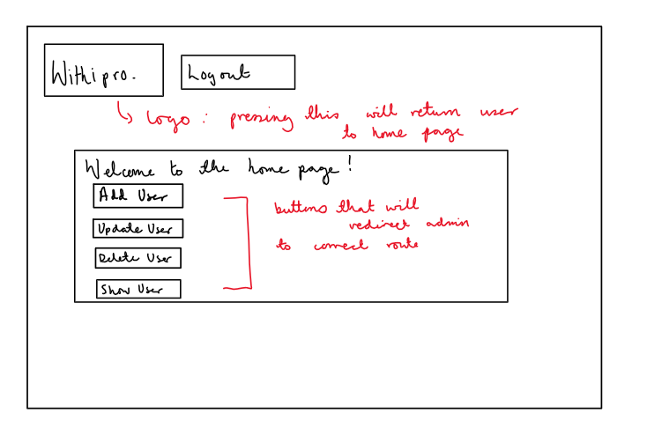

The admin home page is thoughtfully designed to provide a streamlined and efficient user experience. Key functionalities are easily accessible through four prominent buttons: "Add User," "Update User," "Delete User," and "Show Users." These buttons will serve as intuitive entry points to essential features, facilitating quick navigation for administrators.

The use of Flexbox in structuring the button container ensures a responsive and visually pleasing layout, adapting seamlessly to different screen sizes. Absolute positioning is applied to the logo to maintain visibility without disrupting the primary content, with carefully set width and height to maintain a balanced aspect ratio.

A notable feature on the admin home page is the display of a message, providing relevant information or updates to the administrator. The Python code within the Flask route ensures that only authenticated administrators can access these specific features, redirecting unauthorized users to the login page.

The HTML code will utilize Jinja2 templating for dynamic content, enhancing the integration with Flask and allowing for flexibility in rendering dynamic messages or updates on the admin home page. Feedback from administrators could lead to potential improvements, such as personalized dashboards or additional administrative functionalities.

## Add user Page

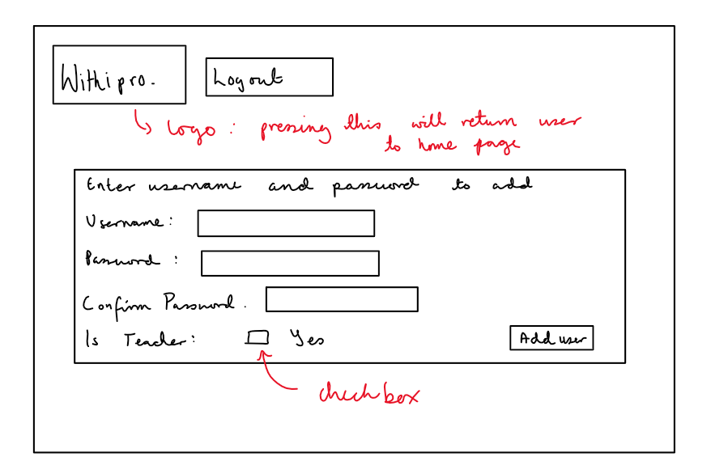

The header will include a message, providing administrators with instructions or feedback related to the user addition process. The main section will encompass a form structured as a table. It will have input fields for the new user's username, password, and a checkbox indicating whether the user is a teacher.

**A** crucial element is the confirmation password field, ensuring that administrators enter the password correctly. This helps prevent errors and enhances security by reducing the risk of unintentional typos. A checkbox labelled "Is Teacher" allows administrators to specify whether the new user is a teacher. This provides flexibility in managing user roles within the system.

Including a confirmation password field is a security measure to minimize the risk of password entry errors. It ensures that the administrator enters the correct password by requiring them to confirm it, reducing the likelihood of mistakes.

Upon submitting the form, the entered data (username, password, and is_teacher) is retrieved using request.form. The function is then called with this data as arguments.

The results from the user addition operation are processed. If an error occurs (e.g., username already exists or passwords do not match), an error message is displayed. Otherwise, a success message is shown. The rendered template will display the messages and the form. If the addition is successful, the administrator may be redirected to the home page with an updated message.

## Delete user Page

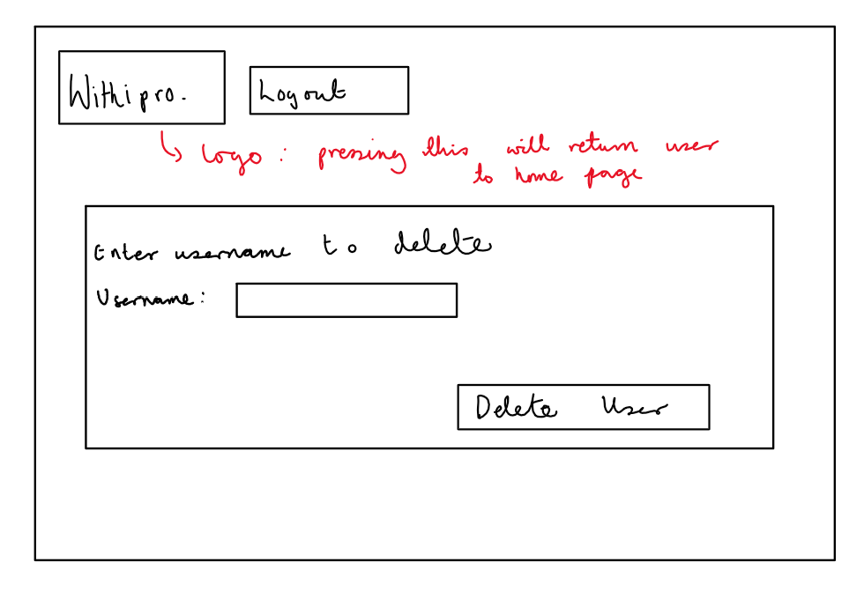

The page will follow a clean and minimalistic design to focus on the essential elements. It will consist of the following components:

1. Header: The header includes a message to guide administrators, indicating that they need to enter the username to delete a user.
2. Form Section: The main section contains a form with a single input field for the username. The form is structured using a table for alignment. The form ensures an intuitive user experience, allowing administrators to easily input the username of the user they want to delete.
3. Submit Button: A submit button is aligned to the right, allowing administrators to initiate the user deletion process. The button is appropriately labelled "Delete User" to convey its purpose.

A prominent message at the top will inform administrators about the purpose of the page, guiding them to enter the username for user deletion. Using a table structure for the form will enhance visual organization and alignment. The input field is labelled clearly with "Username," providing a clear indication of the required information.

The Flask route will be defined to handle both GET and POST requests. Upon submitting the form, the entered username will be retrieved using request.form['username']. The function is then called with the username as an argument. The results from the deletion operation are processed using a SQL query. If an error occurs (e.g., the specified username does not exist), an error message is displayed. Otherwise, a success message is shown. If the deletion is successful, the administrator will be redirected to the home page with the updated message.

Error messages, if any, will be prominently displayed to provide feedback on the success or failure of the user deletion operation.

## Show all users Page

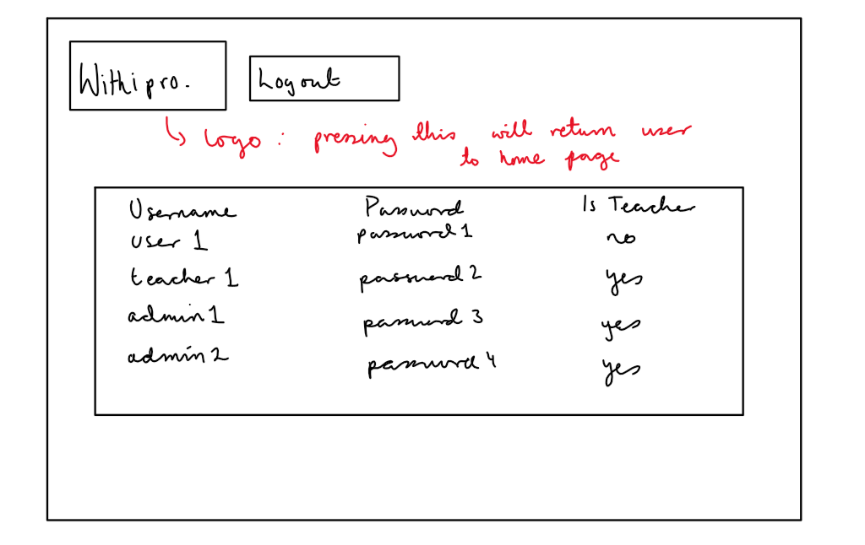

The function would use a SQL statement (SELECT * FROM users) and retrieve all entries from the users’ table. The result is a list of tuples, where each tuple represents a user's information. The list of user data would be returned.

The HTML template will display a table with columns for "Username," "Password," and "Is Teacher," presenting the retrieved user information in a structured format. I will convert the Boolean value to a more accessible representation, such as "Yes" for hidden and "No" for the is hidden variable, to ensure that the status of each user is easily discernible on the page.

## Update user Page

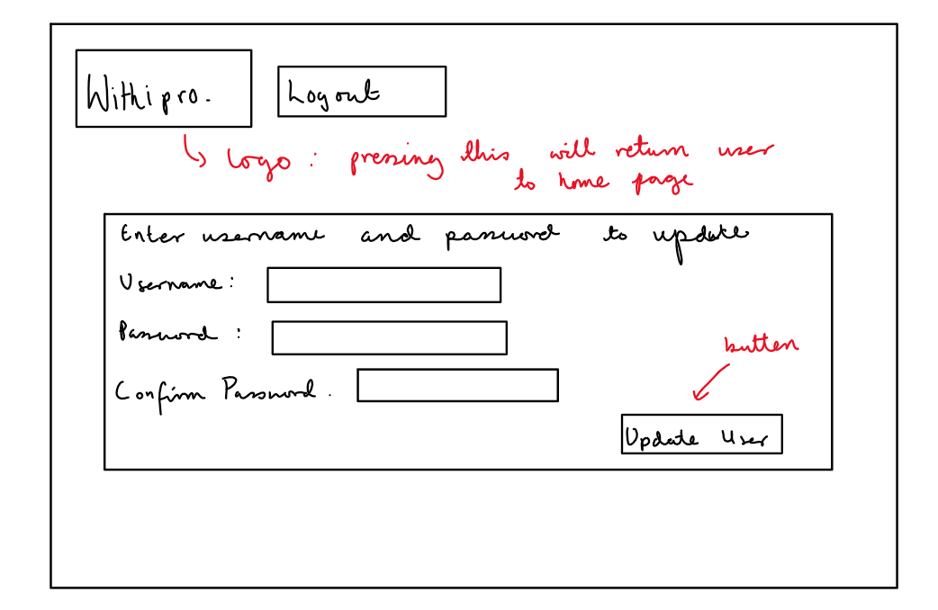

The header will contain a message providing administrators with instructions or feedback related to the user update process. The primary section consists of a form structured as a table. It includes input fields for the username, the new password, and a confirmation password. Like the "Add User" page, a confirmation password field is included. This ensures that administrators correctly enter the new password, reducing the risk of errors.

Utilizing a table structure for the form enhances visual organization and alignment. Each input field is labelled clearly, contributing to a user-friendly experience.

Upon submitting the form, the entered data (username, new password) will be retrieved using request.form. The function will be called with this data as arguments. The results from the user update operation will be processed using UPDATE users SET password =? WHERE username =? If an error occurs (e.g., username does not exist or passwords do not match), an error message will be displayed. Otherwise, a success message will show. The rendered template displays the messages and the form. If the update is successful, the administrator may be redirected to the home page (home.html) with an updated message.

# User Input Table

|  |  |  |  |  |  |  |
| --- | --- | --- | --- | --- | --- | --- |
| Variable | Datatype | Required | Page | Validation Check | Valid Data | Erroneous Data |
| username | String | Yes | Login , Update User , Delete User | Checks if not null and compares against values in users table | john_doe | Empty input / non-existent username |
| password | String | Yes | Login, Update User , Delete User | Checks if not null and compares against values in users table | secure_password | Empty input / non-existent username |
| username | String | Yes | Add User | Checks if not null | john_doe | Empty input |
| password | String | Yes | Add User | Checks if not null | secure_password | Empty input |
| Confirm password | String | Yes | Add User, Update User | Checks if not null | secure_password | Empty input |
| exam_paper | File | Yes | upload_pdf | Checks if not null | exam_paper.pdf | Empty input |
| regex_pattern | String | Yes | upload_pdf | Checks if not null | ^[a-zA-Z0-9]+$ | Empty input |
| year | String | Yes | delete_pdf , show_images | Checks if not null | 2022 | Empty input / non-existent in metadata table |
| subject | String | Yes | delete_pdf , show_images | Checks if not null | Math | Empty input / non-existent in metadata table |
| level | String | Yes | delete_pdf , show_images | Checks if not null | GCSE | Empty input / non-existent in metadata table |
| exam_code | String | Yes | delete_pdf , show_images | Checks if not null | 75612 | Empty input / non-existent in metadata table |
| exam_board | String | Yes | delete_pdf , show_images | Checks if not null | AQA | Empty input / non-existent in metadata table |
| paper_number | String | Yes | delete_pdf , show_images | Checks if not null | 2 | Empty input / non-existent in metadata table |
| year | String | No | search | N/A | 2018 | n/a |
| subject | String | No | search | N/A | Computer Science | n/a |
| level | String | No | search | N/A | A-level | n/a |
| exam_code | String | No | search | N/A | 85132 | n/a |
| exam_board | String (check boxes) | No | search | N/A | Pearson | n/a |
| paper_number | String | No | search | N/A | 1 | n/a |
| keywords | String | No | search | N/A | Binary | n/a |
| additional_keywords | String | No | search | N/A | Software | n/a |
| more_keywords | String | No | search | N/A | Landmarks | n/a |
| selected_ids | List (returned by checkbox) | Yes | compile | Checks if not null | [1,23,45,78] | n/a |
| question_numbers | List (returned by checkbox) | Yes | compile | Checks if not null | [01.1,09,13,23] | n/a |
| hidden_value | Boolean (returned by changing radio buttons) | Yes | compile (Update Hidden Status) | Checks if not null | [0,1,0,0] | n/a |

Form Navigation Design

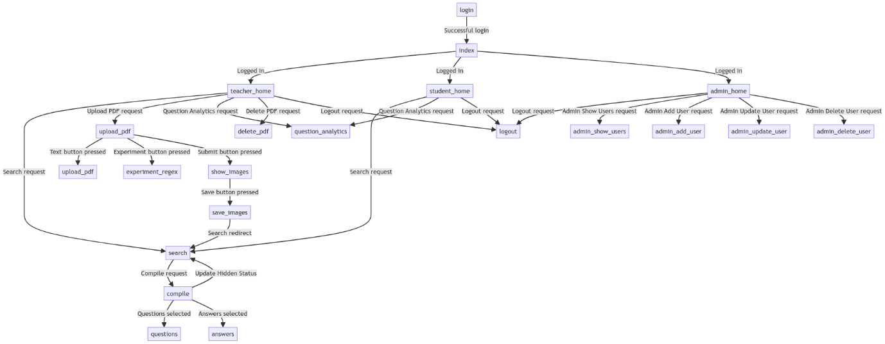

# File Structure

Here is a design of the file structure I will use the following design to ensure clarity whilst development. I have outlined the file structure design that I will adhere to for clarity during development. I plan to organize the project as follows: the main Flask application files, 'withipro_flask.py' and 'withipro_sqlite.py', along with the SQLite database file 'withipro_database.db' will be placed in the root directory. Additionally, I will create a separate folder named 'static' to house the logo ('logo.png') and the default image ('sad.png'). All HTML templates will be stored in a dedicated 'templates' folder.

* + withipro_flask.py
  + withipro_sqlite.py
  + withipro_database.db
  + images_extraction.py
  + /templates
    - adminadduser.html
    - admindeleteuser.html
    - adminshowuser.html
    - adminupdateuser.html
    - answers.html
    - base.html
    - delete_pdf.html
    - experiment_regex.html
    - home.html
    - layout.html
    - login.html
    - pdf_text.html
    - question_analytics.html
    - questions.html
    - search.html
    - show_images.html
    - student_home.html
    - teacher_home.html
    - upload_pdf.html
  + /static
    - logo.png
    - sad.png

# Potential SQL Commands

|  |  |
| --- | --- |
| SQL Command | Result |
| SELECT * FROM questions; | This command retrieves all records from the questions table, providing a complete list of questions. |
| SELECT * FROM questions WHERE year = '2023'; | This command filters questions based on the specified year. |
| SELECT * FROM questions WHERE exam_board = 'AQA'; | This command filters questions based on the exam board |
| SELECT * FROM questions WHERE paper_number = '1'; | This command filters questions based on the specific paper |
| SELECT q.question_text, a.answer_text  FROM questions q  JOIN answers a ON q.question_id = a.question_id  WHERE q.year = '2023'; | This command retrieves questions and their corresponding answers for a specific year ('2023' in this example) by performing an inner join between the questions and answers tables. |
| SELECT * FROM answers WHERE question_id = 1; | This command retrieves all answers associated with a specific question |
| SELECT DISTINCT exam_board FROM questions; | This command retrieves a list of distinct exam boards present in the questions table. |
| SELECT q.question_text, a.answer_text  FROM questions q  JOIN answers a ON q.question_id = a.question_id  WHERE q.question_id IN (1, 2, 3); -- List of selected question IDs | This command compiles a custom booklet by retrieving selected questions and their corresponding answers based on a list of selected question IDs. Adjust the list of IDs to match the user's selection. |
| UPDATE questions  SET is_hidden = 1  WHERE year = '2022'; | This command updates the is_hidden flag to hide questions from a specific year |
| SELECT * FROM questions WHERE is_hidden = 0; | This command retrieves questions that are not hidden, allowing users to see only non-hidden questions. |

# Data Flow Diagram

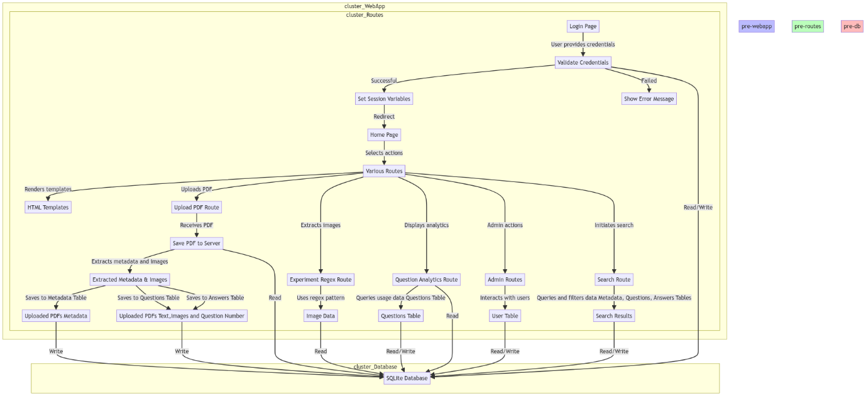

# Security Considerations

I will be hard coding the login details for administrators. Hardcoding admin users refers to manually specifying and embedding administrative user credentials directly into the code or configuration, rather than dynamically generating or creating admin accounts within the application. This approach is considered safer because it reduces the risk of unauthorized manipulation of the database or attempts to impersonate an admin. By hardcoding admin users, the credentials are stored securely on the server, and potential attackers would need direct access to the server to modify them. This adds an extra layer of security compared to dynamically creating admin accounts, which might expose vulnerabilities if not implemented carefully. While hardcoding admin users provides a more robust defence against unauthorized access, it is crucial to ensure that the server itself is well-protected to maintain the overall security of the system.

Securing the database involves implementing various measures to protect sensitive information and ensure the integrity of user data. One critical aspect is the use of password hashing, a process that transforms plaintext passwords into a secure, irreversible format before storing them in the database. This adds an additional layer of protection, making it more challenging for unauthorized users to decipher the actual passwords even if they gain access to the stored data.

In the current implementation of the program, I have not implemented password to facilitate easier testing and development. While this choice streamlines the testing process, I do acknowledge that real-world applications must prioritize the security of user credentials. It is important to safeguard user accounts from potential breaches.

Beyond password hashing, other security measures should be considered. Access controls, ensuring that users have appropriate permissions only for necessary actions, can prevent unauthorized manipulation of data. Additionally, encrypting sensitive data during transmission and storage enhances overall security.

As part of the ongoing development process, future iterations of the program will prioritize the integration of advanced security measures, including robust password hashing, to fortify the overall security posture of the application and protect user information effectively.

# Modularisation

In designing a comprehensive system for handling image extraction within a web application, I decided to split the code into three distinct programs, each with its own dedicated functionality, serves to enhance modularity, maintainability, and overall system efficiency.

The **Flask Code** will constitute the web application's core, responsible for handling user requests, managing routes, and rendering dynamic content. By isolating the web-related logic within the Flask code, the application will gain a clear separation of concerns. This not only simplifies the overall structure of the application but also allows for easier testing and updates to the web interface without impacting other components.

The **SQLite Code** is dedicated to managing the database interactions, specifically using SQLite. By separating the database-related operations into a distinct program, I can create a modular and scalable approach. This separation facilitates easier maintenance, updates, and even potential transitions to different database systems in the future. It also ensures that database-related concerns do not clutter the main application logic, promoting a cleaner and more maintainable codebase. I will also include the metadata extraction program into this python file.

The code responsible for **image extraction** will be isolated to handle the intricate process of extracting information from images. This separation acknowledges the complexity and resource-intensive nature of image processing tasks. By keeping this functionality in its own program, I can test it extensively during development without being cluttered by the other processes. This approach enables me to switch or upgrade the image extraction algorithm without affecting the rest of the application.

# Testing Plan

To ensure the system will be able to correctly handle all user inputs (both correct and incorrect) as well as correctly navigate between web pages and execute algorithms correctly, I have planned several testing methods.

Input and Output Testing Design

The table below is designed to test the actual outcome vs. the expected outcome for every user input and system output in the case of normal (correct and expected) data, erroneous (would cause the system to throw an exception, e.g. incorrect data types) data and boundary data (less expected data, e.g. blank fields).

|  |  |  |  |
| --- | --- | --- | --- |
| No. | *Description* | *Inputs* | *Expected Outcome* |
| *1.1* | Test the login functionality by entering invalid details | I will enter the username as user and password as password | Appropriate error messages for invalid entries. Will not proceed until both username and password are entered. |
| *1.2* | Test the login functionality and navigation to admin features. | I will enter the username as admin1 and password as password3. This is one of the admin logins I have hardcoded into the database. | Successful login with valid credentials.  Should see Welcome to the home page! and four buttons: add user, update user, delete user and show user. |
| *1.3* | Test the login functionality and navigation to teacher features. | I will enter the username as teacher1 and password as password2. | Successful login with valid credentials.  Should see Welcome to the Teacher's Home Page and four buttons: search, upload, question analytics and delete. There should also be a to-do list for the pdfs that need to be uploaded as their exam paper/mark scheme are already in the database |
| *1.4* | Test the login functionality and navigation to student features. | I will enter the username as user1 and password as password1. | Successful login with valid credentials.  Should see Welcome to the Student's Home Page and two buttons: search and question analytics. |
| *2.1* | Test adding users (admin feature). | Example 1: Valid input (non-existing username, matching passwords, teacher checkbox selected).  Example 2: Invalid input (existing username).  Example 3: Invalid input (non-matching passwords). | I should see a box for username, password and confirm password.  There should be a check box that can be selected to make a new teacher login.  Test outcomes should be:  Successful addition of a new user.  Proper error message for existing username.  Proper error message for non-matching passwords.  This can be confirmed by trying to login as the new user or by navigating to the show all feature. |
| *2.2* | Test the functionality to update a user's password (admin feature) | Example 1: Valid input (existing username, matching passwords).  Example 2: Invalid input (non-existing username).  Example 3: Invalid input (non-matching passwords). | I should see a box for username, password and confirm password.  Test outcomes should be:  Successful update of the user's password.  Proper error message for non-existing username.  Proper error message for non-matching passwords. |
| *2.3* | Test the functionality to delete a user (admin feature) | Example 1: Valid input (existing username).  Example 2: Invalid input (non-existing username). | I should see a box for username.  Test outcomes should be:  Successful deletion of the user.  Proper error message for non-existing username. |
| *2.4* | Test the functionality to display all users. (admin feature) |  | Display of all users in the system. |
| *3.1* | Upload PDF paper - Verify that the user can successfully upload a PDF file and see the appropriate response. | The following tests from 3.1 – 3.6 will be repeated for three different exam papers and their respective mark schemes:  June 2022 A- level AQA Computer Science Paper 2  June 2018 GCSE OCR Computer Science Paper 1  June 2018 GCSE AQA Geography Paper 1  This is as the objective was for this process to work for exam papers from any exam board, year, level, and subject.  I will press the ‘Upload PDF’ button on the teacher home page and then Choose a valid PDF file for upload. | I should see three buttons labled with browse, text, and experiment. There should be a box to enter the regex pattern. There will also be a guide on regex patterns to aid the teacher.  When no document is uploaded: there will be a message saying” No file selected” and the text and experiment buttons will not work and will show a message saying, “Please select a file.”  When a document is uploaded: the file name will be displayed, and the text and experiment buttons will work as expected. |
| *3.2* | Test the text extraction feature | Press Text button. | The user should see the "Extracted Text from the First 5 Pages" on the page.  The page should display the extracted text from the first five pages of the uploaded PDF.  This page will open in a new tab. |
| *3.3* | Test the experiment regex function - Check if the user can experiment with different regex patterns. | Enter a valid regex pattern in the provided input field.  Click the "Submit" button.  Here are the following regex patterns for the chosen exam papers:  [0-9] [0-9] /n --- June 2022 A- level AQA Computer Science Paper 2  [0-9] /n --- June 2018 GCSE OCR Computer Science Paper 1  [0-9] [0-9] /n --- June 2018 GCSE AQA Geography Paper 1  [0-9][0-9] --- June 2022 A- level AQA Computer Science Paper 2 Mark scheme  [0-9] --- June 2018 GCSE OCR Computer Science Paper 1 Mark scheme  [0-9][0-9] --- June 2018 GCSE AQA Geography Paper 1 Mark scheme | I should see the selected regex pattern displayed on the page.  If images are available for the entered regex pattern, they should be displayed.  If no images are available, then an error message should be displayed.  This page will open in a new tab. |
| *3.4* | Check the extracted images and metadata extracted | Return to the Upload PDF page and submit the desired regex pattern.  I will be redirected to the Show Images page.  I will enter any missing metadata information, the image type and question number.  I will need to change the image type to Questions if it is an exam paper or to Answers if it is a mark scheme using the drop-down menu. | I should see boxes to enter metadata information (year, subject, level, exam code, exam board, paper number). These boxes will be prefilled for the AQA papers but for the OCR paper, I will have to enter the information.  I should see the images with a box for the question number for each of them.  After clicking the "Save" button, the images and metadata should be saved successfully.  The page should redirect to the search page. |
| *3.5* | Check if the images have been saved to the database | There are many ways of testing of the image has been uploaded into the database. I have listed some of the search parameters I could enter to retrieve the questions from the exam paper.  Enter the year of the paper in the "Year" field.  Enter the subject of the paper in the "Subject" field.  Click the "Search" button. | The page should display search options and fields.  Once I have entered/selected the search parameters, the questions from the entire paper will be displayed with a select checkbox to the left of each image and two radio buttons to the right of each image to display the hidden status of the question.  None of the questions that were assigned the question number zero would be returned as they would be deleted.  There will be three buttons: Questions, Answers and Update Hidden Status.  The query should return a list of all question images – if this is a mark scheme this query will return nothing, however the to-do list proves that the paper/mark scheme has been uploaded successfully. |
| Enter the exam code of the paper in the "Exam Code" field.  Click the "Search" button. |
| Enter the level of the paper in the "Level" field.  Enter the paper number in the "Paper Number" field.  Click the "Search" button. |
| Enter the exam board of the paper in the "Exam Board" field.  Enter the paper number in the "Paper Number" field.  Click the "Search" button. |
| I could run the SQLite program to run the show all function show that the pdf has successfully been uploaded to the database by selecting all records from the relevant tables. |
| 3.6 | Check if the application cleans up uploaded PDF files after processing |  | The uploaded PDF file should be removed from the uploads file |
| 4.1 | Perform a search without entering any parameters. | No input. | All available papers should be displayed. |
| 4.2 | Search for papers by specifying the year and examboard. | Year = 2022, Exam board = AQA | Display the A-Level AQA Computer Science Paper from June 2022. |
| 4.3 | Search for papers using a single keyword. | Keyword = binary | Display questions that contain the word binary from the A-Level Computer Science Paper from June 2022 and GCSE OCR Computer Science Paper from June 2018 |
| 4.4 | Search for papers using three keywords. | Keyword: binary  Additional Keyword: software  More Keyword: land | Display the questions with any of these key words |
| 4.5 | Manually check the SQLite database to ensure the "Show All" function retrieves all papers. |  | All papers, including the provided ones, should be listed. All the data from all the tables should be outputted |
| 4.6 | Compile a list of questions. | Select a few questions using checkboxes and press Questions and Answers. | Two new tabs open: question page with completed parts of selected questions (e.g. if I select 3.4 then enter question 3 should be returned and answer page with completed parts of selected questions. |
| 4.7 | Update the hidden status of selected questions as a teacher. | Select questions, change the "Show/Hide" value, and press “Update Hidden Status.”  Select AQA in the exam board section of the search parameter. I will then hide parts 1.2, 1.3 and 11. | Hidden status of selected questions should be updated.  This can be checked by hiding a question by logging in as teacher then logging in as a student and trying to search for questions 1.1, 1.2 and 2.1 when the only search parameter is 2022. |
| 5.1 | Attempt to delete a PDF with incomplete information. | Year: 2022  Subject: Computer Science  Level: A-level  Exam Code: 75172  Exam Board: AQA  Paper Number: (leave blank) | An error message should be displayed, indicating that all fields must be filled. |
| 5.2 | Provide valid information to delete a PDF | Year: 2022  Subject: Computer Science  Level: A-level  Exam Code: 75172  Exam Board: AQA  Paper Number: 2 | The PDF, associated questions, and answers should be deleted from the database. The PDF file should be removed from the server. |
| 5.3 | Attempt to delete a PDF that does not exist in the database. | Provide information for a PDF that is not in the database. | Redirect to the same page. No changes should be made to the database or server files. An error message should be displayed, indicating that the database has no such pdf. |
| 5.4 | Verify that questions and answers associated with the deleted PDF are also removed | Perform a search or query in the database to confirm the absence of questions and answers related to the deleted PDF. For example, I will search for 2022 AQA Computer science questions | No questions or answers should be found for the deleted PDF. |
| 5.5 | Attempt to delete a PDF with incorrect information (e.g., wrong exam code). | Year: 2018  Subject: Computer Science  Level: GCSE  Exam Code: CS2018  Exam Board: OCR  Paper Number: 1 | Redirect to the same page. No changes should be made to the database or server files. An error message should be displayed, indicating that the database has no such pdf. |
| 6 | Question Analytics | Select a question to compile | This question features in the question analytics page. |

# Testing

I have successfully completed the testing phase according to the detailed testing plan. To ensure a comprehensive understanding of the program's performance, I have meticulously documented the testing process in a video format. This video not only captures the step-by-step execution of the test cases outlined in the testing plan but also provides insightful commentary to the intricacies of the program's behaviour. By presenting the testing results in a visual format, stakeholders can gain a holistic perspective on the program's functionality, making it easier to identify any potential issues and assess the overall robustness of the software. This approach facilitates a thorough evaluation of the program's reliability and effectiveness.

Here is the video link:

|  |  |  |  |  |  |
| --- | --- | --- | --- | --- | --- |
| No. | *Description* | *Inputs* | *Expected Outcome* | *Actual Outcome* | *Timestamp* |
| *1.1* | Test the login functionality by entering invalid details | I will enter the username as user and password as password | Appropriate error messages for invalid entries. Will not proceed until both username and password are entered. | As expected. | 00:00:55 |
| *1.2* | Test the login functionality and navigation to admin features. | I will enter the username as admin1 and password as password3. This is one of the admin logins I have hardcoded into the database. | Successful login with valid credentials.  Should see Welcome to the home page! and four buttons: add user, update user, delete user and show user. | As expected. | 00:01:26 |
| *1.3* | Test the login functionality and navigation to teacher features. | I will enter the username as teacher1 and password as password2. | Successful login with valid credentials.  Should see Welcome to the Teacher's Home Page and four buttons: search, upload, question analytics and delete. There should also be a to-do list for the pdfs that need to be uploaded as their exam paper/mark scheme are already in the database | As expected. | 00:02:11 |
| *1.4* | Test the login functionality and navigation to student features. | I will enter the username as user1 and password as password1. | Successful login with valid credentials.  Should see Welcome to the Student's Home Pageand two buttons: search and question analytics. | As expected. | 00:02:56 |
| *2.1* | Test adding users (admin feature). | Example 1: Valid input (non-existing username, matching passwords, teacher checkbox selected).  Example 2: Invalid input (existing username).  Example 3: Invalid input (non-matching passwords). | I should see a box for username, password and confirm password.  There should be a check box that can be selected to make a new teacher login.  Test outcomes should be:  Successful addition of a new user.  Proper error message for existing username.  Proper error message for non-matching passwords.  This can be confirmed by trying to login as the new user or by navigating to the show all feature. | As expected. | Example 1: 00:04:29  00:05:56  Example 2: 00:07:32  Example 3: 00:08:48 |
| *2.2* | Test the functionality to update a user's password (admin feature) | Example 1: Valid input (existing username, matching passwords).  Example 2: Invalid input (non-existing username).  Example 3: Invalid input (non-matching passwords). | I should see a box for username, password and confirm password.  Test outcomes should be:  Successful update of the user's password.  Proper error message for non-existing username.  Proper error message for non-matching passwords. | As expected. | Example 1: 00:10:25  Example 2: 00:11:31  Example 3: 00:12:34 |
| *2.3* | Test the functionality to delete a user (admin feature) | Example 1: Valid input (existing username).  Example 2: Invalid input (non-existing username). | I should see a box for username.  Test outcomes should be:  Successful deletion of the user.  Proper error message for non-existing username. | As expected. | Example 1: 00:13:34  Example 2: 00:14:04 |
| *2.4* | Test the functionality to display all users. (admin feature) |  | Display of all users in the system. | As expected. | 00:03:51 |
| *3.1* | Upload PDF paper - Verify that the user can successfully upload a PDF file and see the appropriate response. | The following tests from 3.1 – 3.6 will be repeated for three different exam papers and their respective mark schemes:  June 2022 A- level AQA Computer Science Paper 2  June 2018 GCSE OCR Computer Science Paper 1  June 2018 GCSE AQA Geography Paper 1  This is as the objective was for this process to work for exam papers from any exam board, year, level, and subject.  I will press the ‘Upload PDF’ button on the teacher home page and then Choose a valid PDF file for upload. | I should see three buttons labled with browse, text, and experiment. There should be a box to enter the regex pattern. There will also be a guide on regex patterns to aid the teacher.  When no document is uploaded: there will be a message saying” No file selected” and the text and experiment buttons will not work and will show a message saying, “Please select a file.”  When a document is uploaded: the file name will be displayed, and the text and experiment buttons will work as expected. | As expected. | Example 1: 00:15:45  Example 2: 00:23:11  Example 3: 00:39:27  Example 4: 00:49:05  Example 5: 01:00:10  Example 6: 01:09:23 |
| *3.2* | Test the text extraction feature | Press Text button. | The user should see the "Extracted Text from the First 5 Pages" on the page.  The page should display the extracted text from the first five pages of the uploaded PDF.  This page will open in a new tab. | As expected. | Example 1: 00:15:49  Example 2: 00:23:21  Example 3: 00:39:33  Example 4: 00:49:13  Example 5: 01:00:15  Example 6: 01:09:27 |
| *3.3* | Test the experiment regex function - Check if the user can experiment with different regex patterns. | Enter a valid regex pattern in the provided input field.  Click the "Submit" button.  Here are the following regex patterns for the chosen exam papers:  **[0-9] [0-9] /n** --- June 2022 A- level AQA Computer Science Paper 2  **[0-9] /n** --- June 2018 GCSE OCR Computer Science Paper 1  **[0-9] [0-9] /n** --- June 2018 GCSE AQA Geography Paper 1  **[0-9][0-9]** --- June 2022 A- level AQA Computer Science Paper 2 Mark scheme  **[0-9]** --- June 2018 GCSE OCR Computer Science Paper 1 Mark scheme  **[0-9][0-9]** --- June 2018 GCSE AQA Geography Paper 1 Mark scheme | I should see the selected regex pattern displayed on the page.  If images are available for the entered regex pattern, they should be displayed.  If no images are available, then an error message should be displayed.  This page will open in a new tab. | As expected. | Example 1: 00:17:17  Example 2: 00:24:30  Example 3: 00:40:13  Example 4: 00:49:55  Example 5: 01:00:43  Example 6: 01:10:12 |
| *3.4* | Check the extracted images and metadata extracted | Return to the Upload PDF page and submit the desired regex pattern.  I will be redirected to the Show Images page.  I will enter any missing metadata information, the image type and question number.  I will need to change the image type to Questions if it is an exam paper or to Answers if it is a mark scheme using the drop-down menu. | I should see boxes to enter metadata information (year, subject, level, exam code, exam board, paper number). These boxes will be prefilled for the AQA papers but for the OCR paper, I will have to enter the information.  I should see the images with a box for the question number for each of them.  After clicking the "Save" button, the images and metadata should be saved successfully.  The page should redirect to the search page. | As expected. | Example 1: 00:19:28  Example 2: 00:26:45  Example 3: 00:41:10  Example 4: 00:51:36  Example 5: 01:01:33  Example 6: 01:12:16 |
| *3.5* | Check if the images have been saved to the database | There are many ways of testing of the image has been uploaded into the database. I have listed some of the search parameters I could enter to retrieve the questions from the exam paper.  Enter the year of the paper in the "Year" field.  Enter the subject of the paper in the "Subject" field.  Click the "Search" button. | The page should display search options and fields.  Once I have entered/selected the search parameters, the questions from the entire paper will be displayed with a select checkbox to the left of each image and two radio buttons to the right of each image to display the hidden status of the question.  None of the questions that were assigned the question number zero would be returned as they would be deleted.  There will be three buttons: Questions, Answers and Update Hidden Status.  The query should return a list of all question images – if this is a mark scheme this query will return nothing, however the to-do list proves that the paper/mark scheme has been uploaded successfully. | As expected. | Example 1: 00:20:31  Example 2: 00:38:15  Example 3: 00:48:21  Example 4: 00:59:17  Example 5: 01:08:27  Example 6: 01:17:09 |
| Enter the exam code of the paper in the "Exam Code" field.  Click the "Search" button. |  |
| Enter the level of the paper in the "Level" field.  Enter the paper number in the "Paper Number" field.  Click the "Search" button. |  |
| Enter the exam board of the paper in the "Exam Board" field.  Enter the paper number in the "Paper Number" field.  Click the "Search" button. |  |
| I could run the SQLite program to run the show all function show that the pdf has successfully been uploaded to the database by selecting all records from the relevant tables. |  |
| 3.6 | Check if the application cleans up uploaded PDF files after processing |  | The uploaded PDF file should be removed from the uploads file | As expected. | 01:17:40 |
| 4.1 | Perform a search without entering any parameters. | No input. | All available papers should be displayed. | As expected. | 01:18:09 |
| 4.2 | Search for papers by specifying the year and exam board. | Year = 2022, Exam board = AQA. | Display the A-Level AQA Computer Science Paper from June 2022. | As expected. | 01:18:34 |
| 4.3 | Search for papers using a single keyword. | Keyword = binary | Display questions that contain the word binary from the A-Level Computer Science Paper from June 2022 and GCSE OCR Computer Science Paper from June 2018 | As expected. | 01:19:26 |
| 4.4 | Search for papers using three keywords. | Keyword: binary  Additional Keyword: software  More Keyword: land | Display the questions with any of these key words | As expected. | 01:21:40 |
| 4.5 | Manually check the SQLite database to ensure the "Show All" function retrieves all papers. |  | All papers, including the provided ones, should be listed. All the data from all the tables should be outputted | As expected. | 01:24:53 |
| 4.6 | Compile a list of questions. | Select a few questions using checkboxes and press Questions and Answers. | Two new tabs open: question page with completed parts of selected questions (e.g. if I select 3.4 then enter question 3 should be returned and answer page with completed parts of selected questions. | As expected. | 01:19:50 |
| 4.7 | Update the hidden status of selected questions as a teacher. | Select questions, change the "Show/Hide" value, and press “Update Hidden Status.”  Select AQA in the exam board section of the search parameter. I will then hide parts 1.2, 1.3 and 11. | Hidden status of selected questions should be updated.  This can be checked by hiding a question by logging in as teacher then logging in as a student and trying to search for questions 1.1, 1.2 and 2.1 when the only search parameter is 2022. | As expected. | 1:23:30 and 1:23:57 |
| 5.1 | Attempt to delete a PDF with incomplete information. | Year: 2022  Subject: Computer Science  Level: A-level  Exam Code: 75172  Exam Board: AQA  Paper Number: (leave blank) | An error message should be displayed, indicating that all fields must be filled. | As expected. | 01:28:06 |
| 5.2 | Provide valid information to delete a PDF | Year: 2022  Subject: Computer Science  Level: A-level  Exam Code: 75172  Exam Board: AQA  Paper Number: 2 | The PDF, associated questions, and answers should be deleted from the database. The PDF file should be removed from the server. | As expected. | 1:28:21 |
| 5.3 | Attempt to delete a PDF that does not exist in the database. | Provide information for a PDF that is not in the database. | Redirect to the same page. No changes should be made to the database or server files. An error message should be displayed, indicating that the database has no such pdf. | As expected. | 01:29:16 |
| 5.4 | Verify that questions and answers associated with the deleted PDF are also removed | Perform a search or query in the database to confirm the absence of questions and answers related to the deleted PDF. For example, I will search for 2022 AQA Computer science questions | No questions or answers should be found for the deleted PDF. | As expected. | 1:28:32 |
| 5.5 | Attempt to delete a PDF with incorrect information (e.g., wrong exam code). | Year: 2018  Subject: Computer Science  Level: GCSE  Exam Code: CS2018  Exam Board: OCR  Paper Number: 1 | Redirect to the same page. No changes should be made to the database or server files. An error message should be displayed, indicating that the database has no such pdf. | As expected. | 01:31:17 |
| 6 | Question Analytics | Select a question to compile | This question features in the question analytics page. | As expected. | 01:33:10 |

# Coding

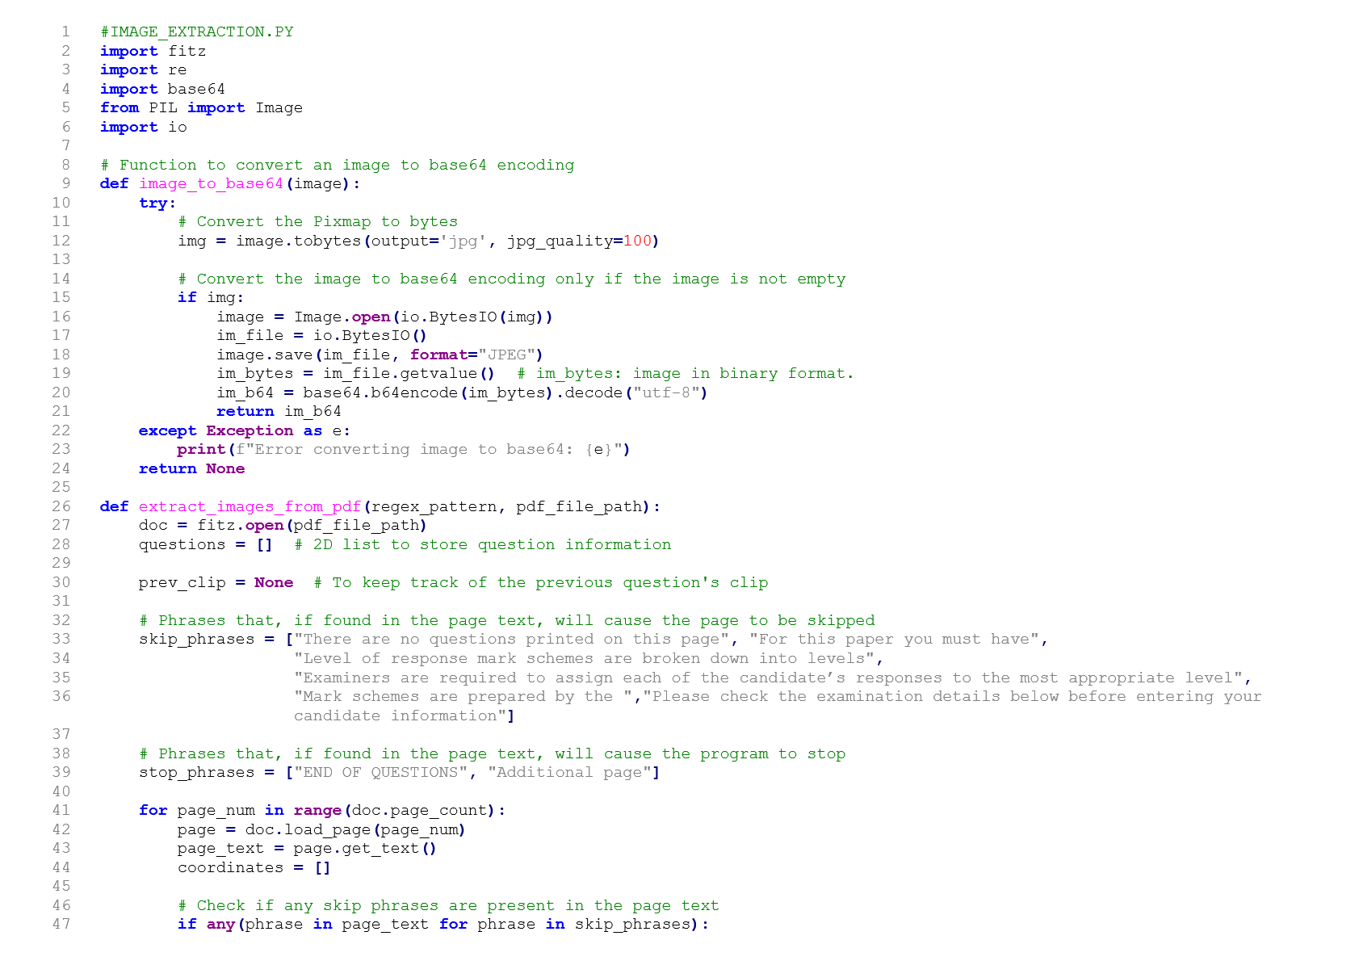

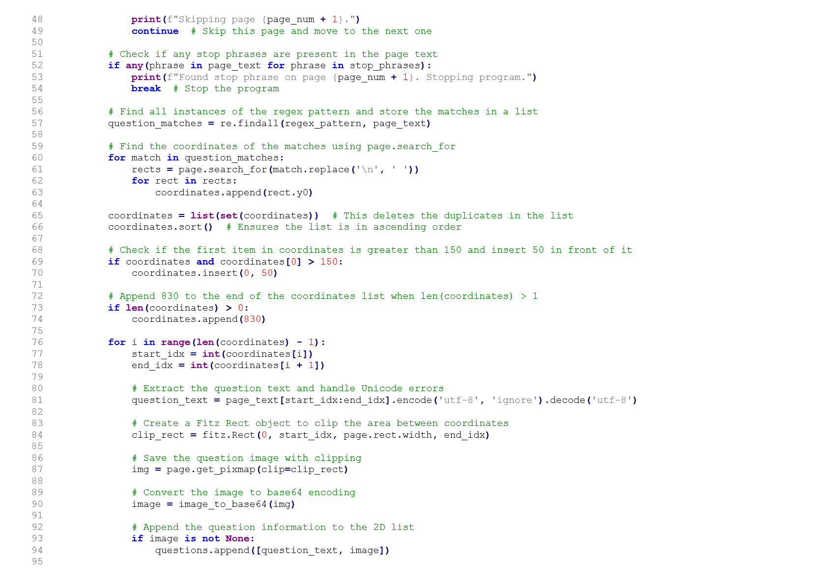

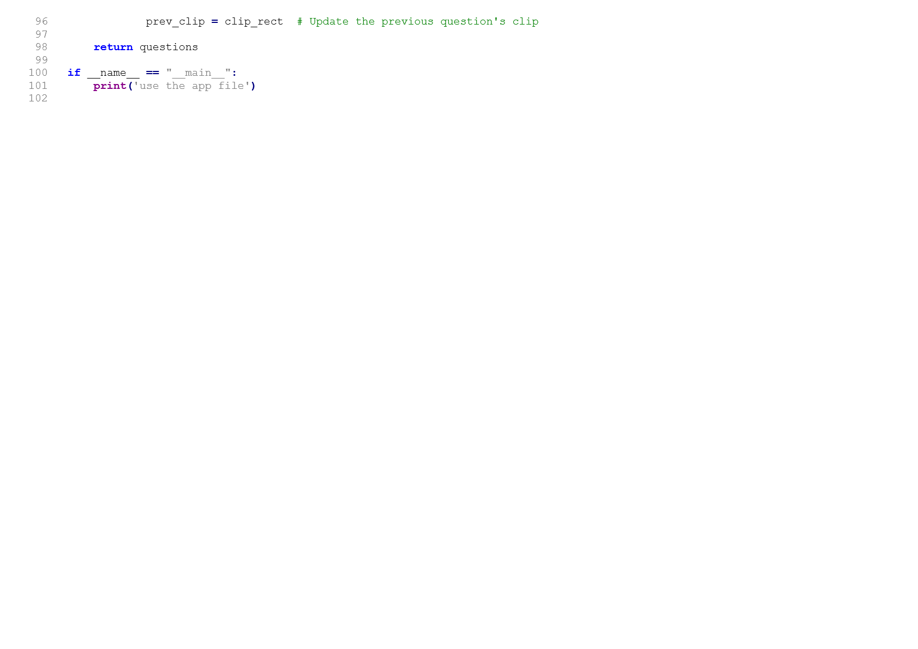

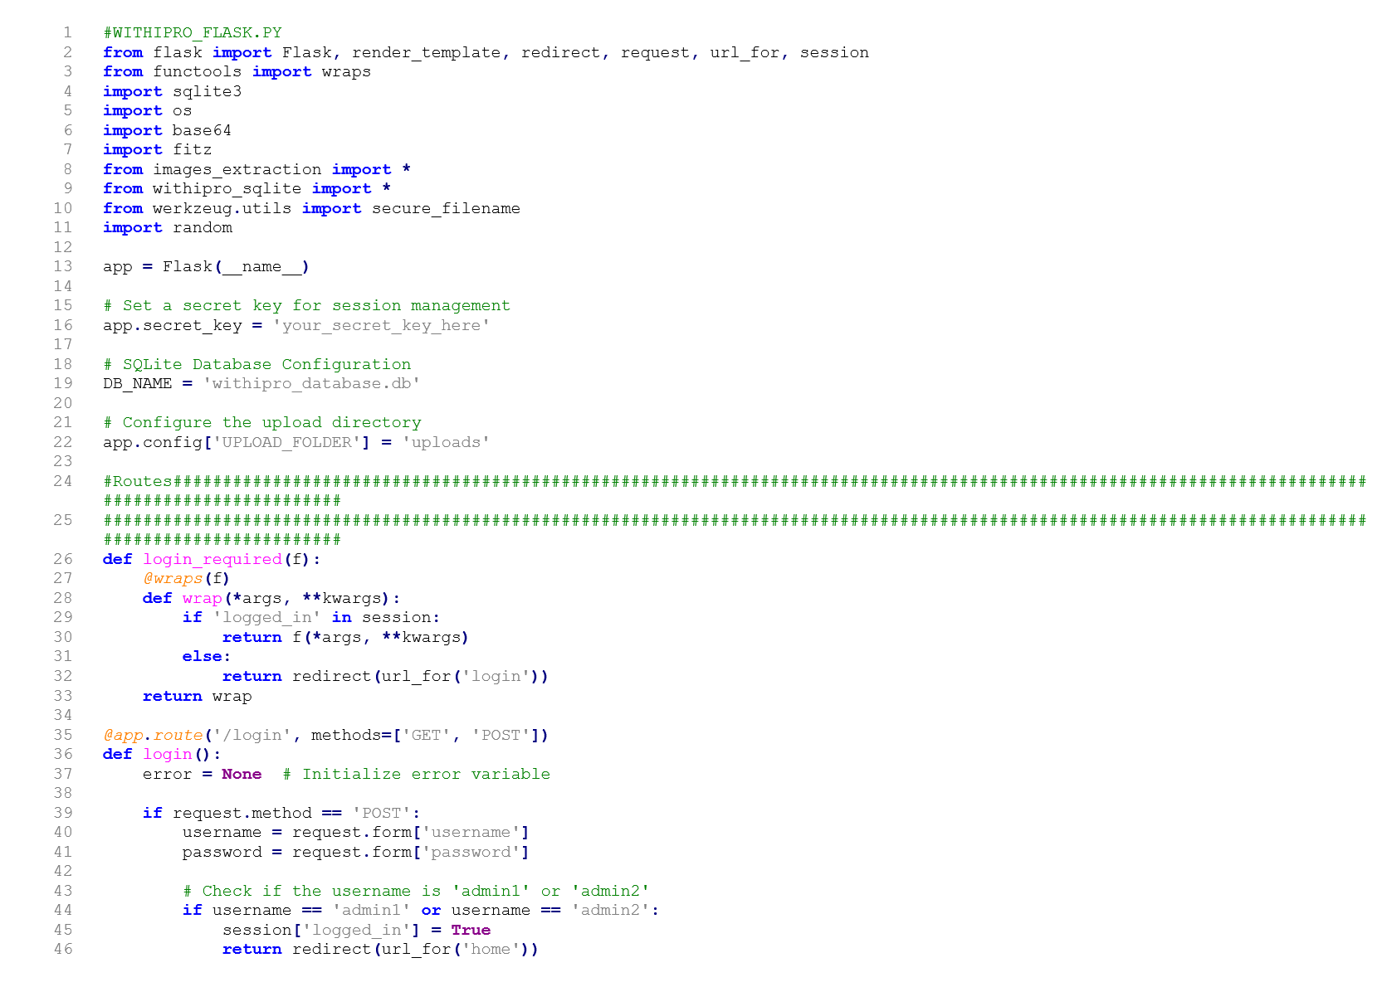

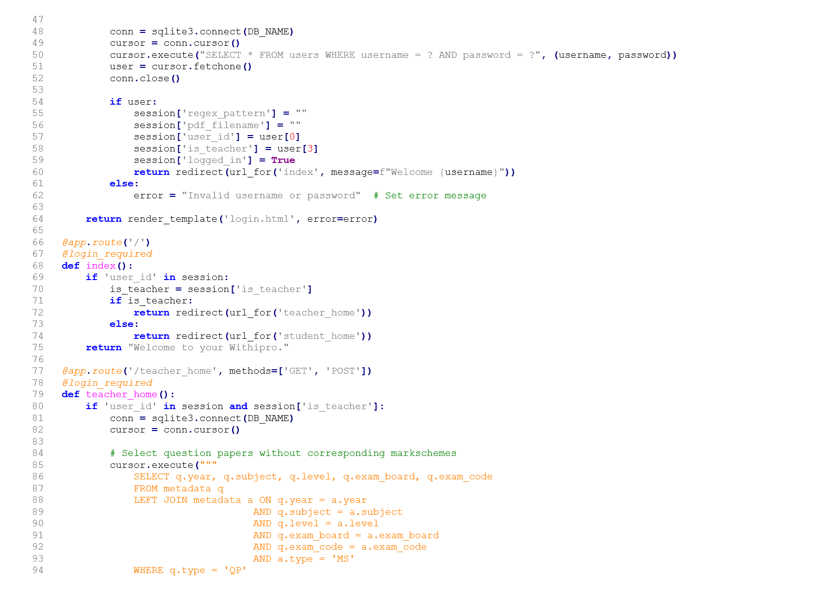

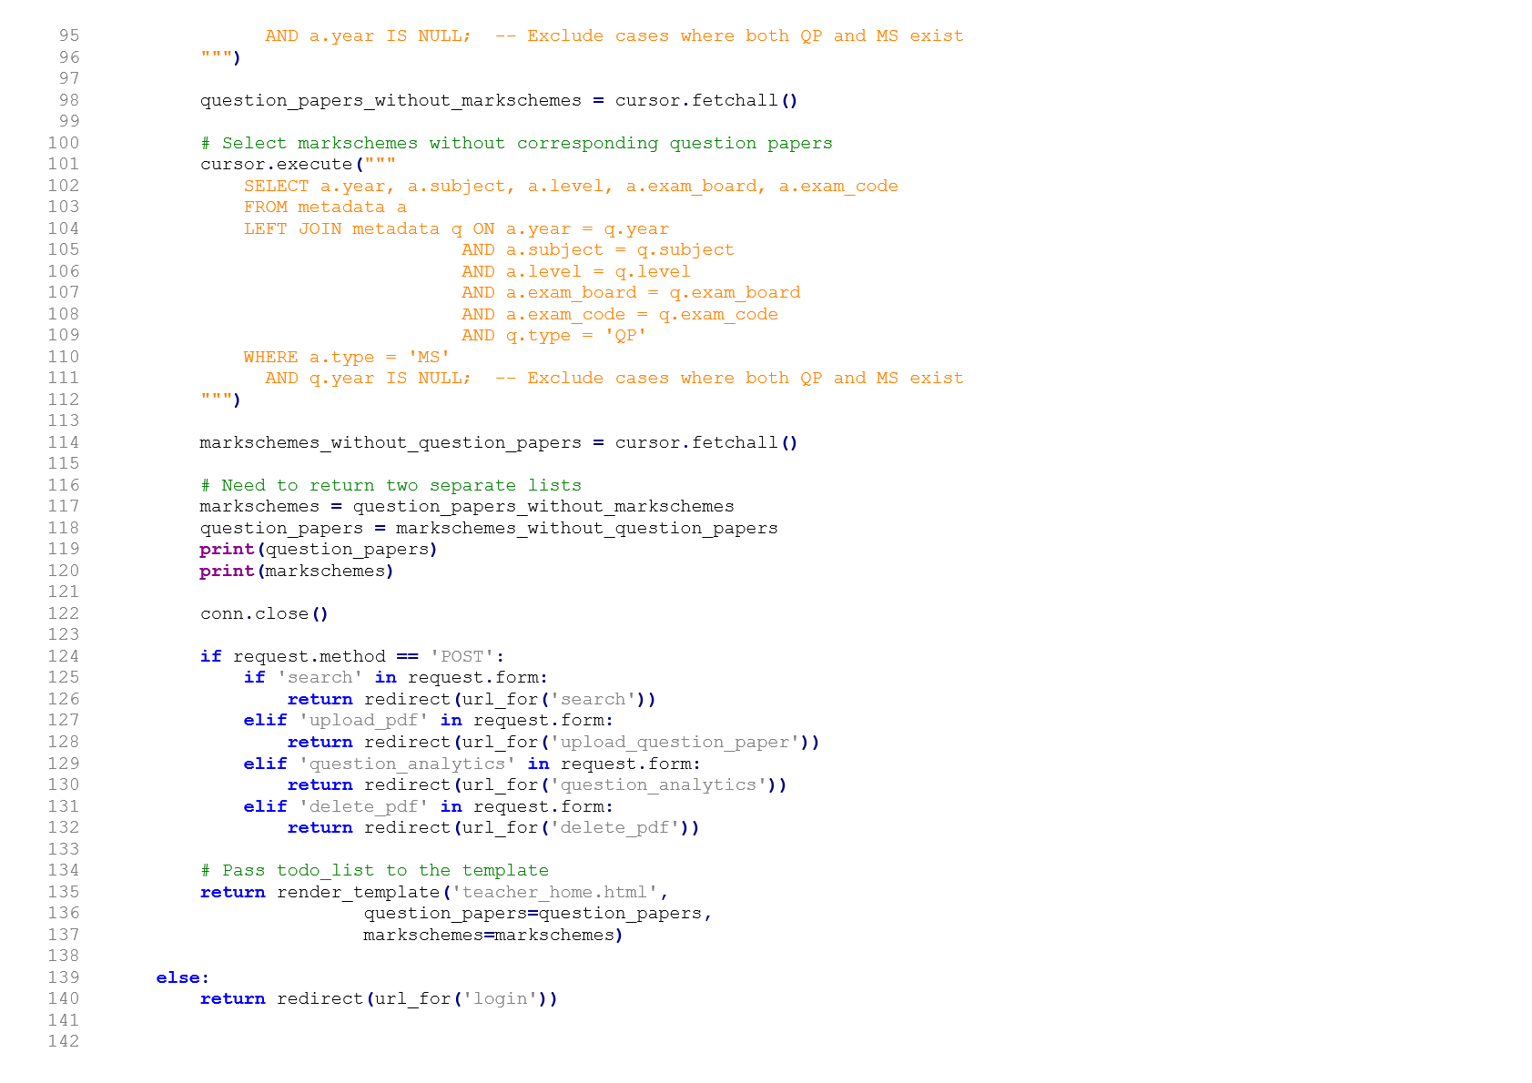

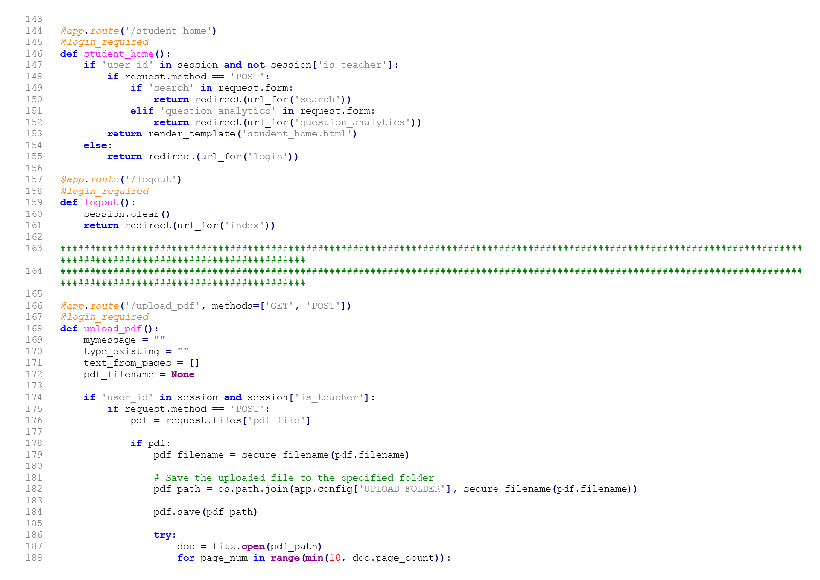

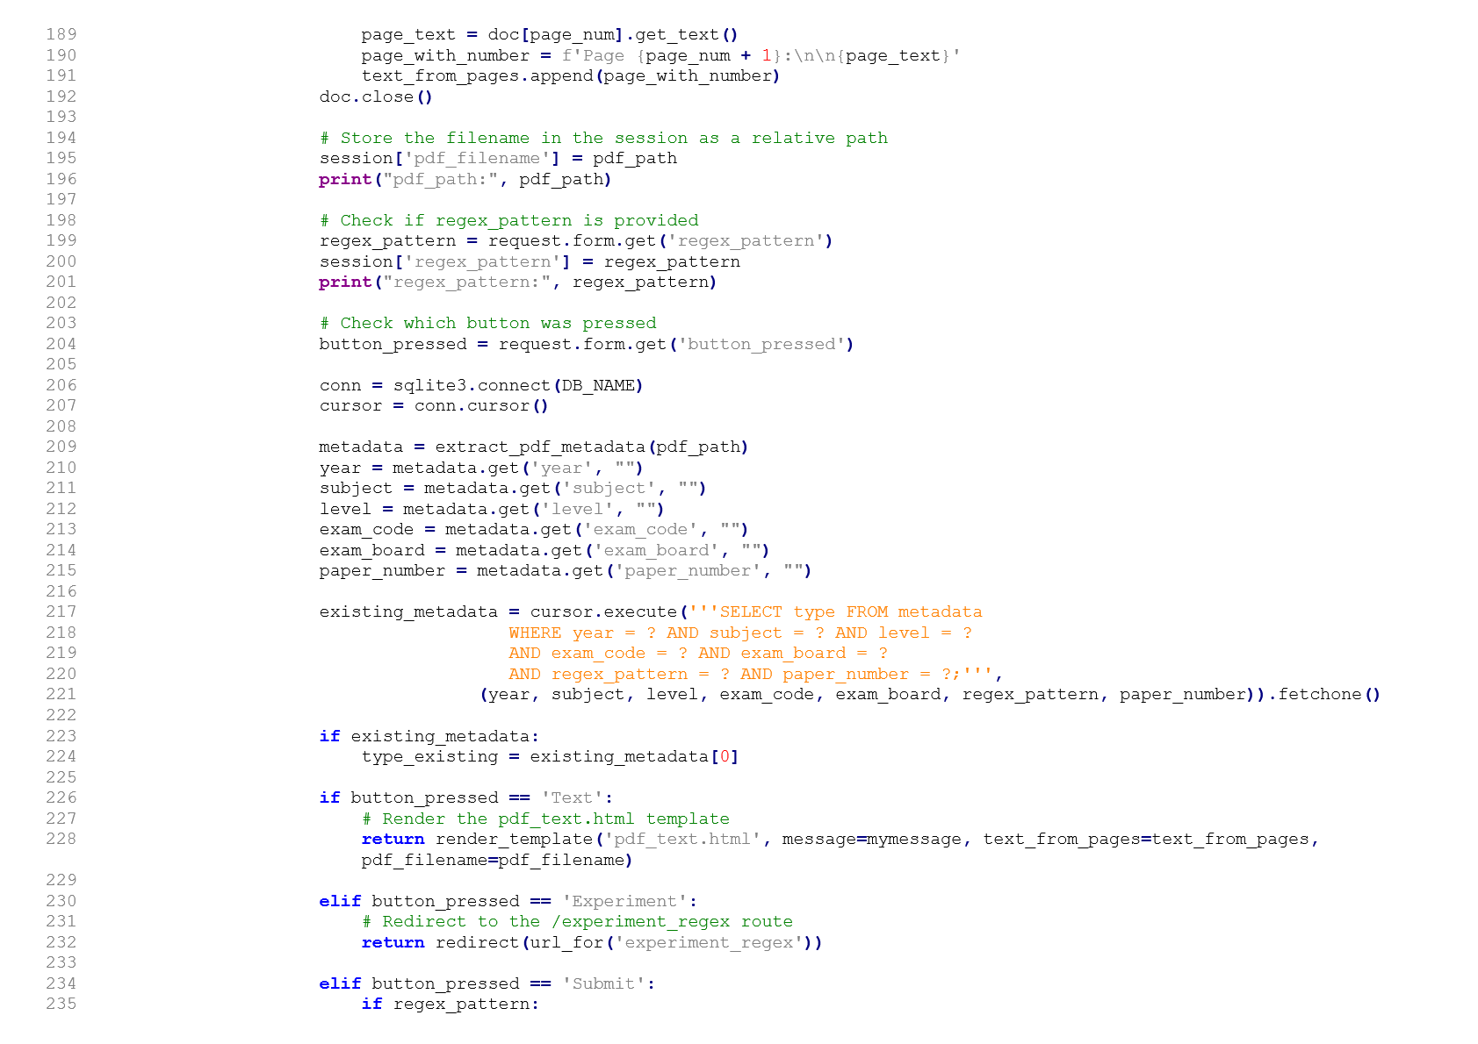

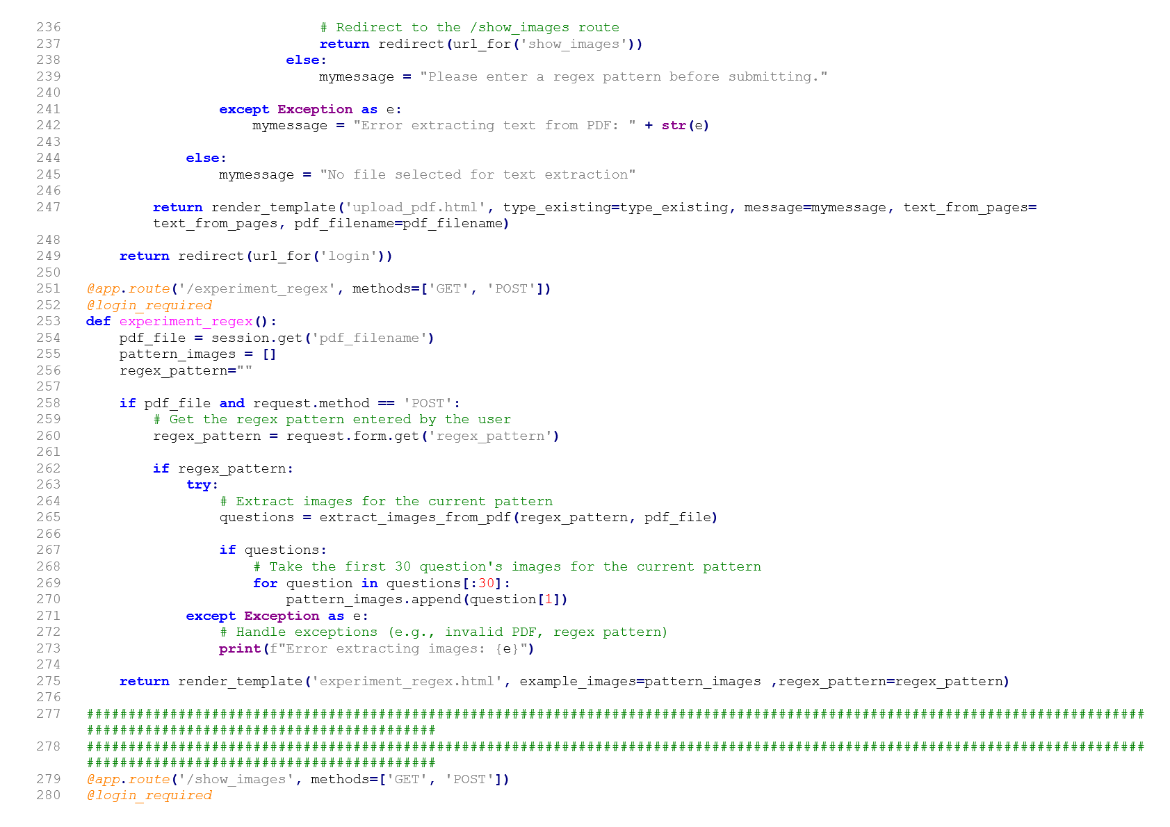

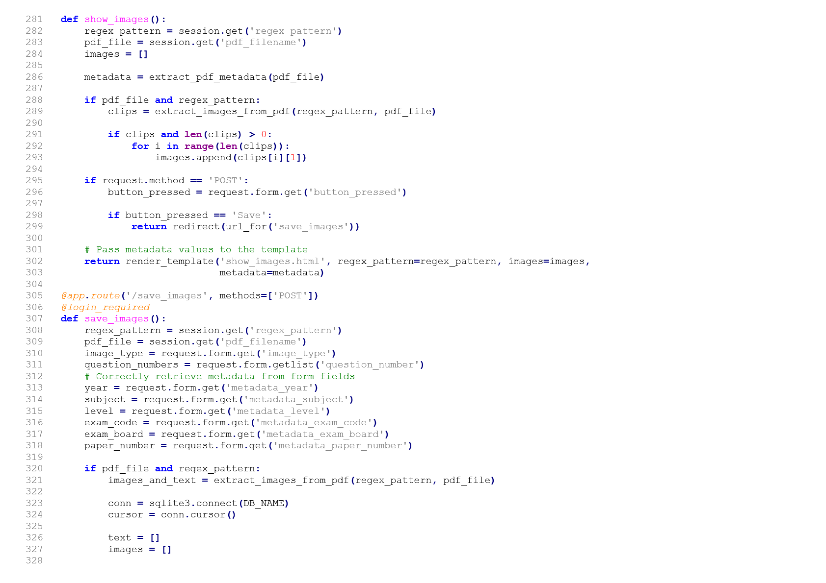

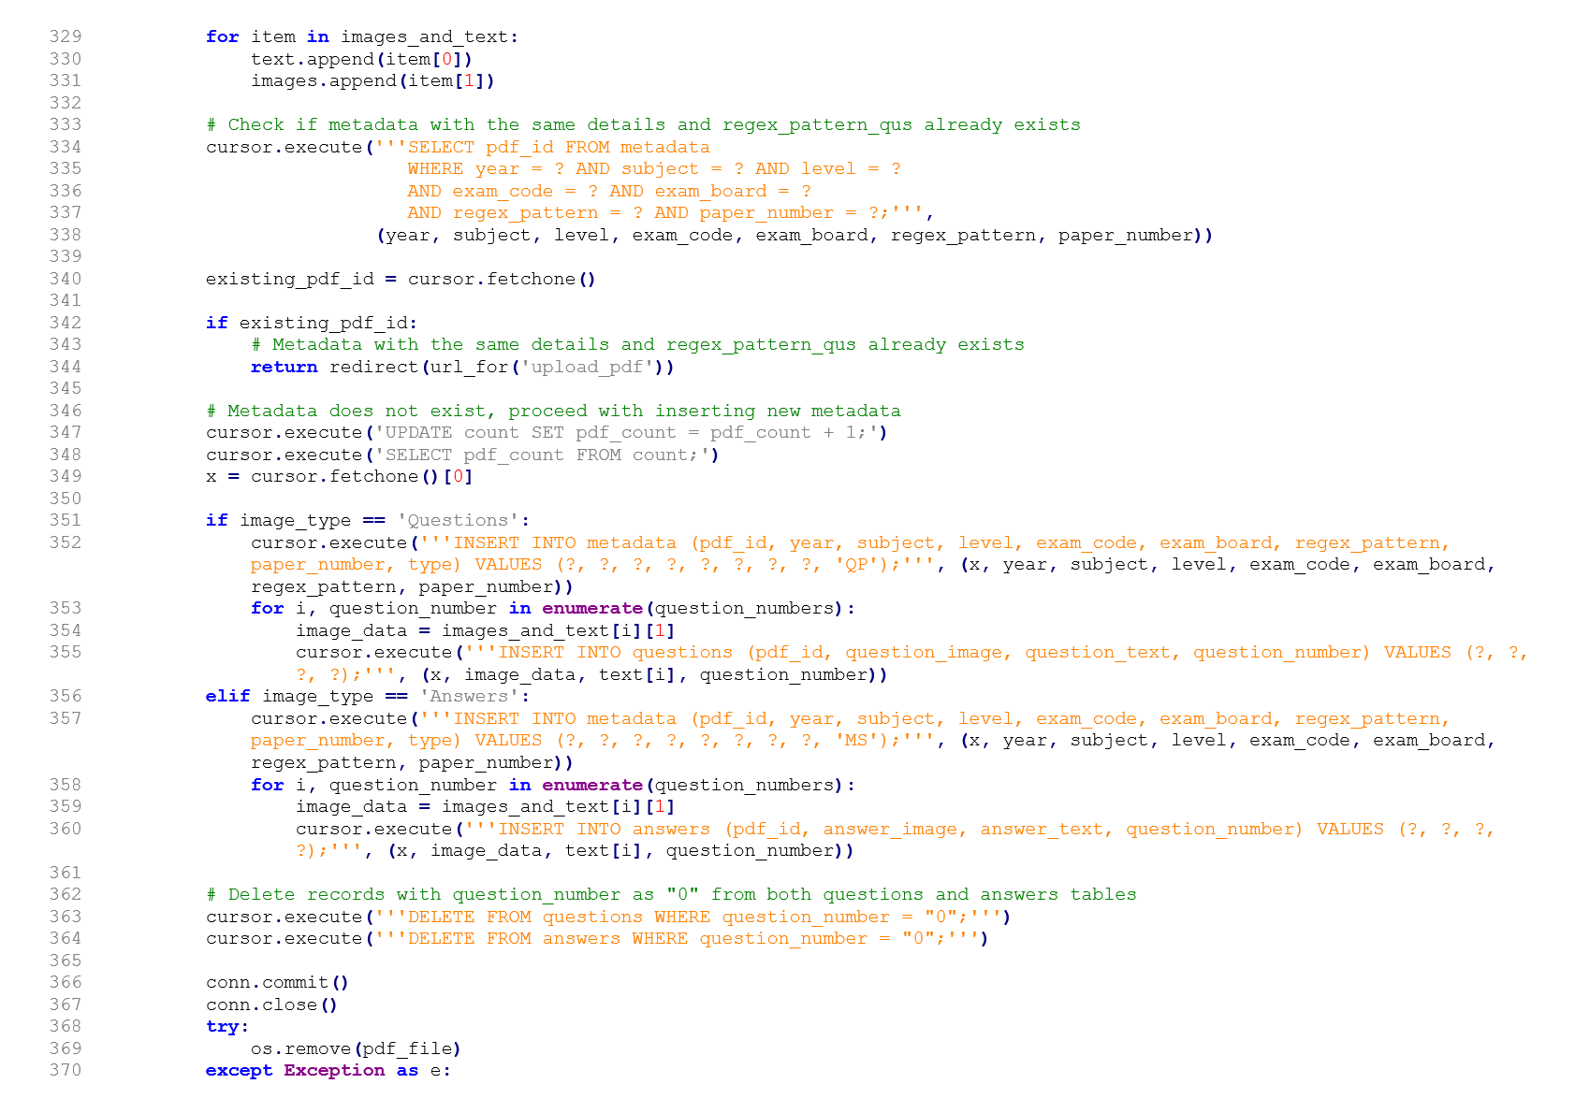

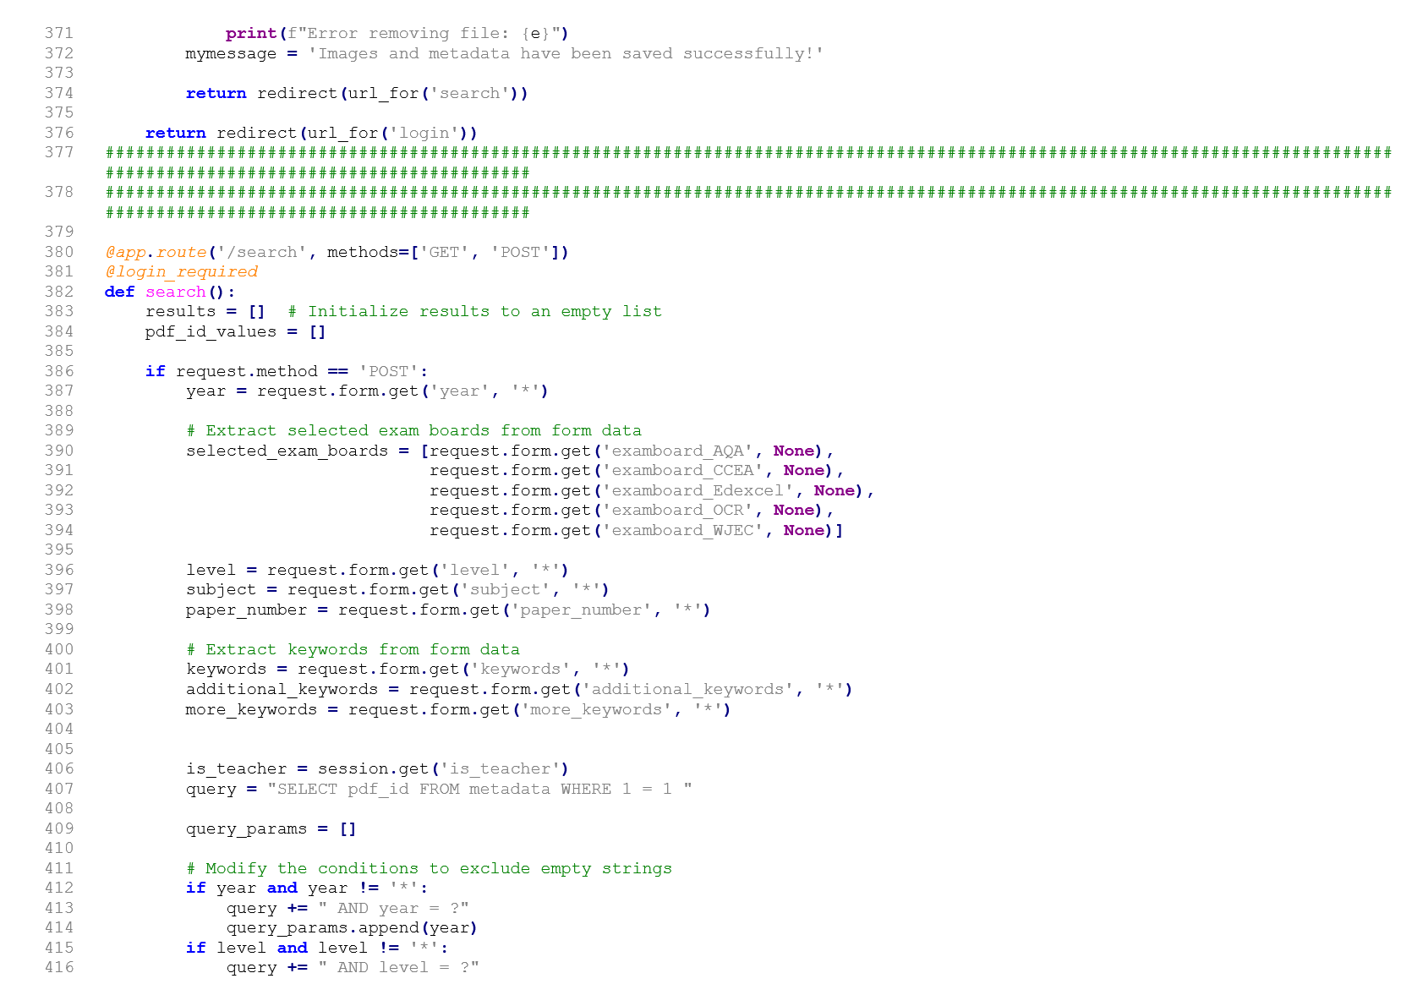

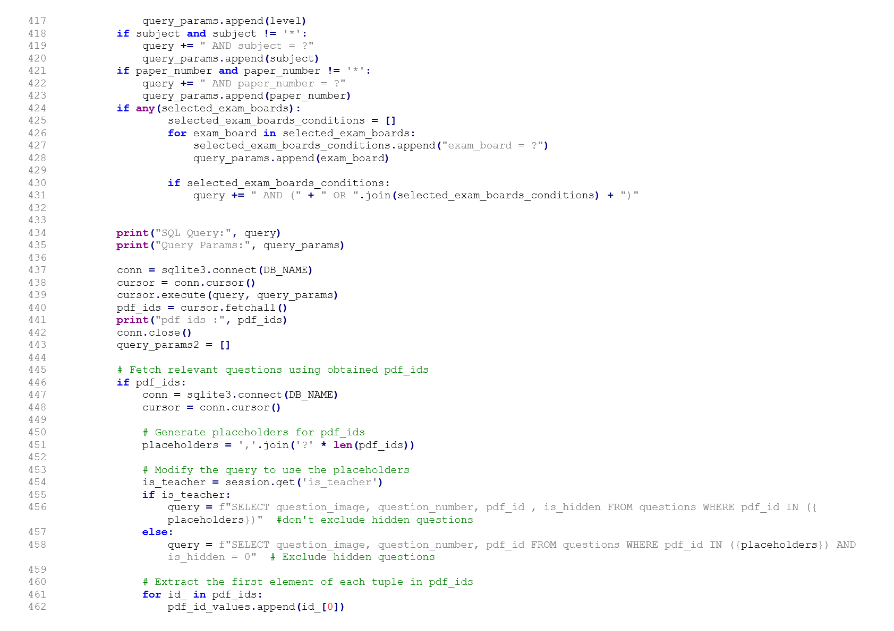

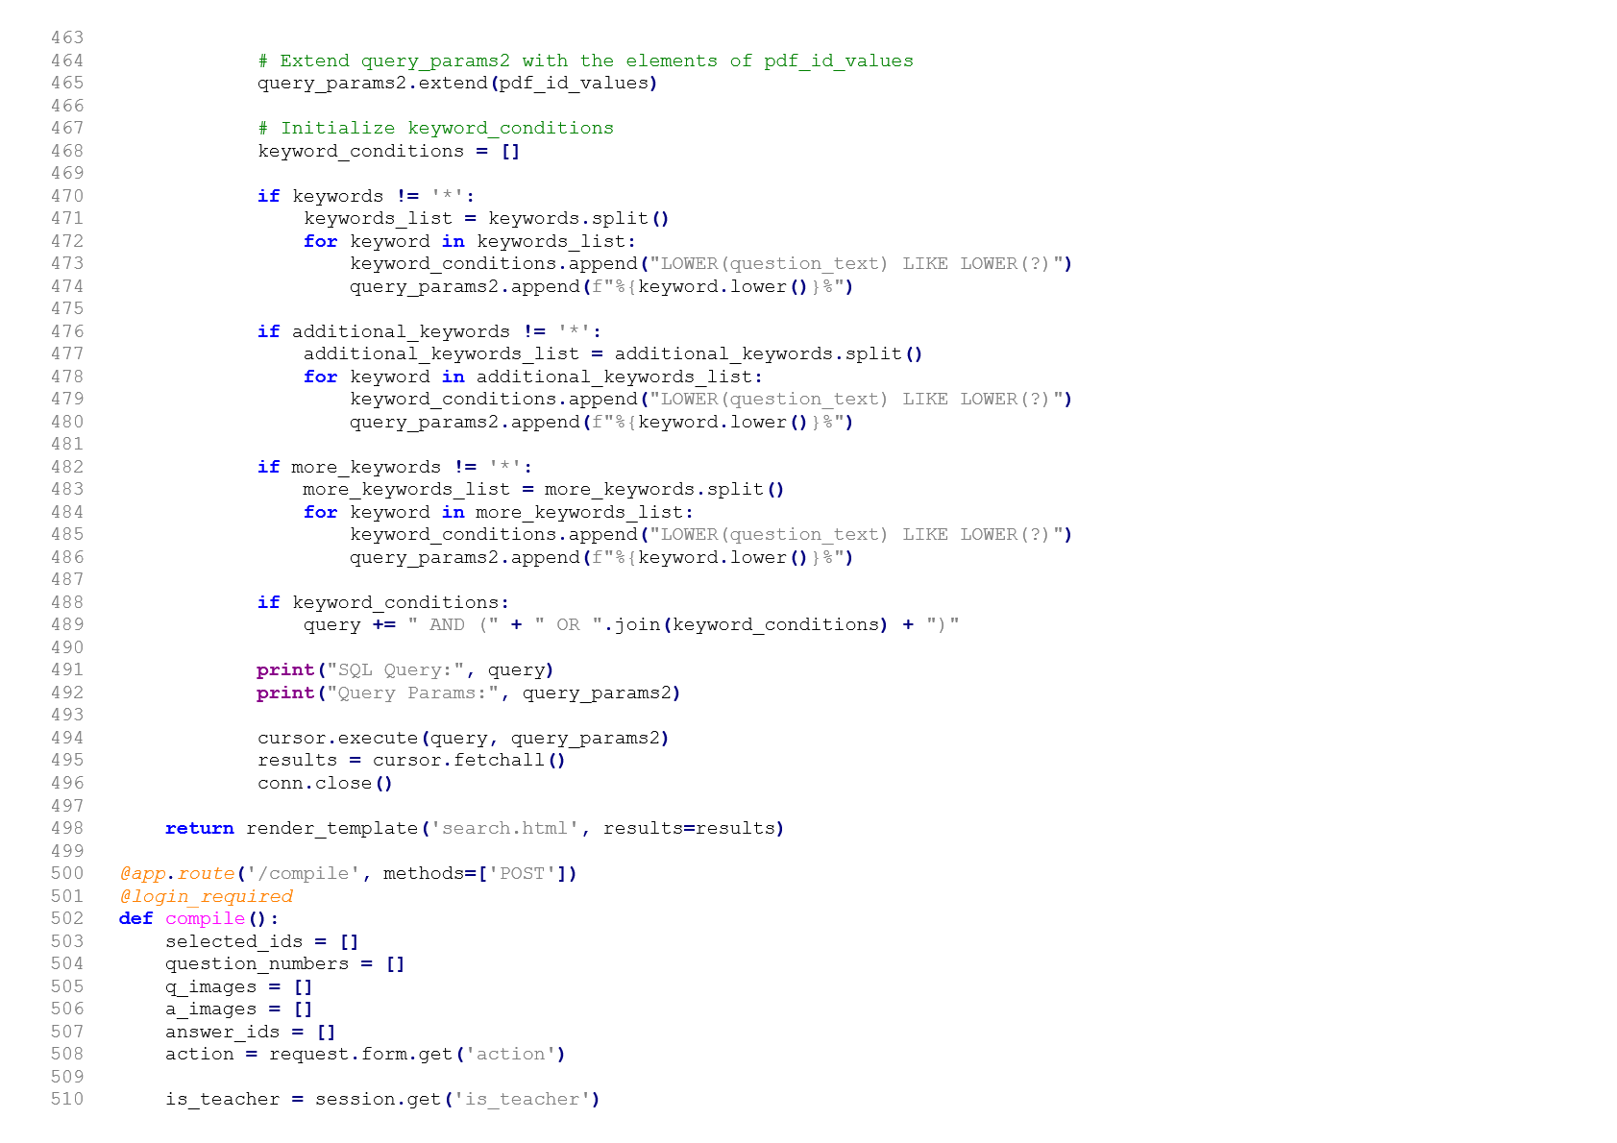

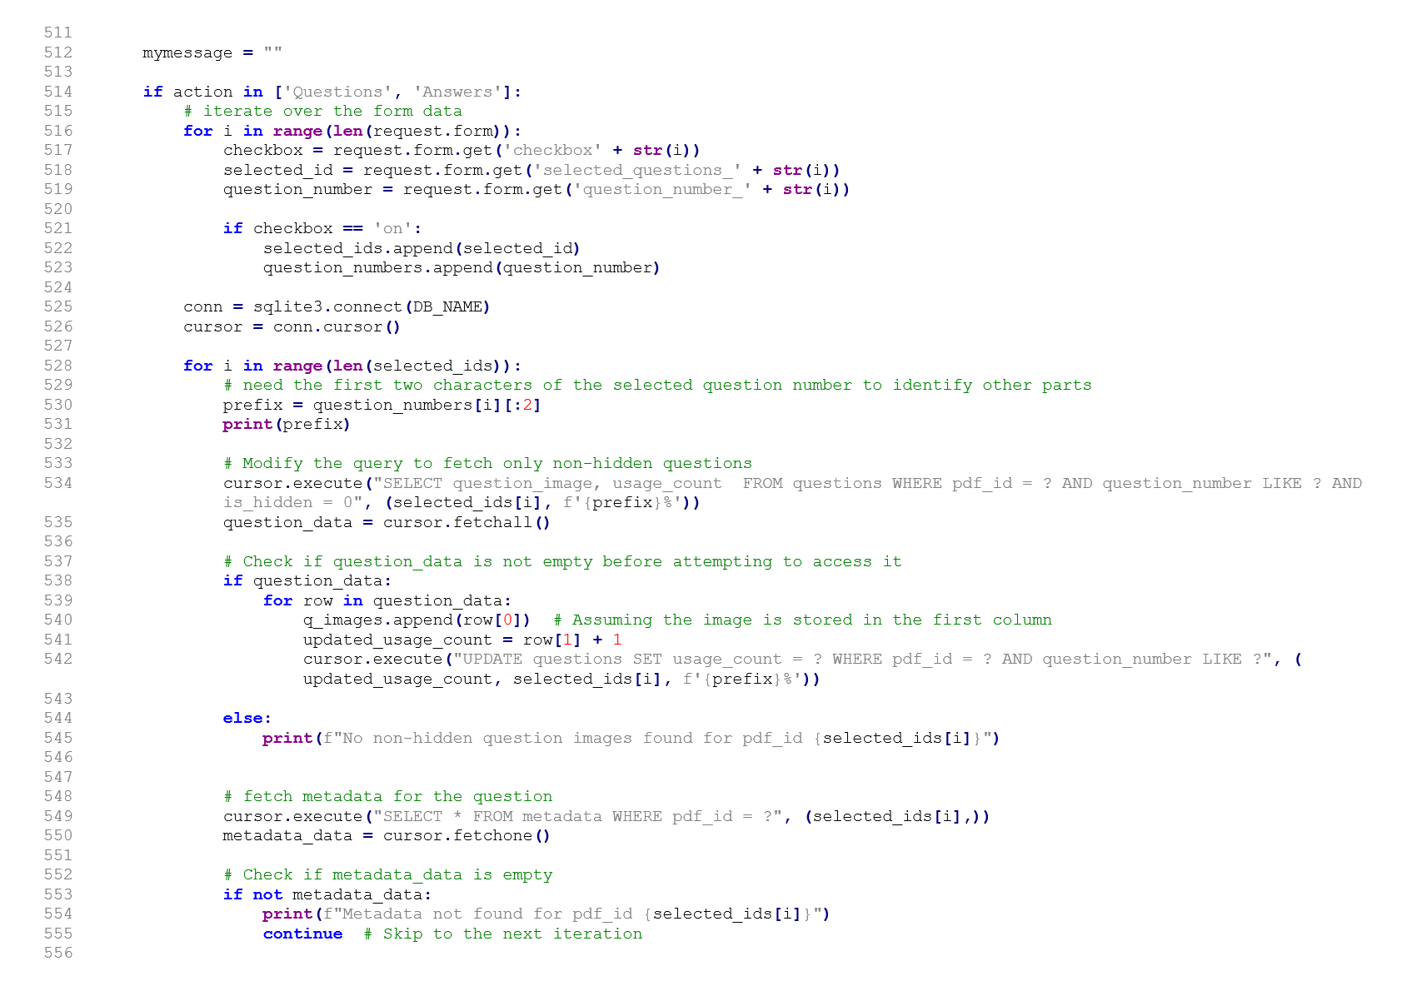

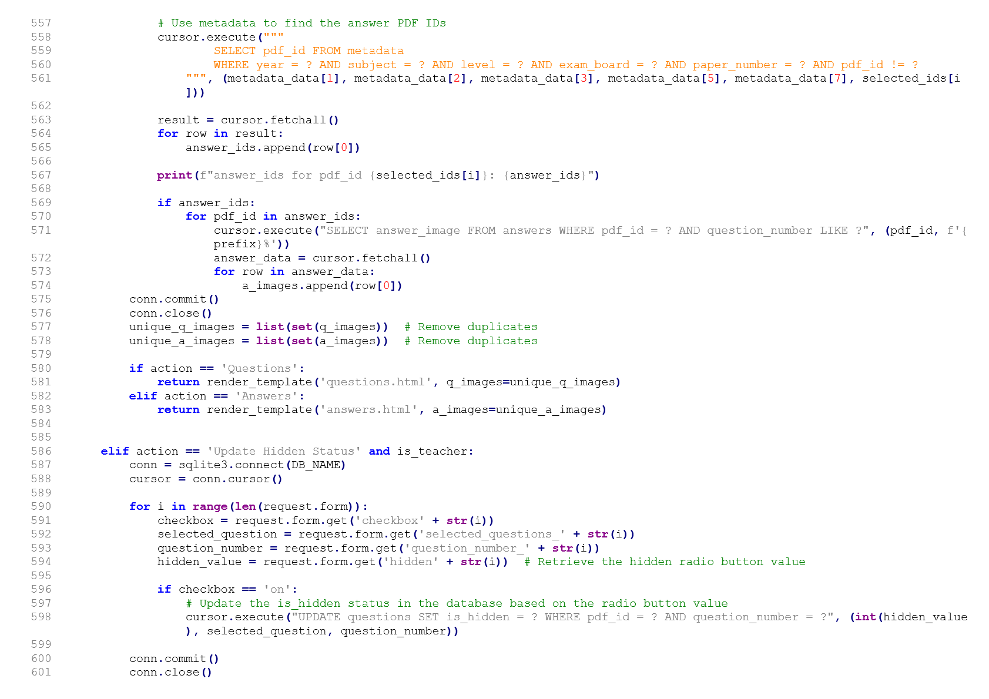

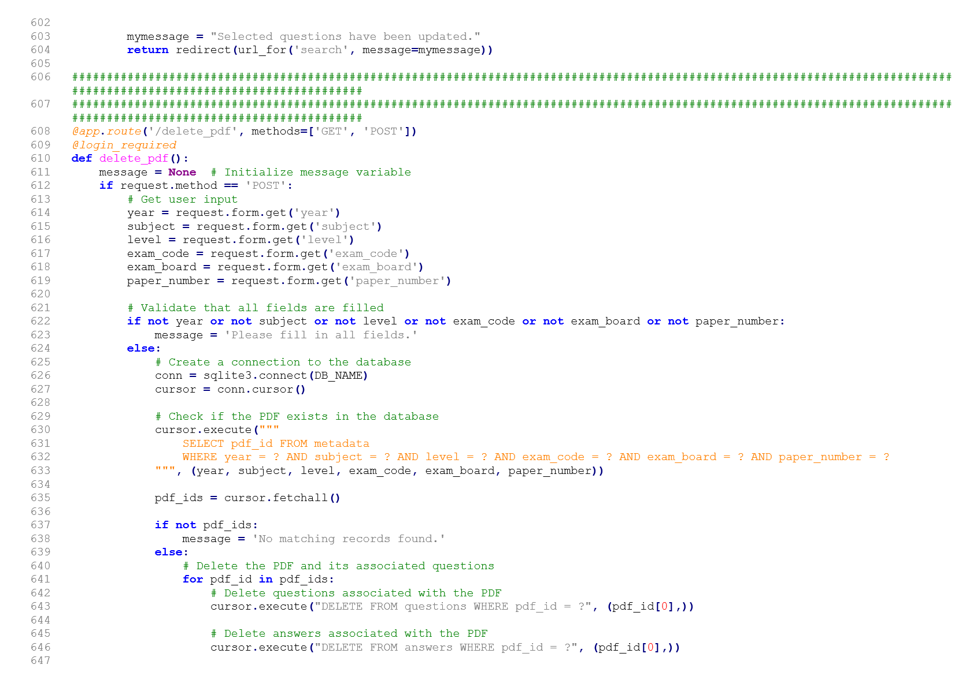

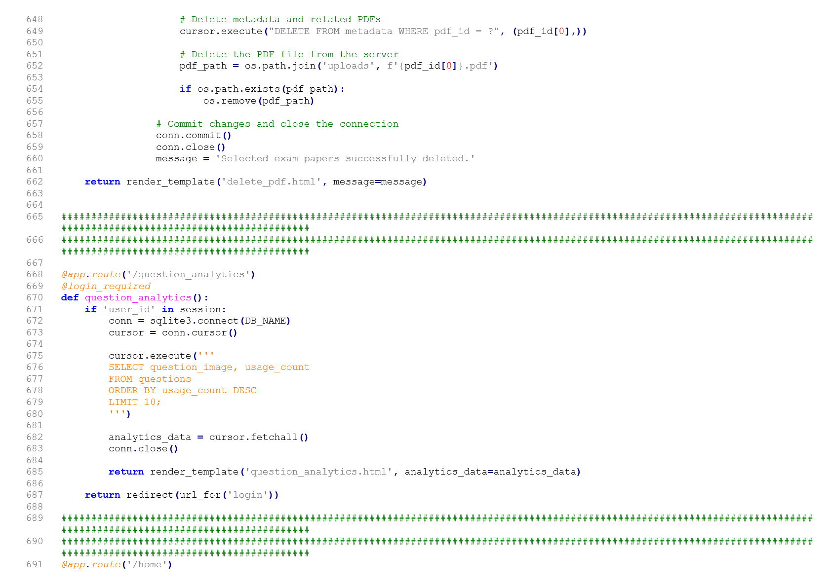

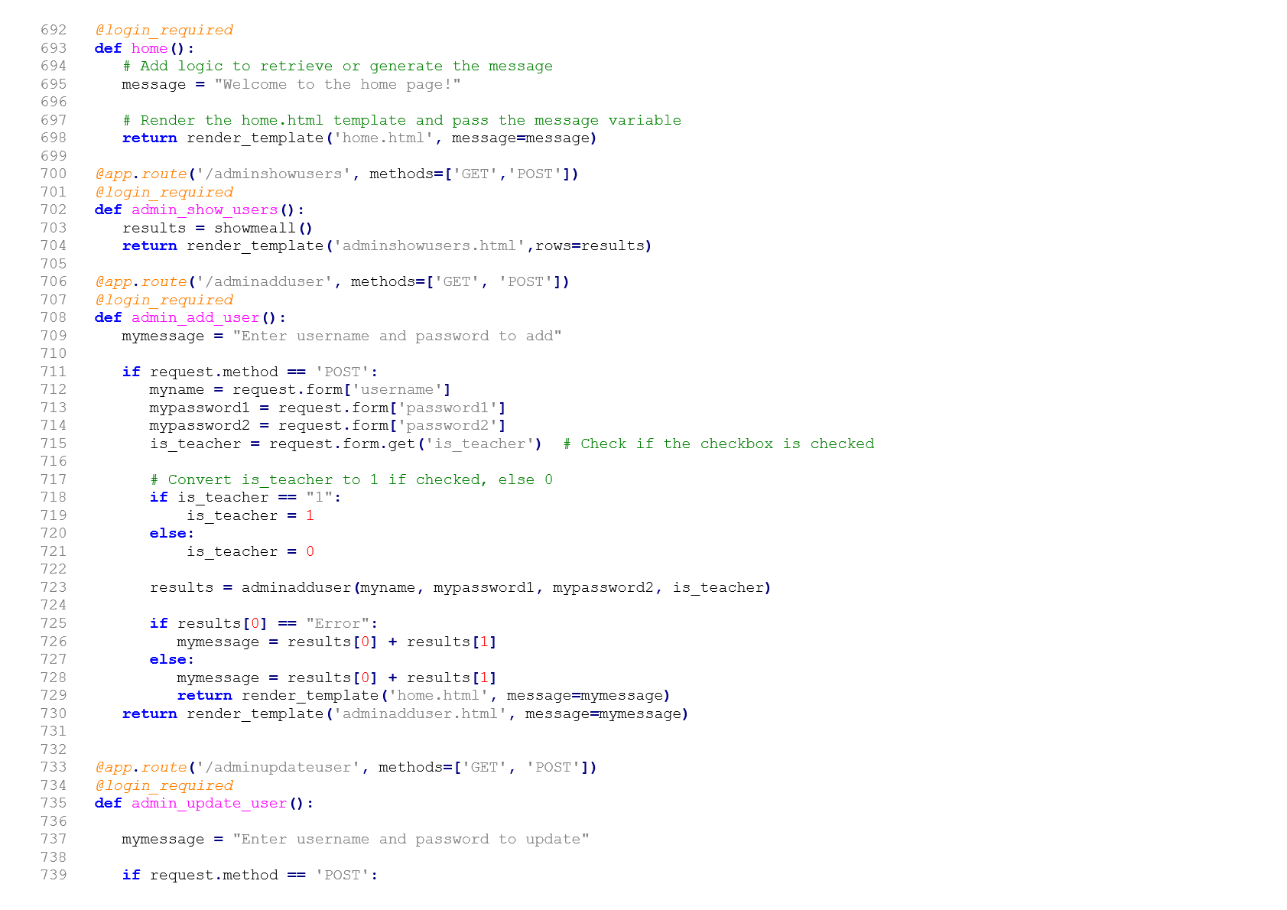

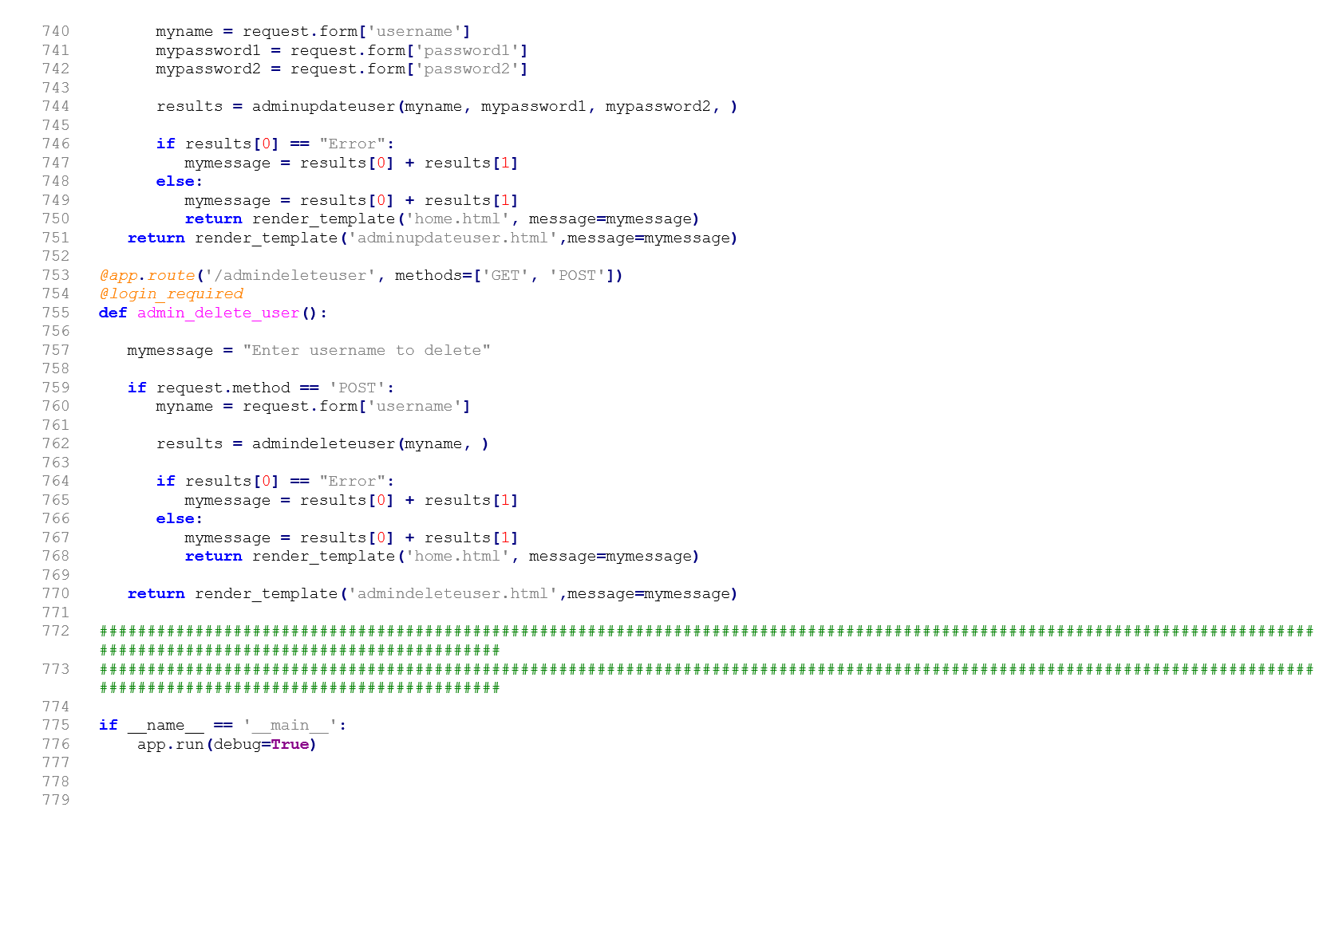

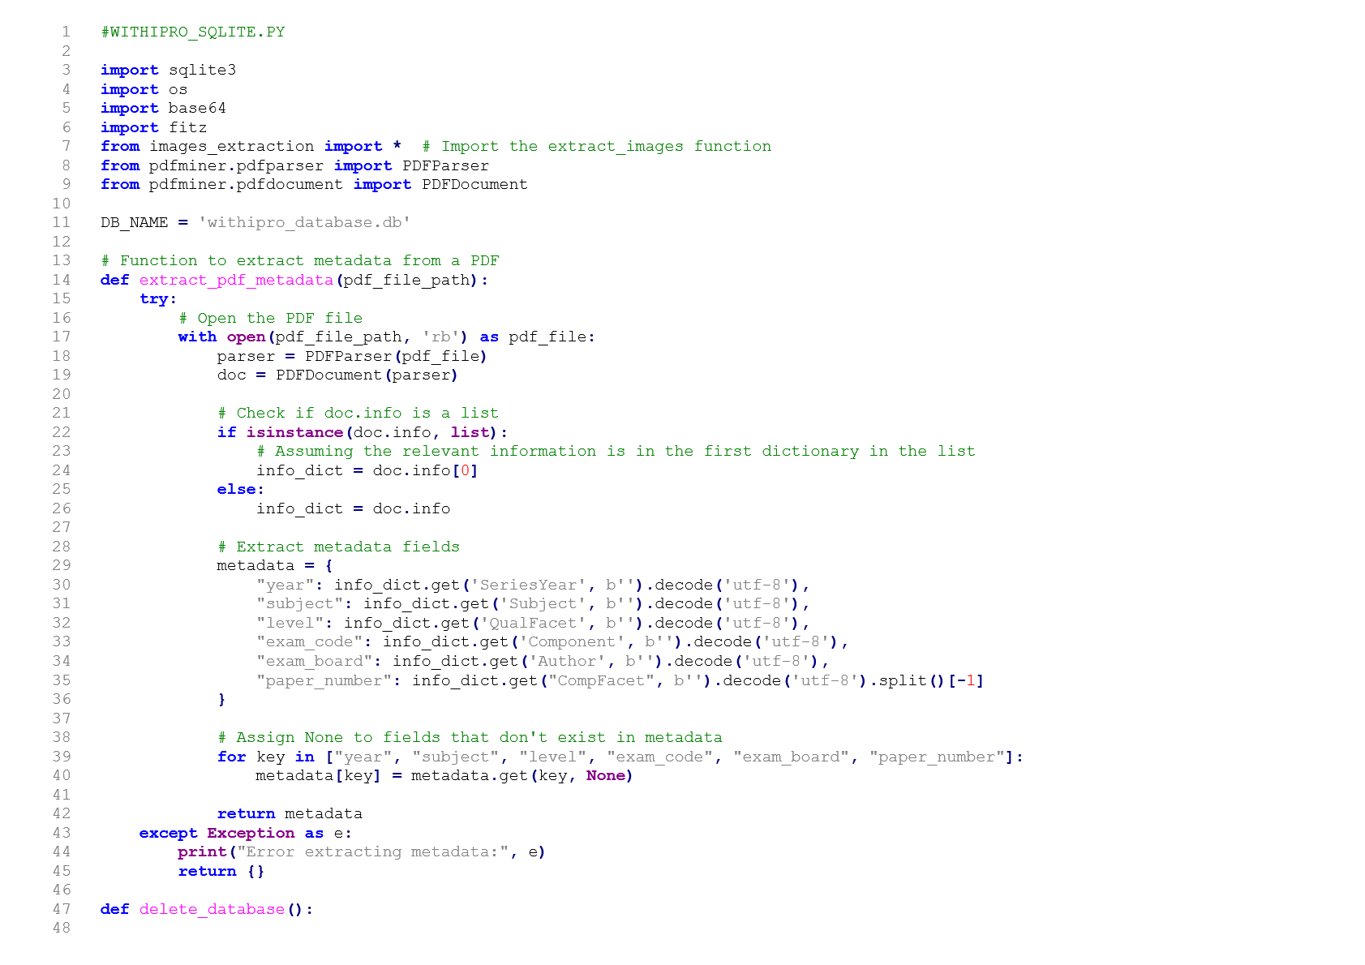

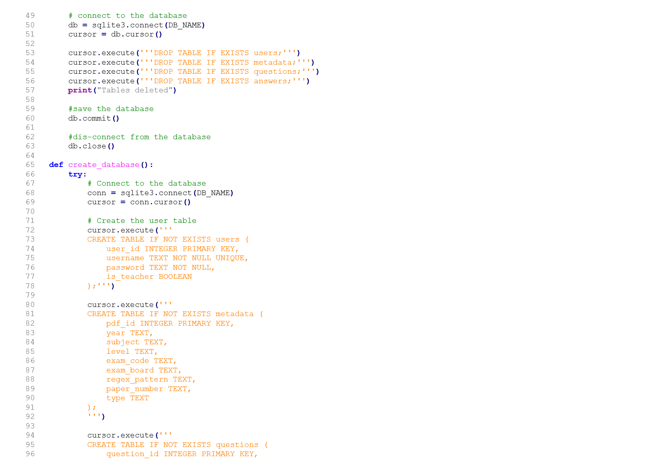

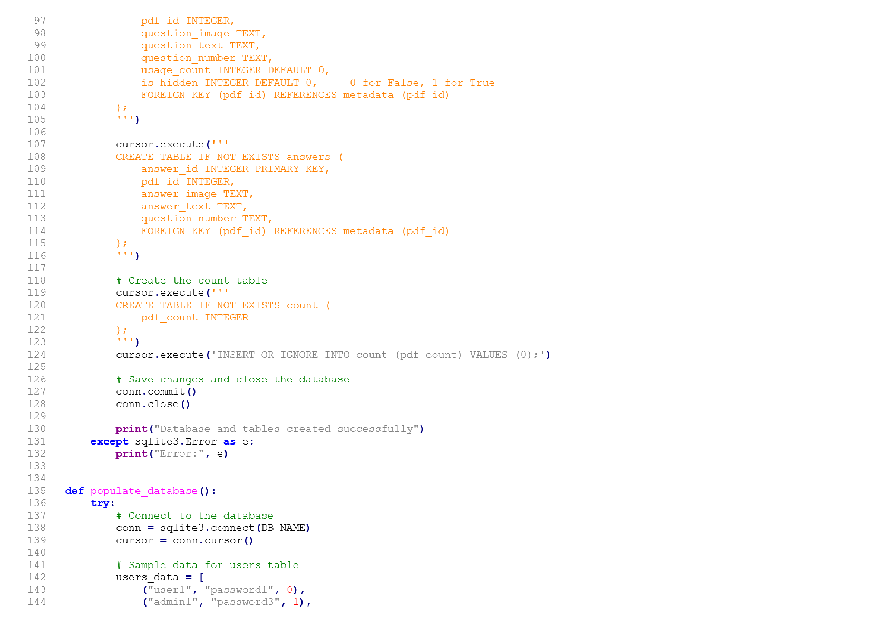

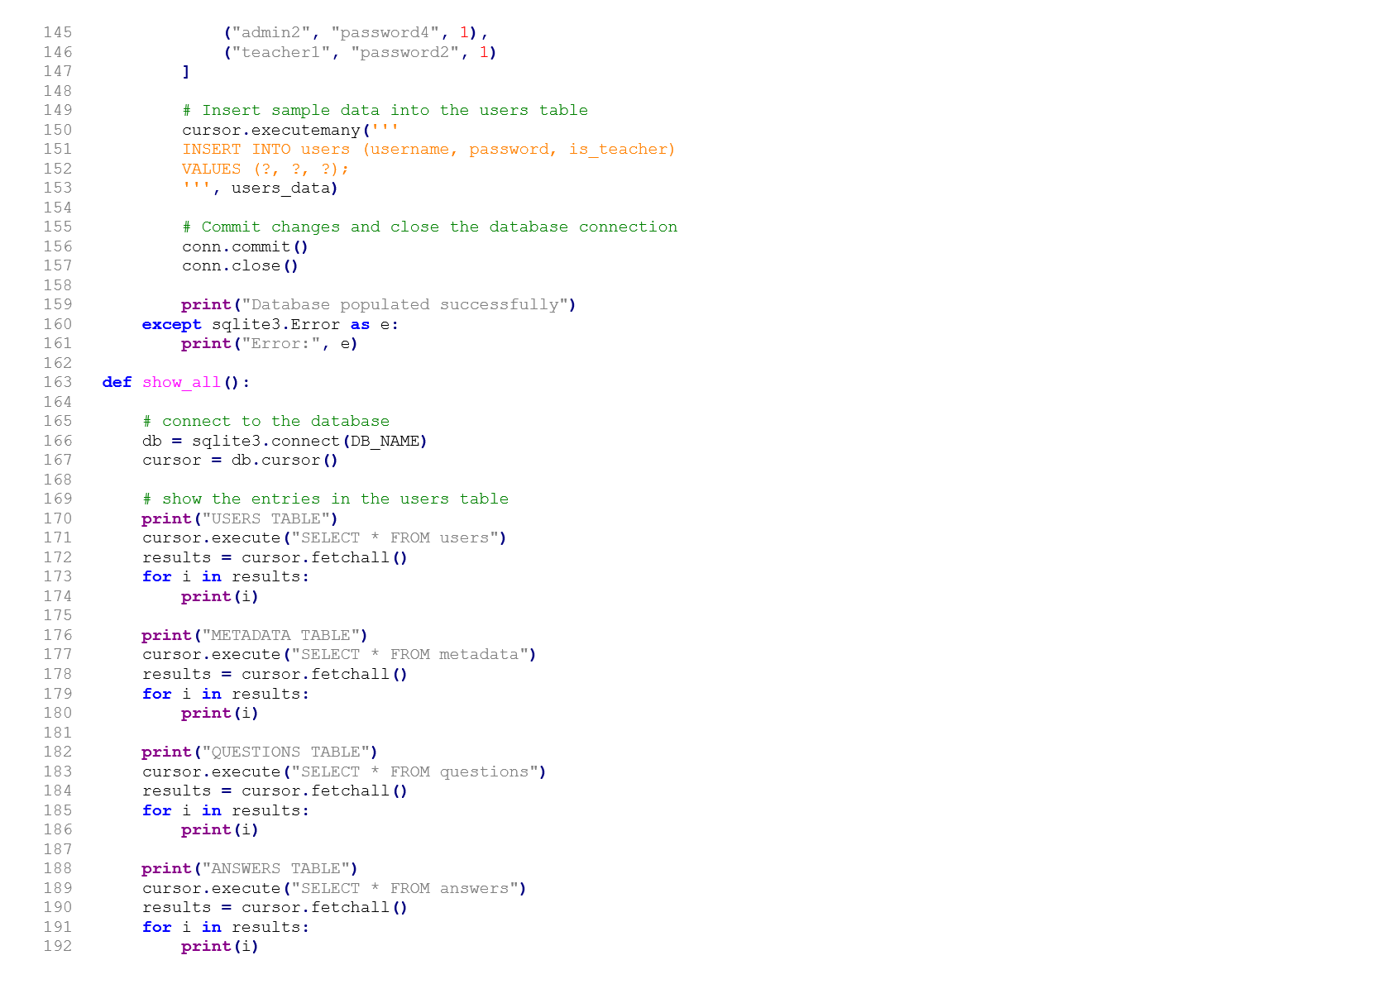

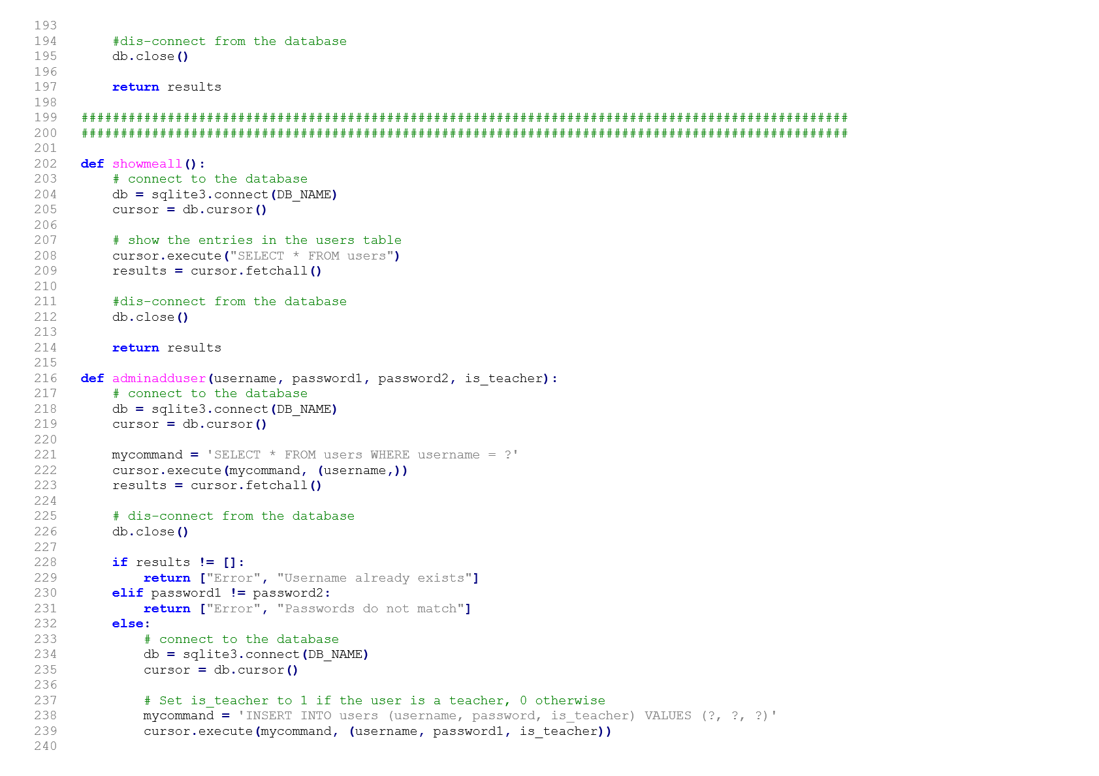

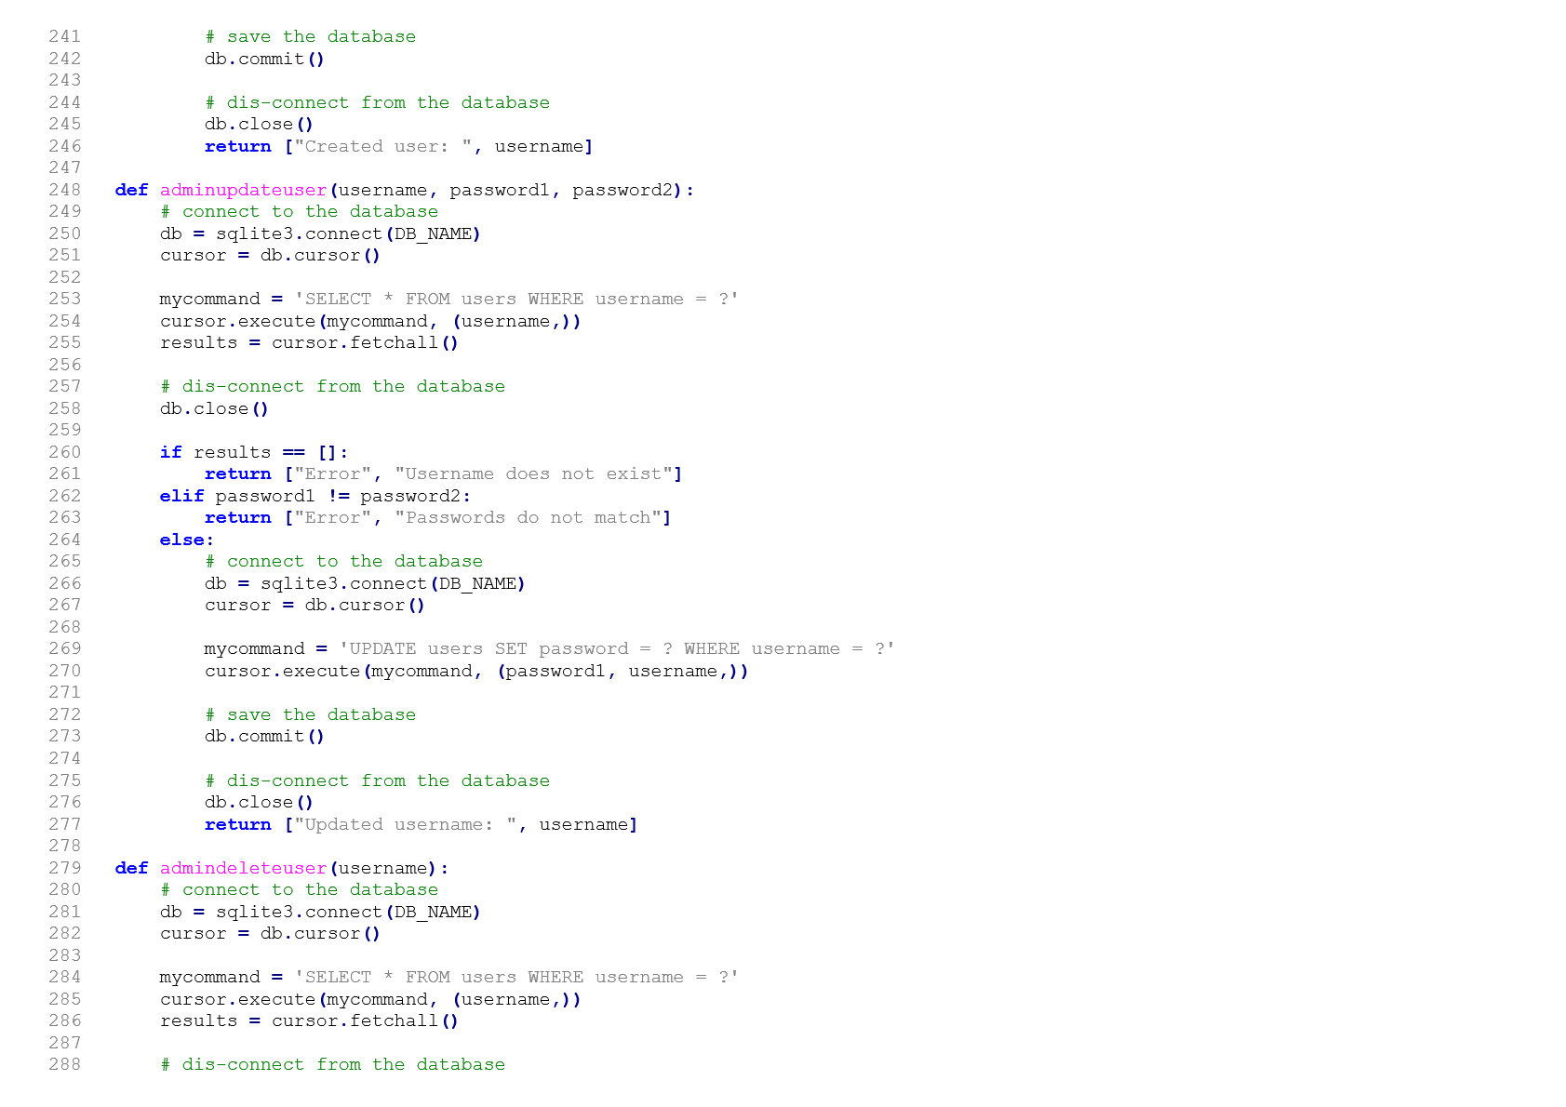

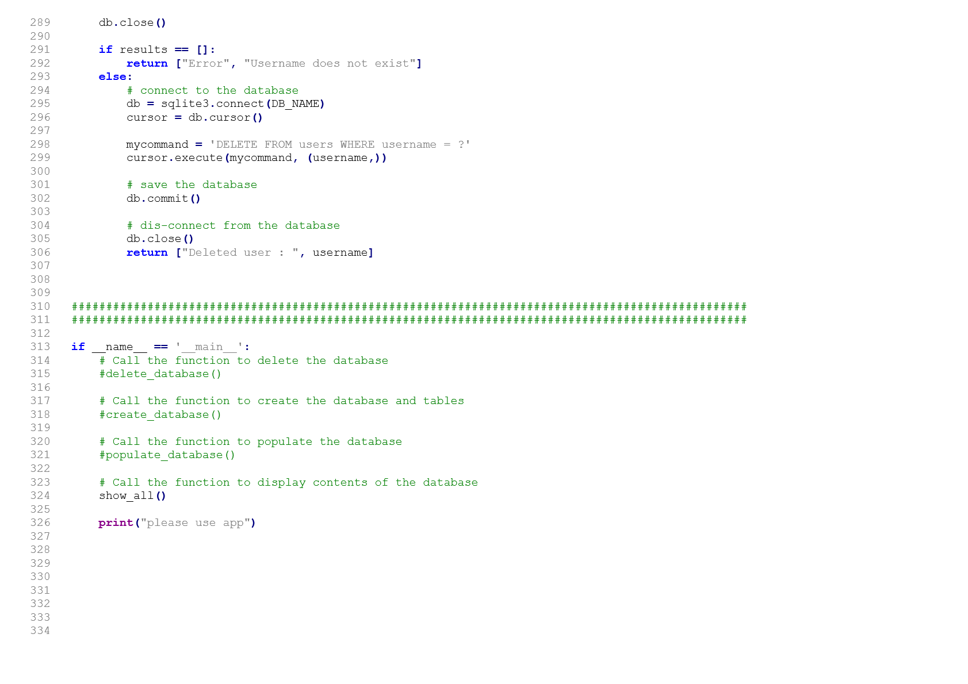

# HTML

## Adding a user

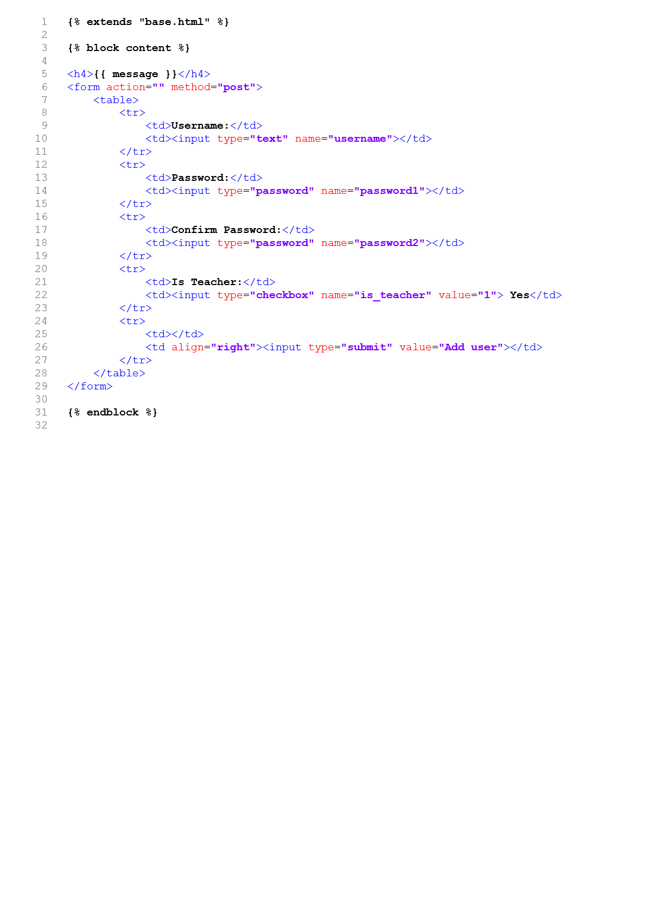

## Deleting a user

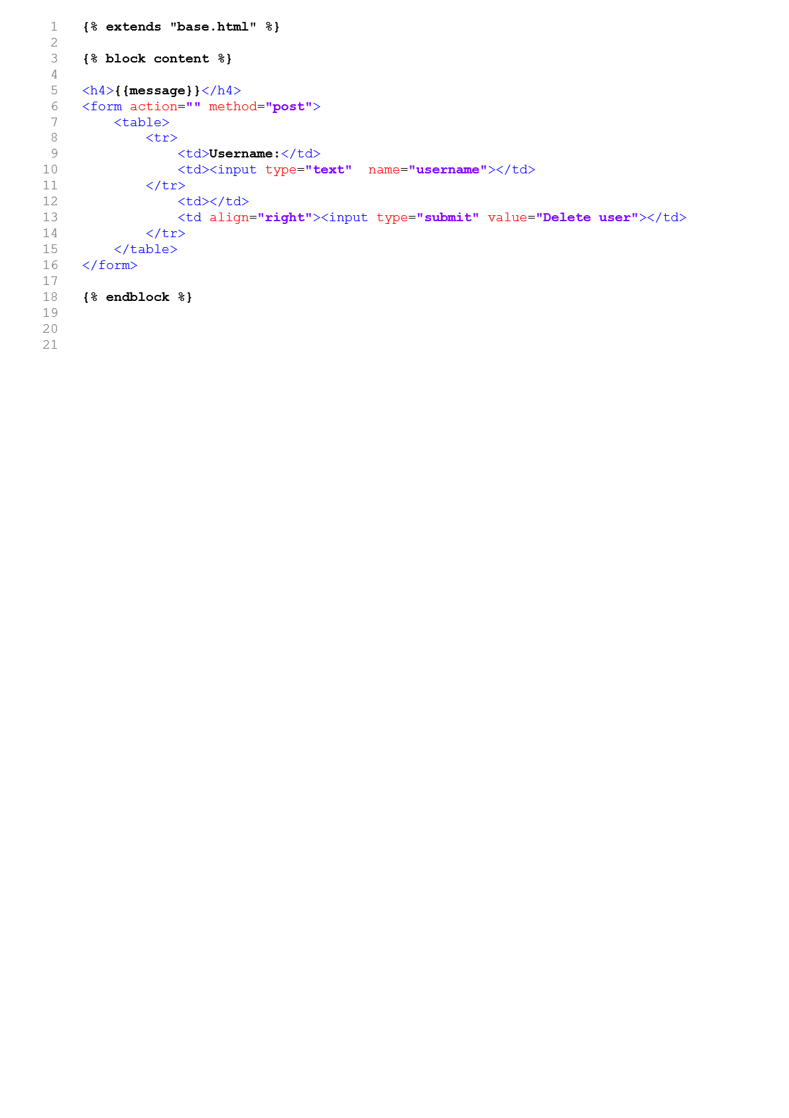

Showing list of users 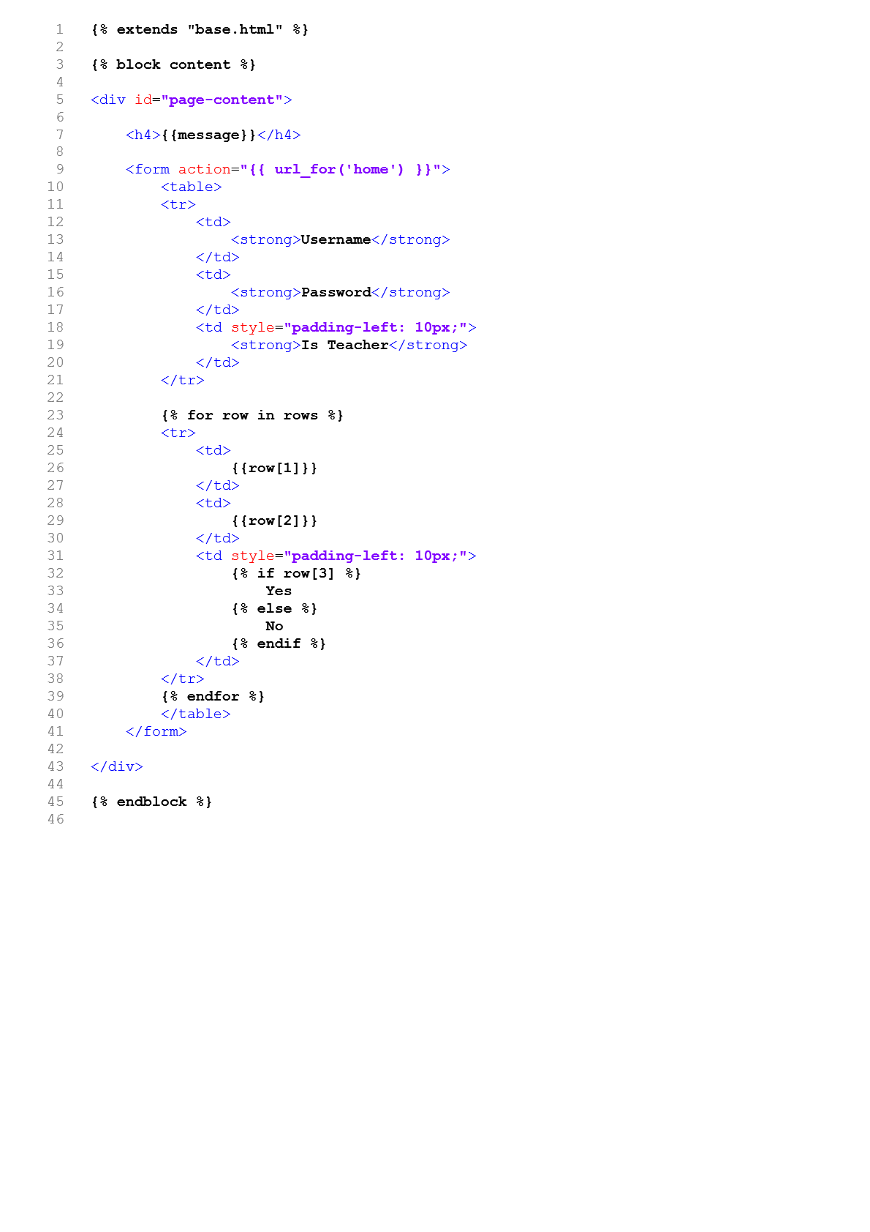

## Updating a user

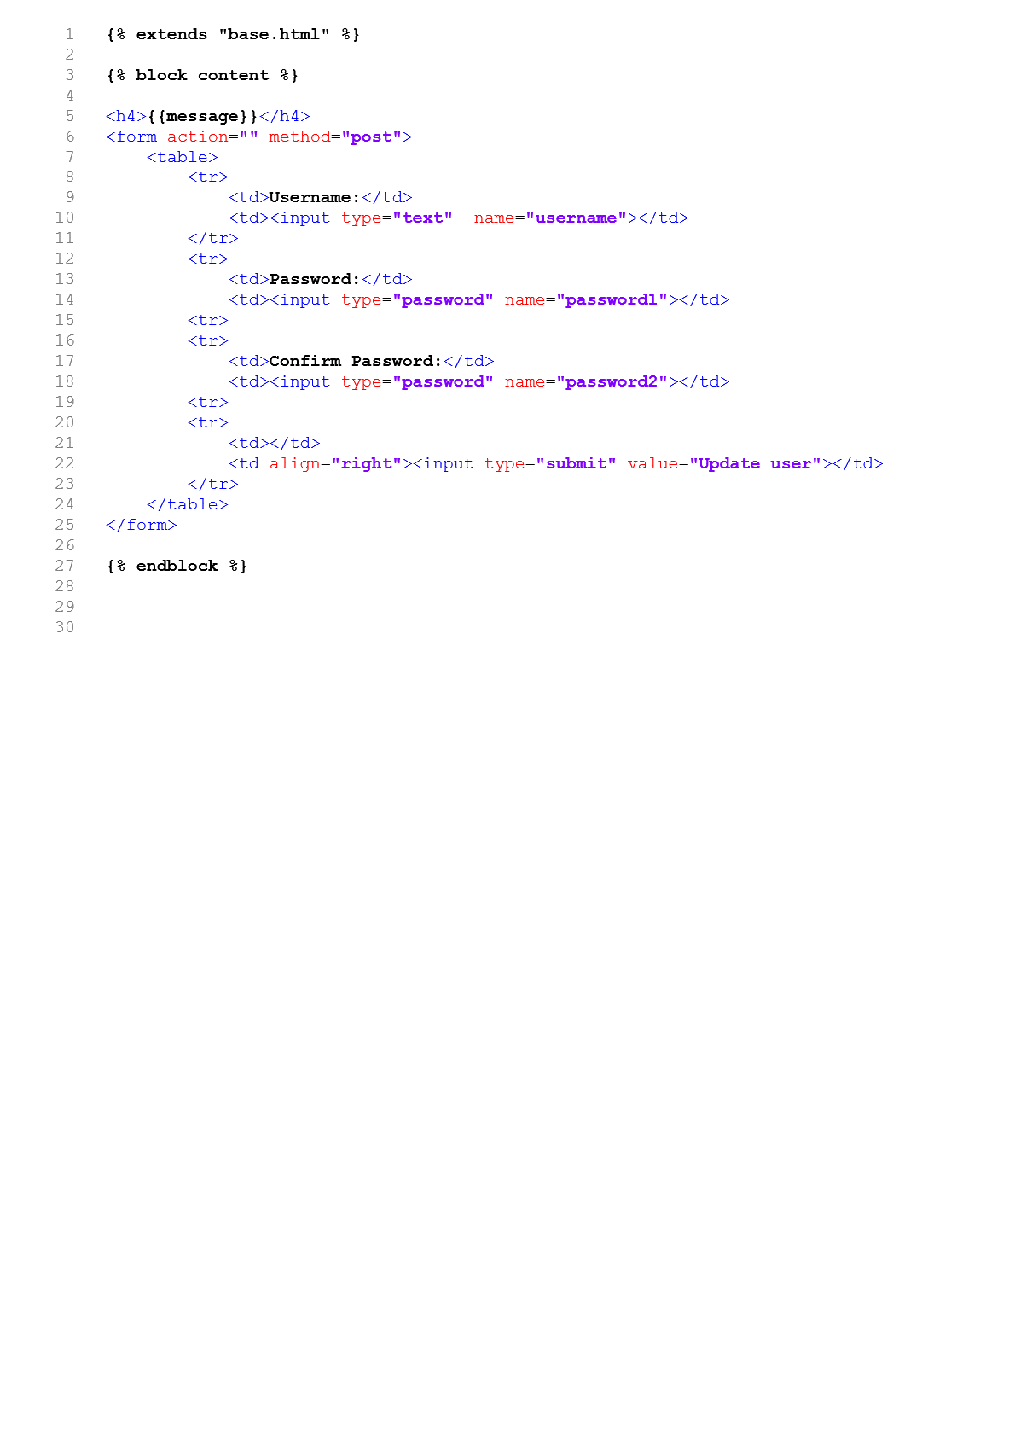

Admin home

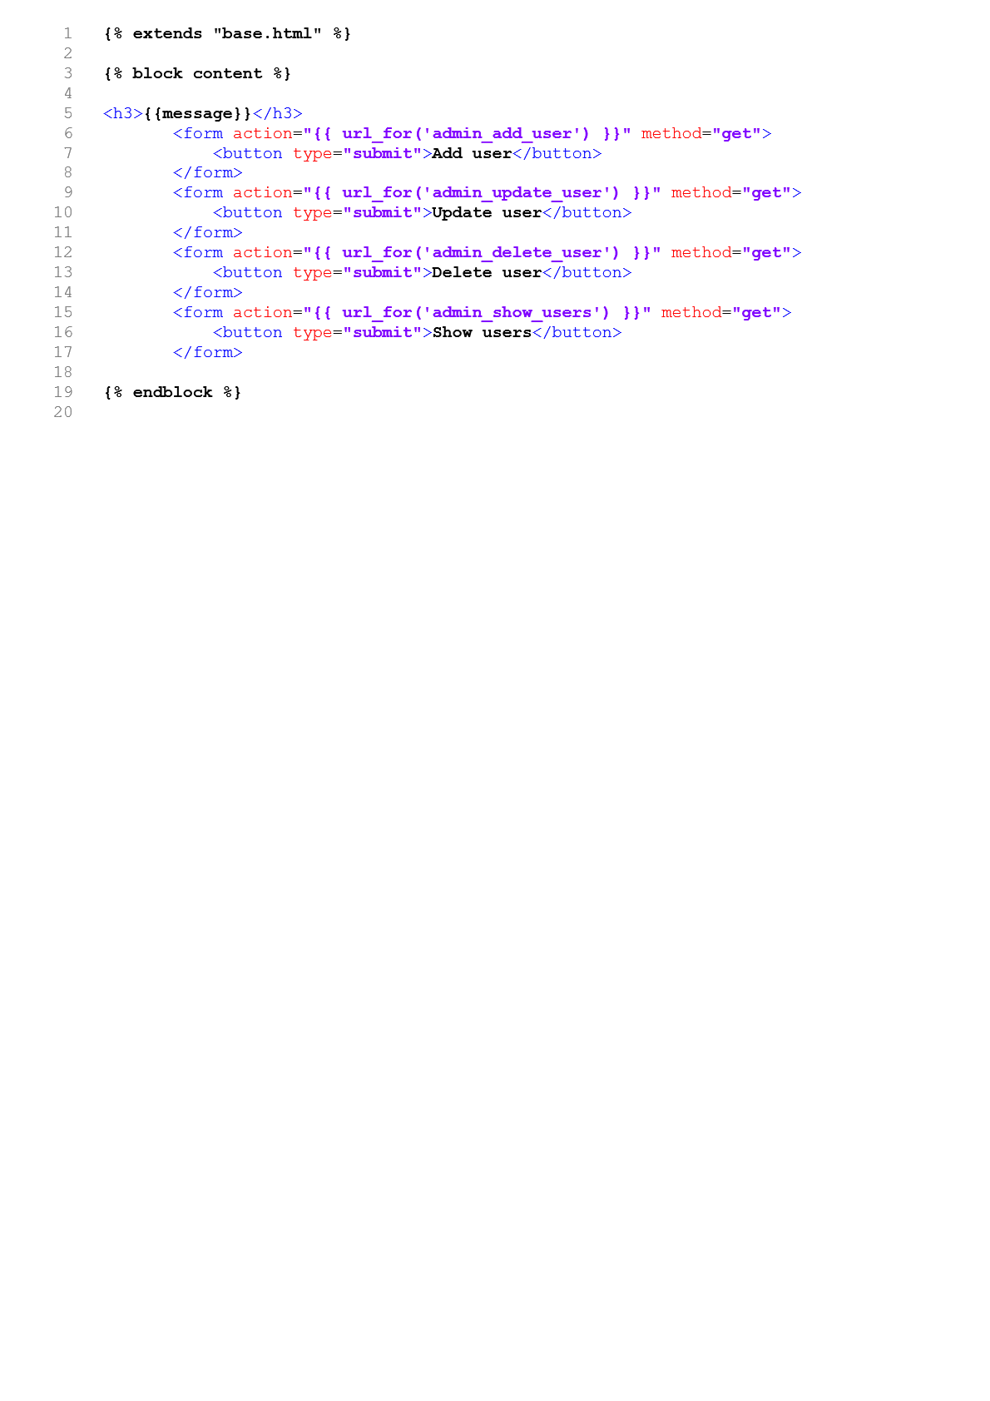

Base of Admin Sections 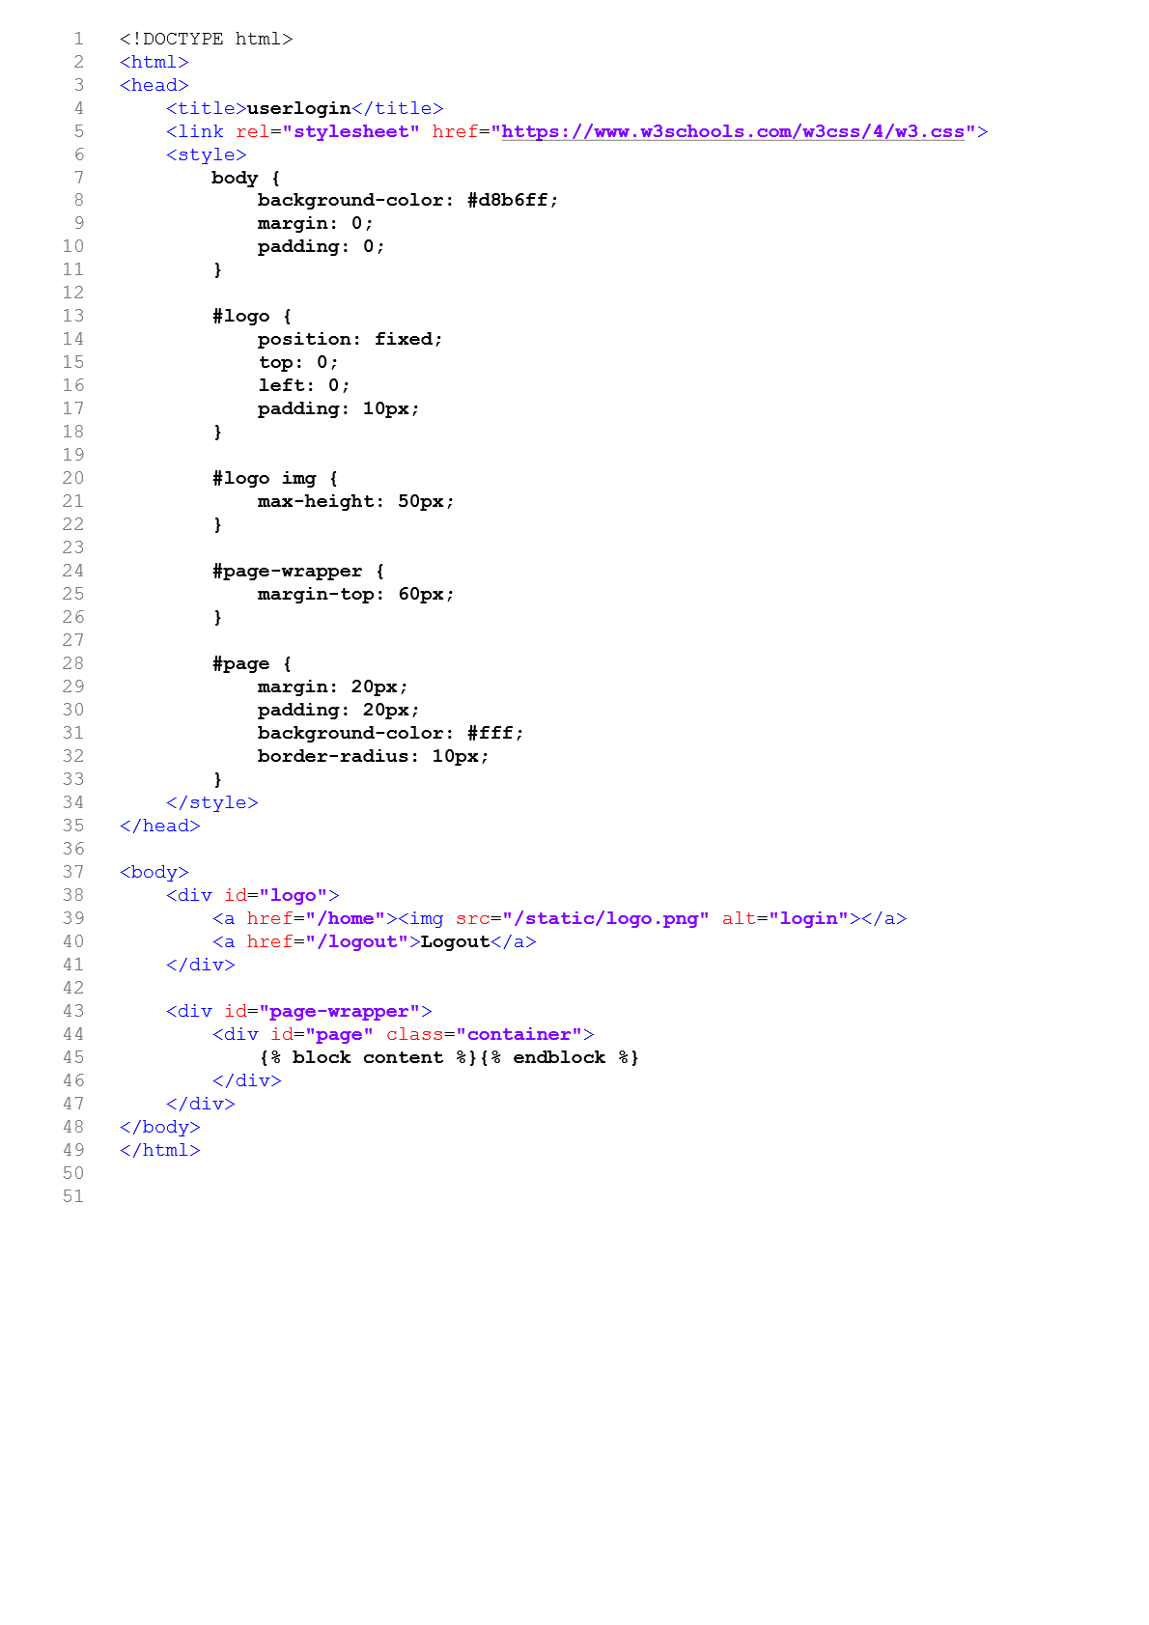

## Layout

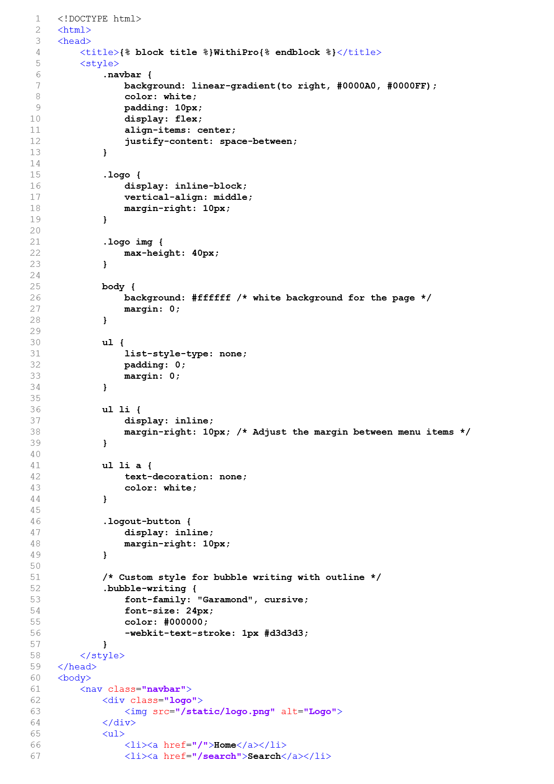

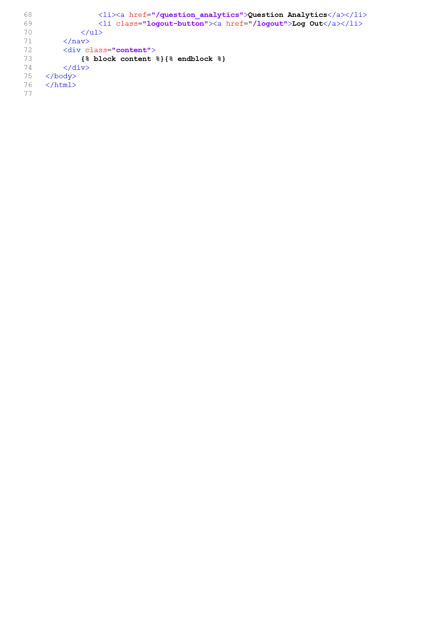

Login

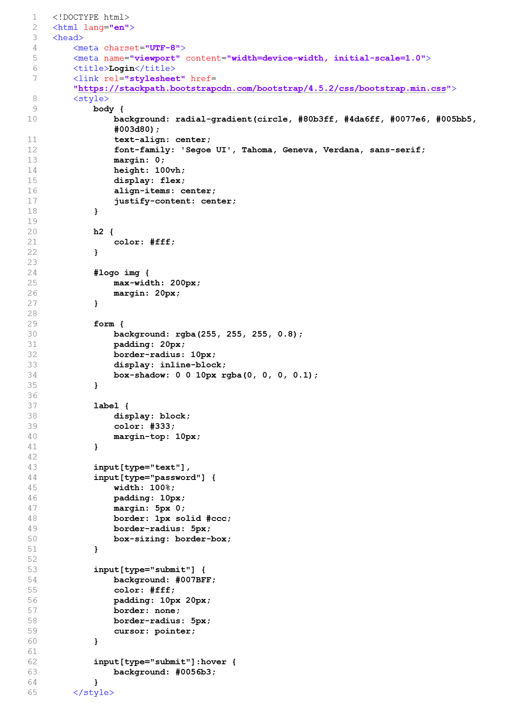

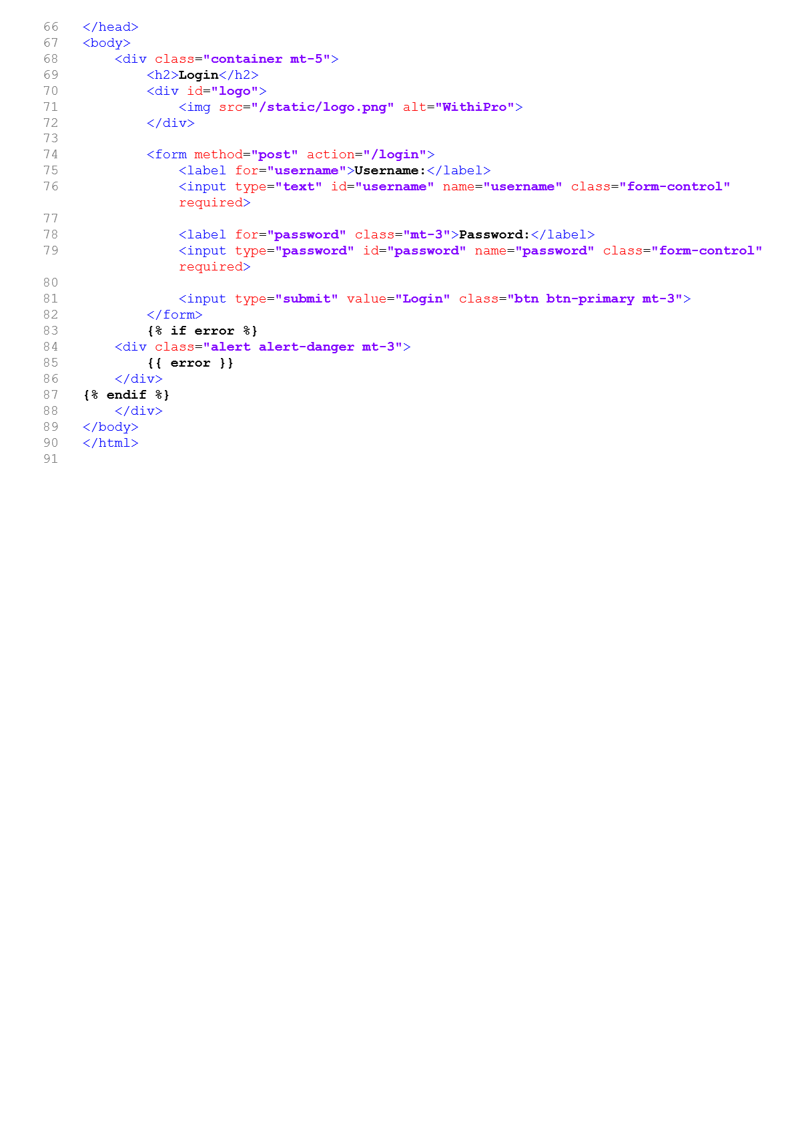

Teacher Home

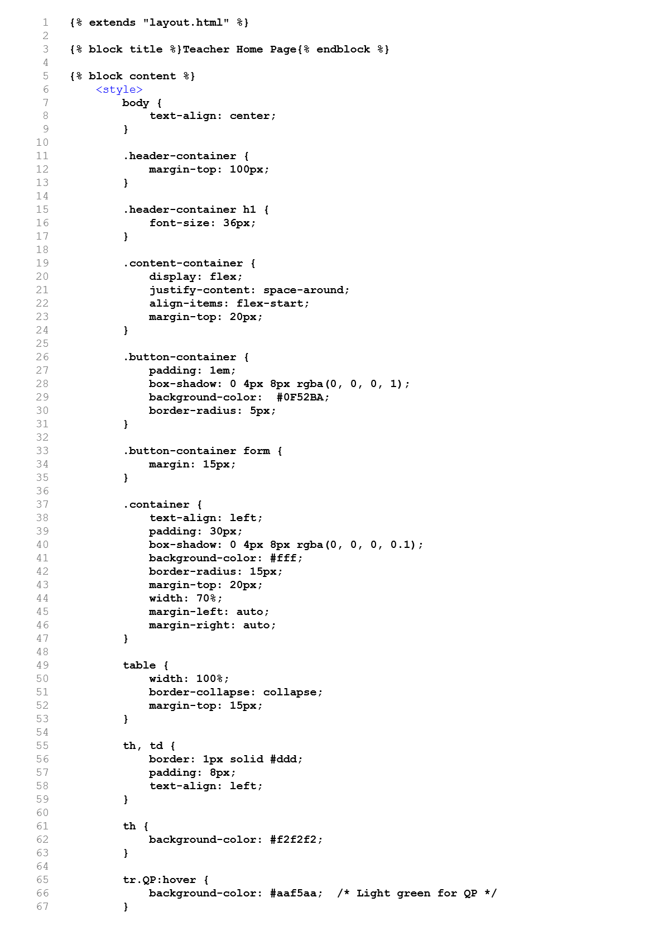

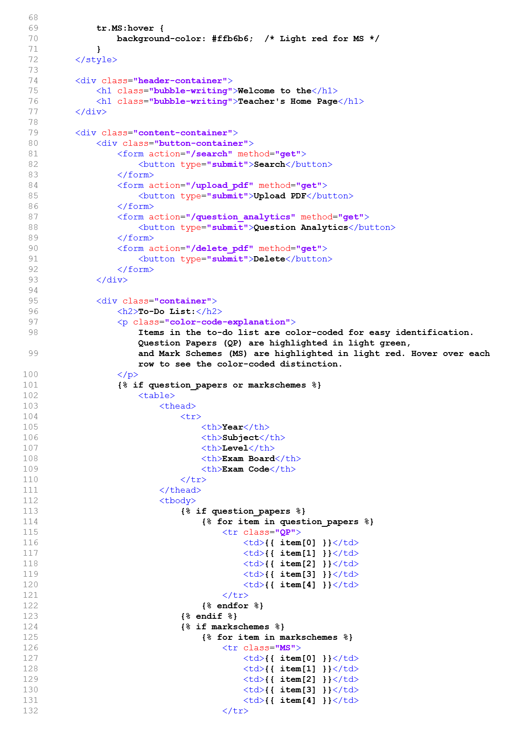

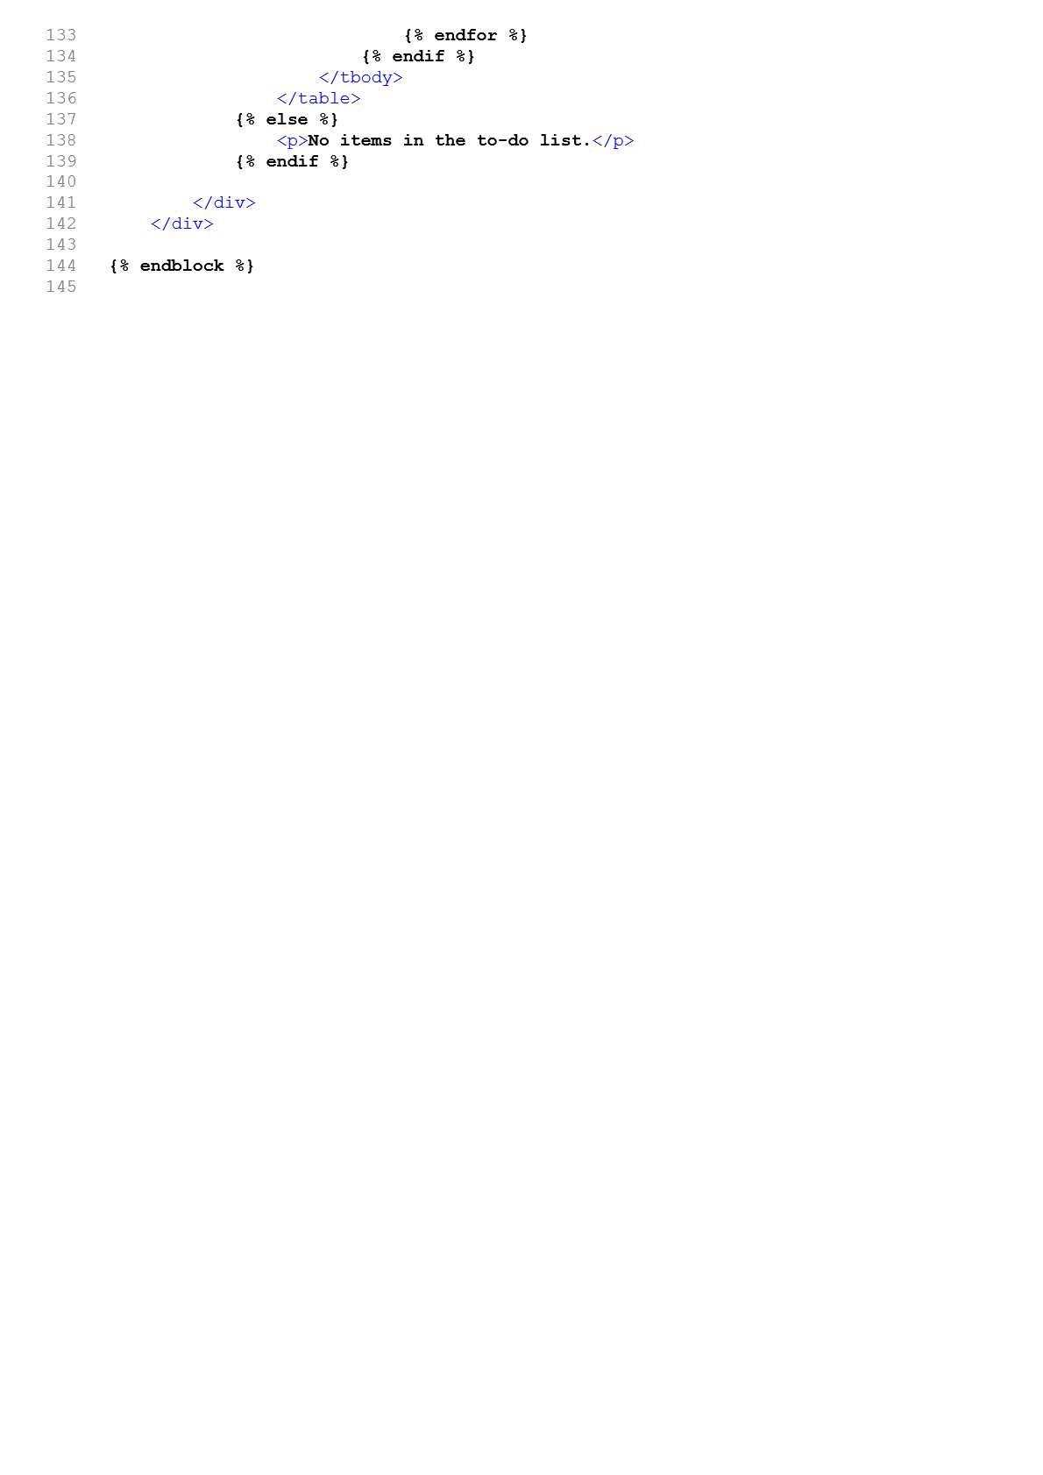

## Student Home

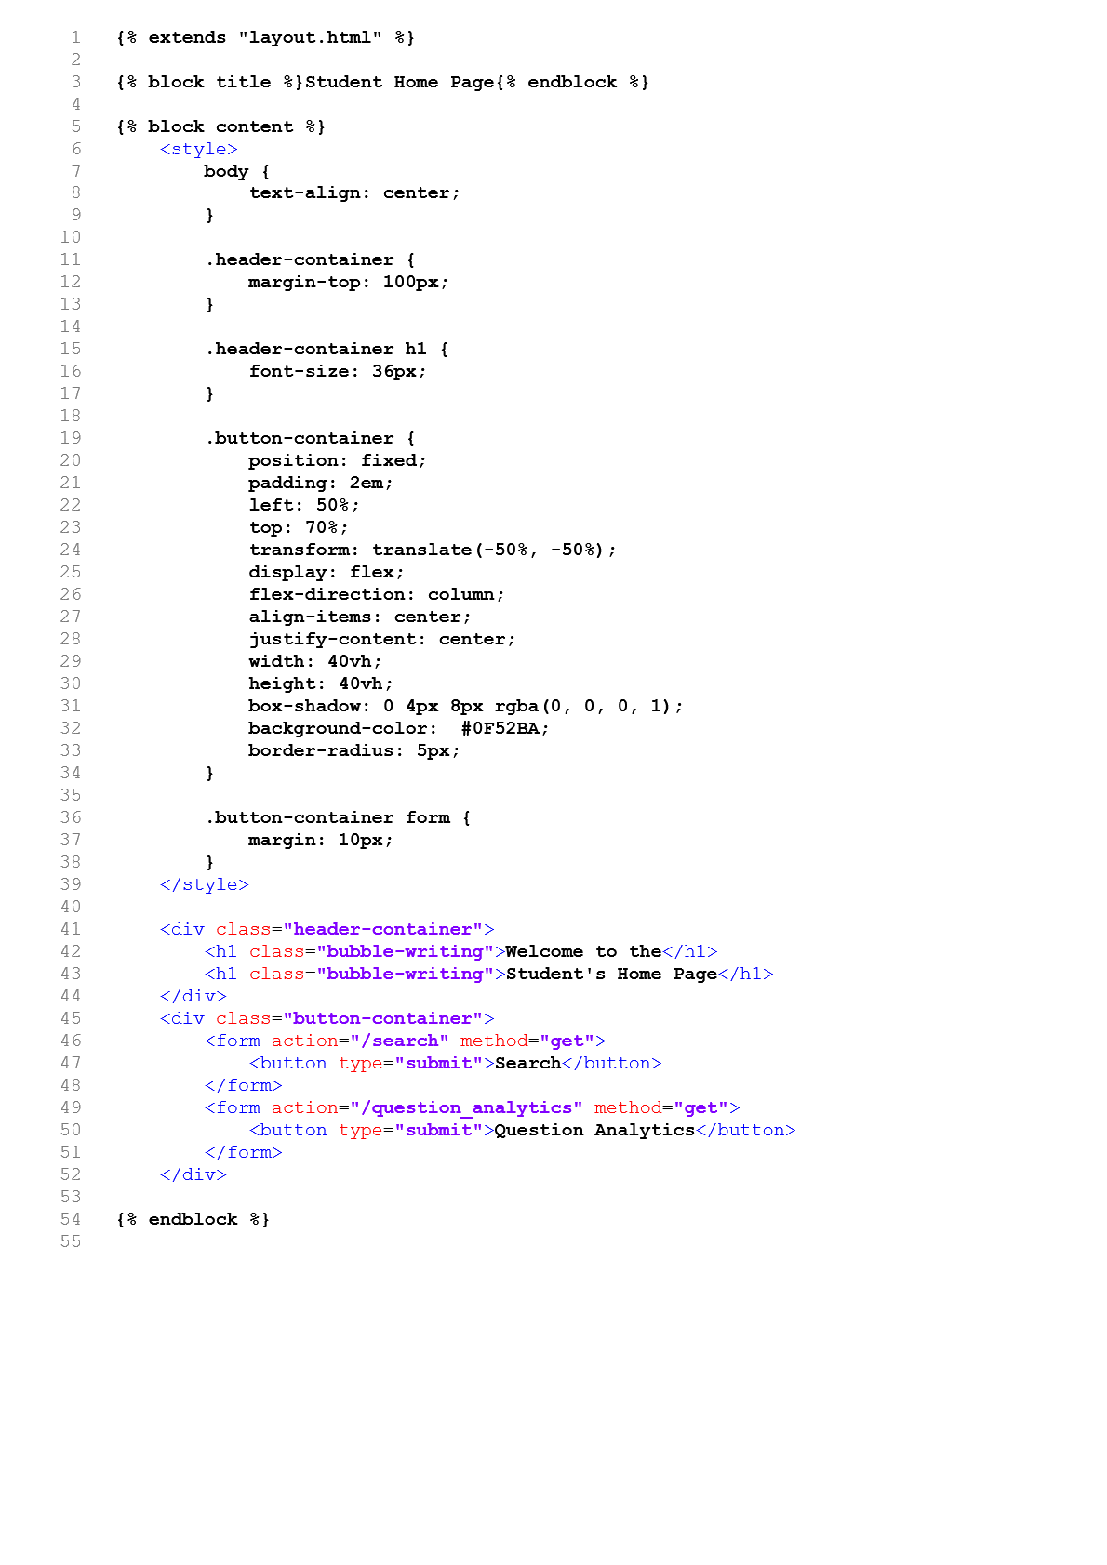

Uploading a PDF

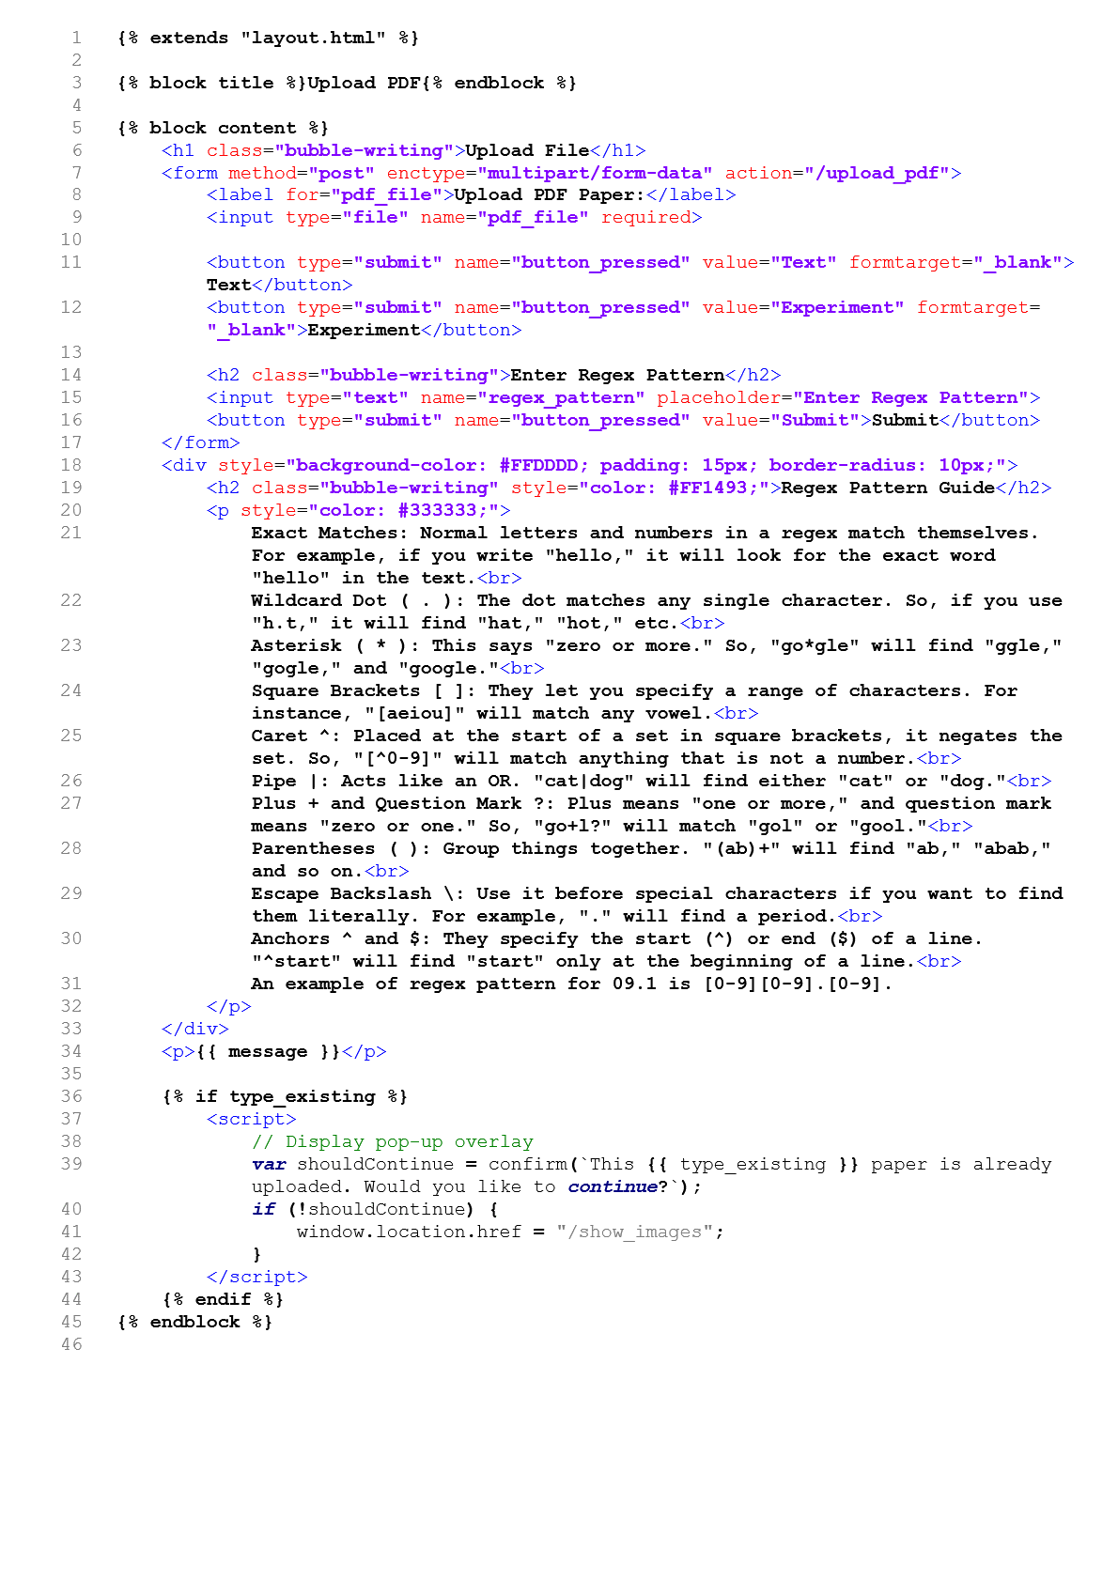

Experimenting with regex

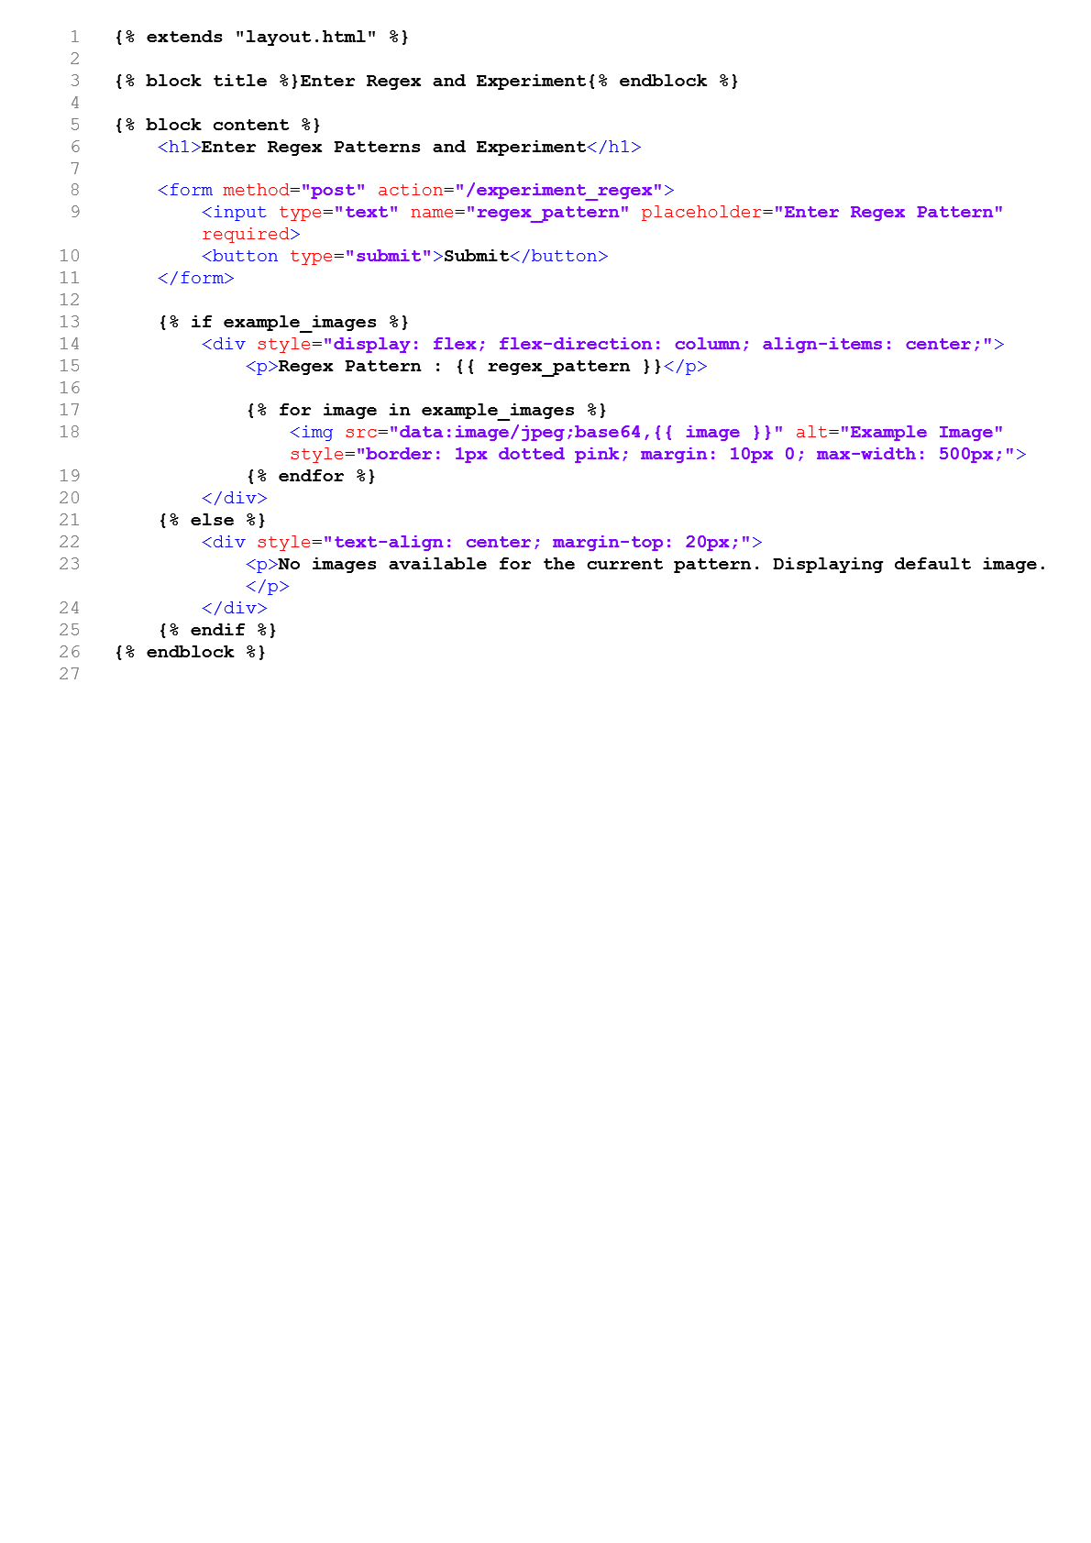

## Text from PDF

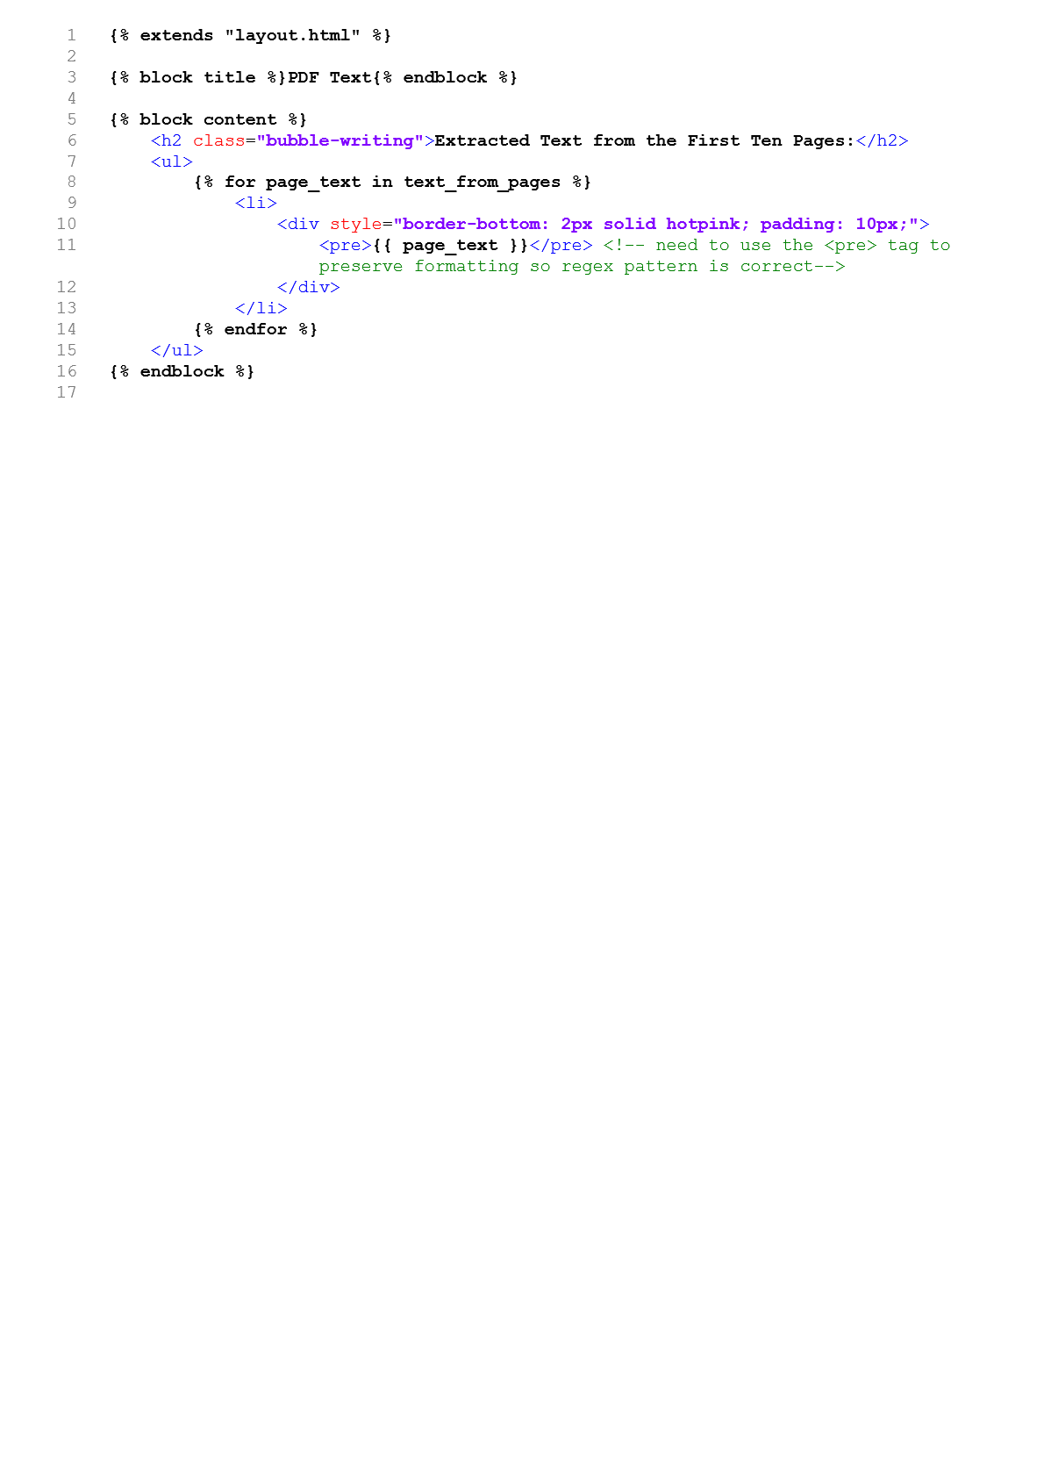

Showing Images

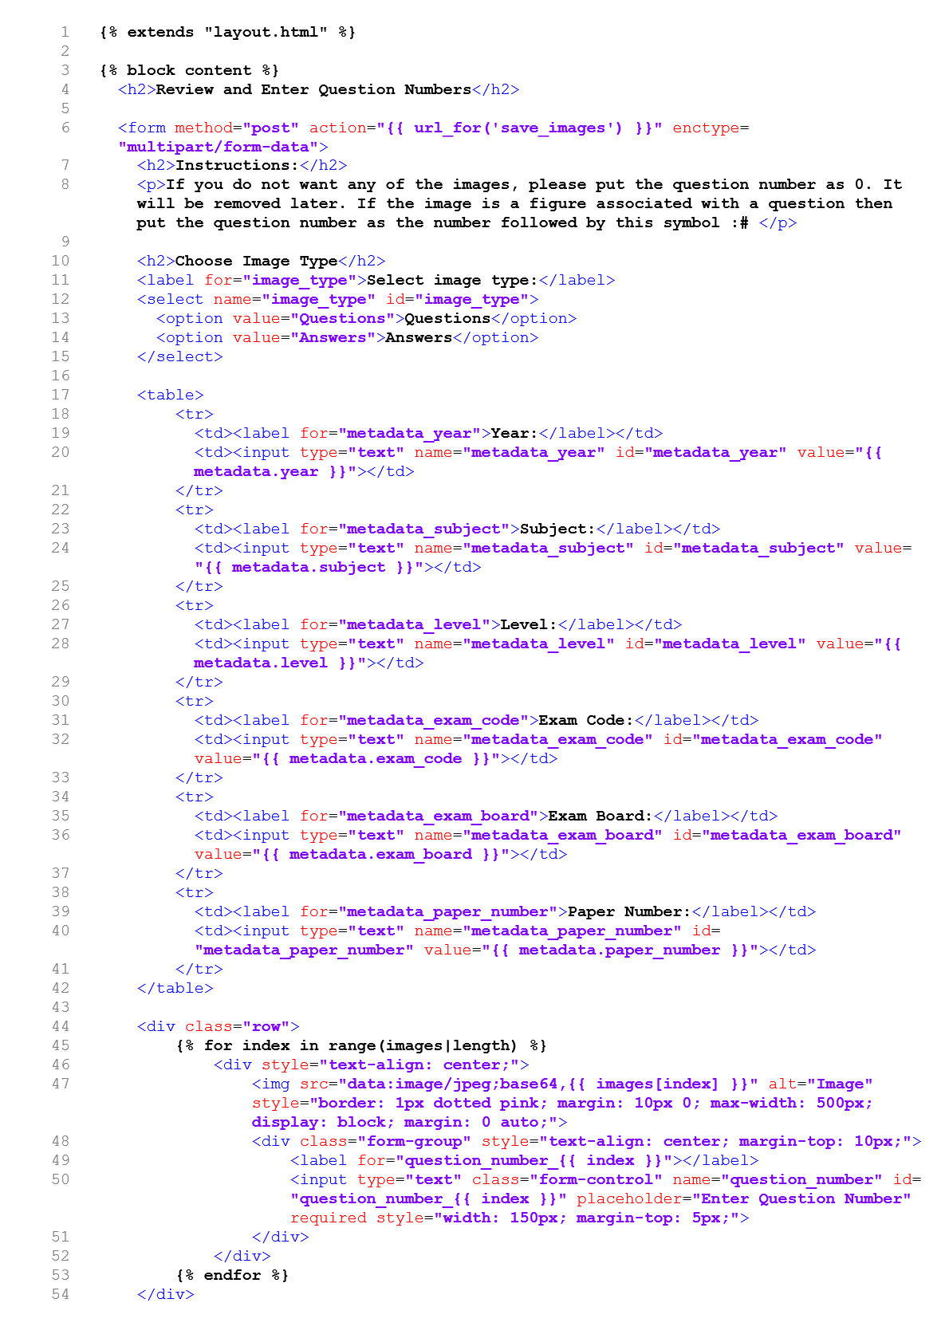

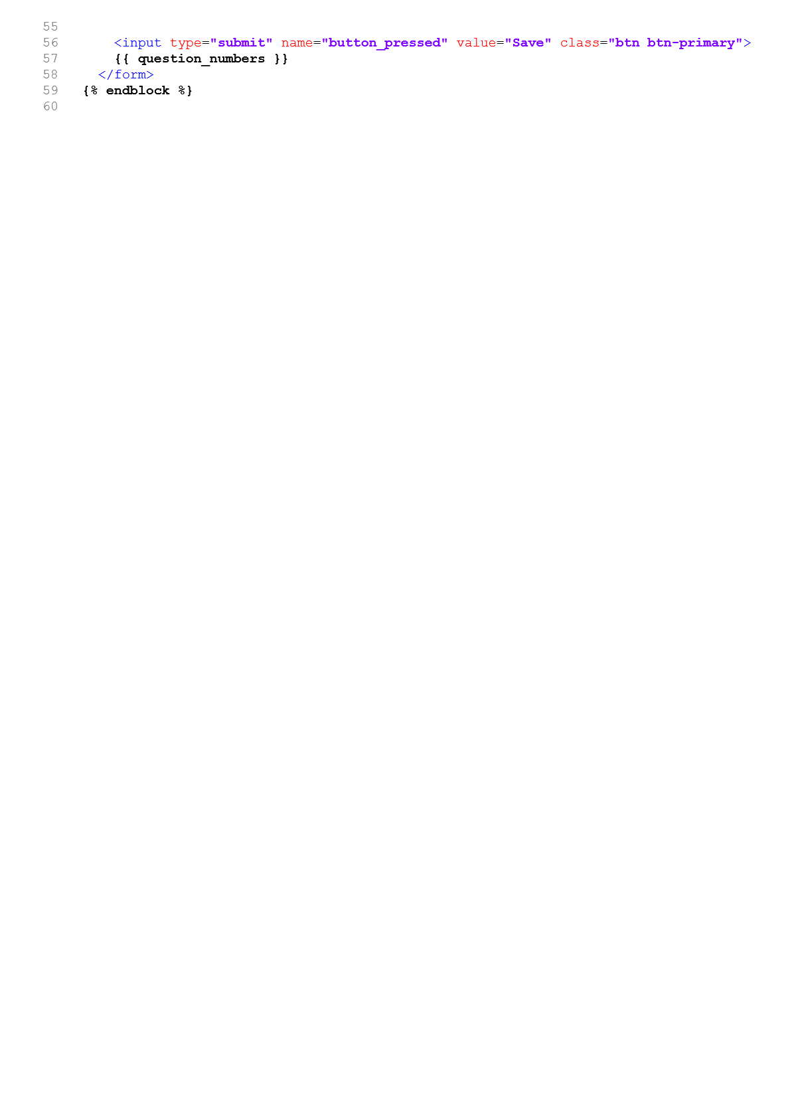

Search

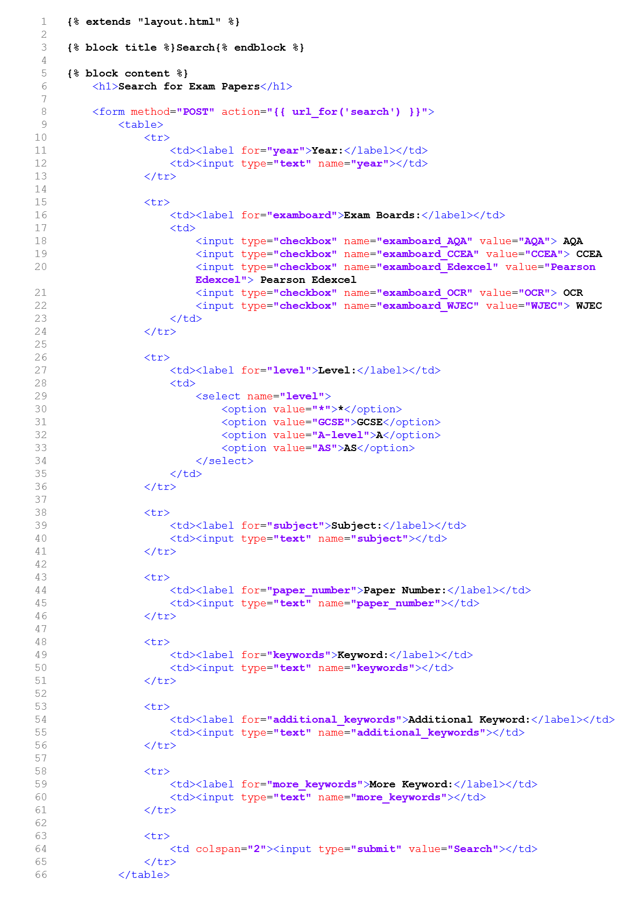

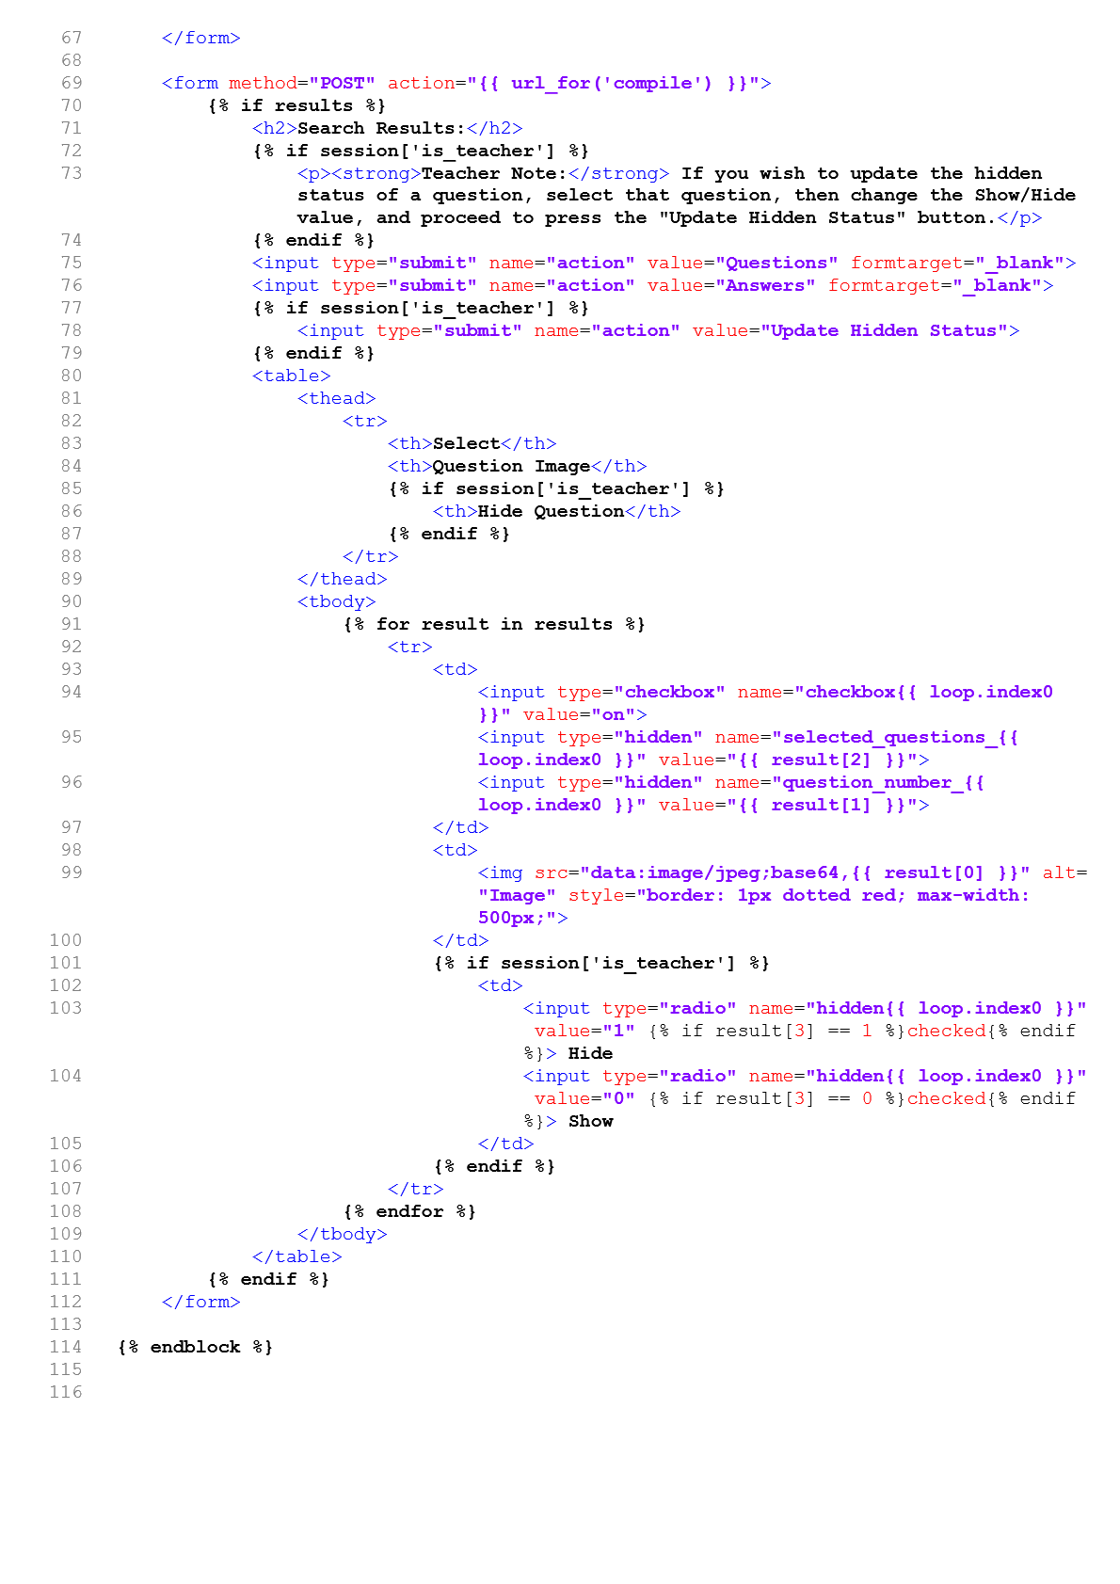

Questions from Compile

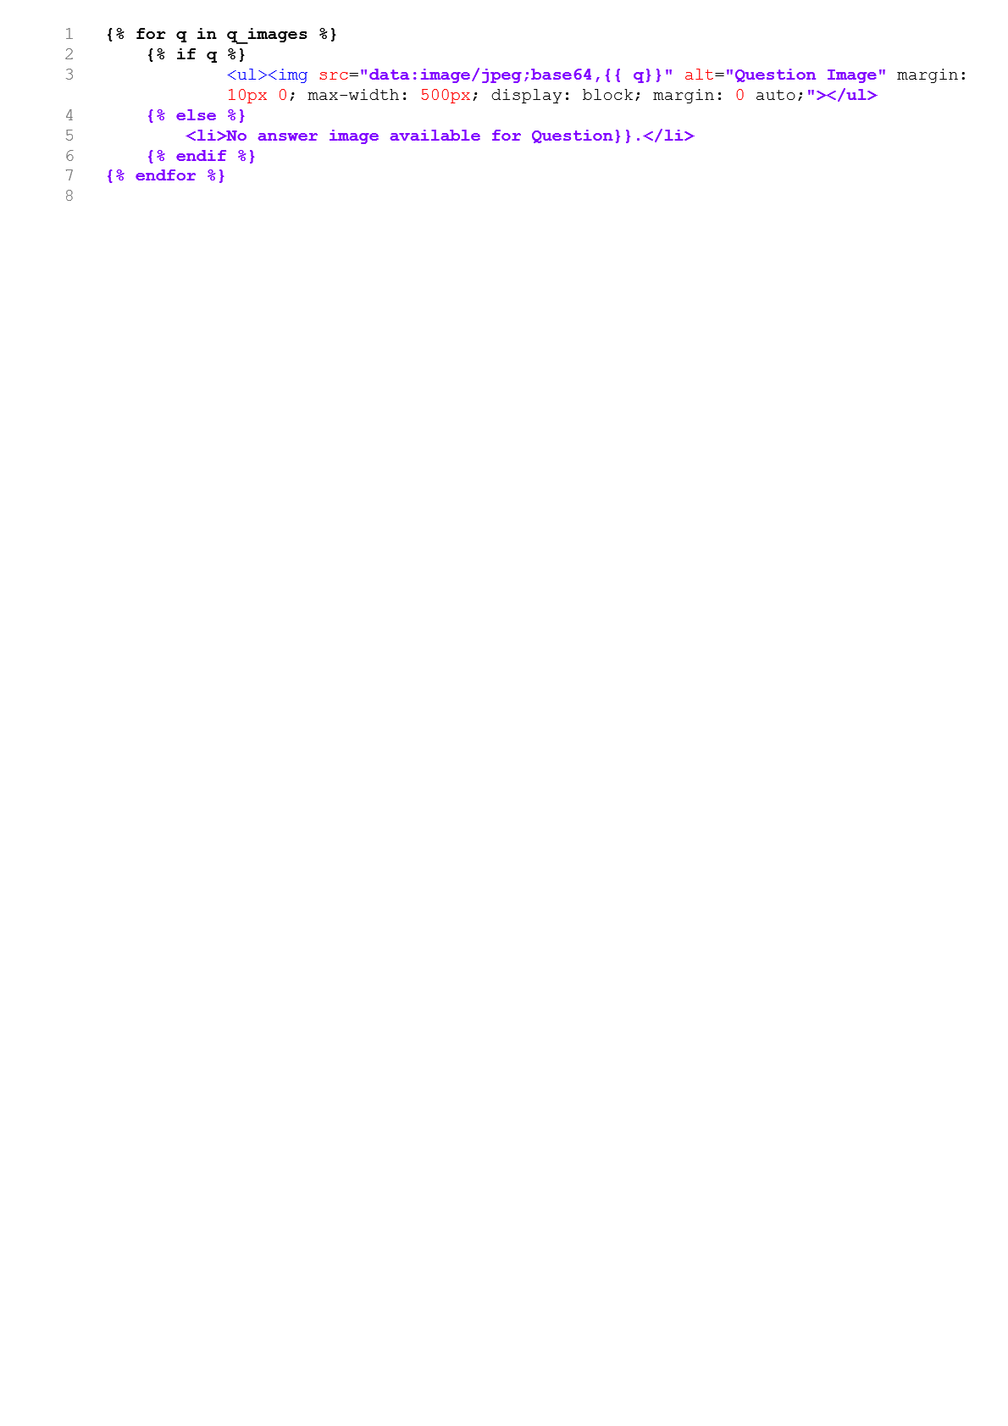

Answers from Compile

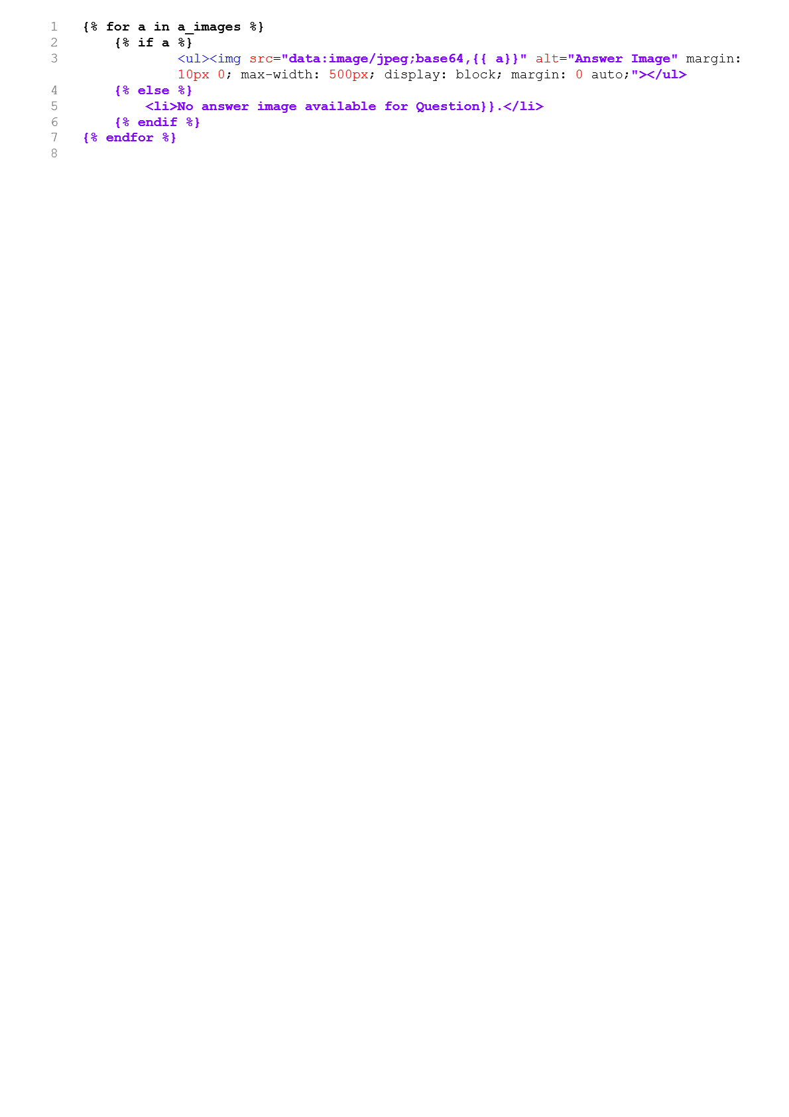

## Deleting PDFs

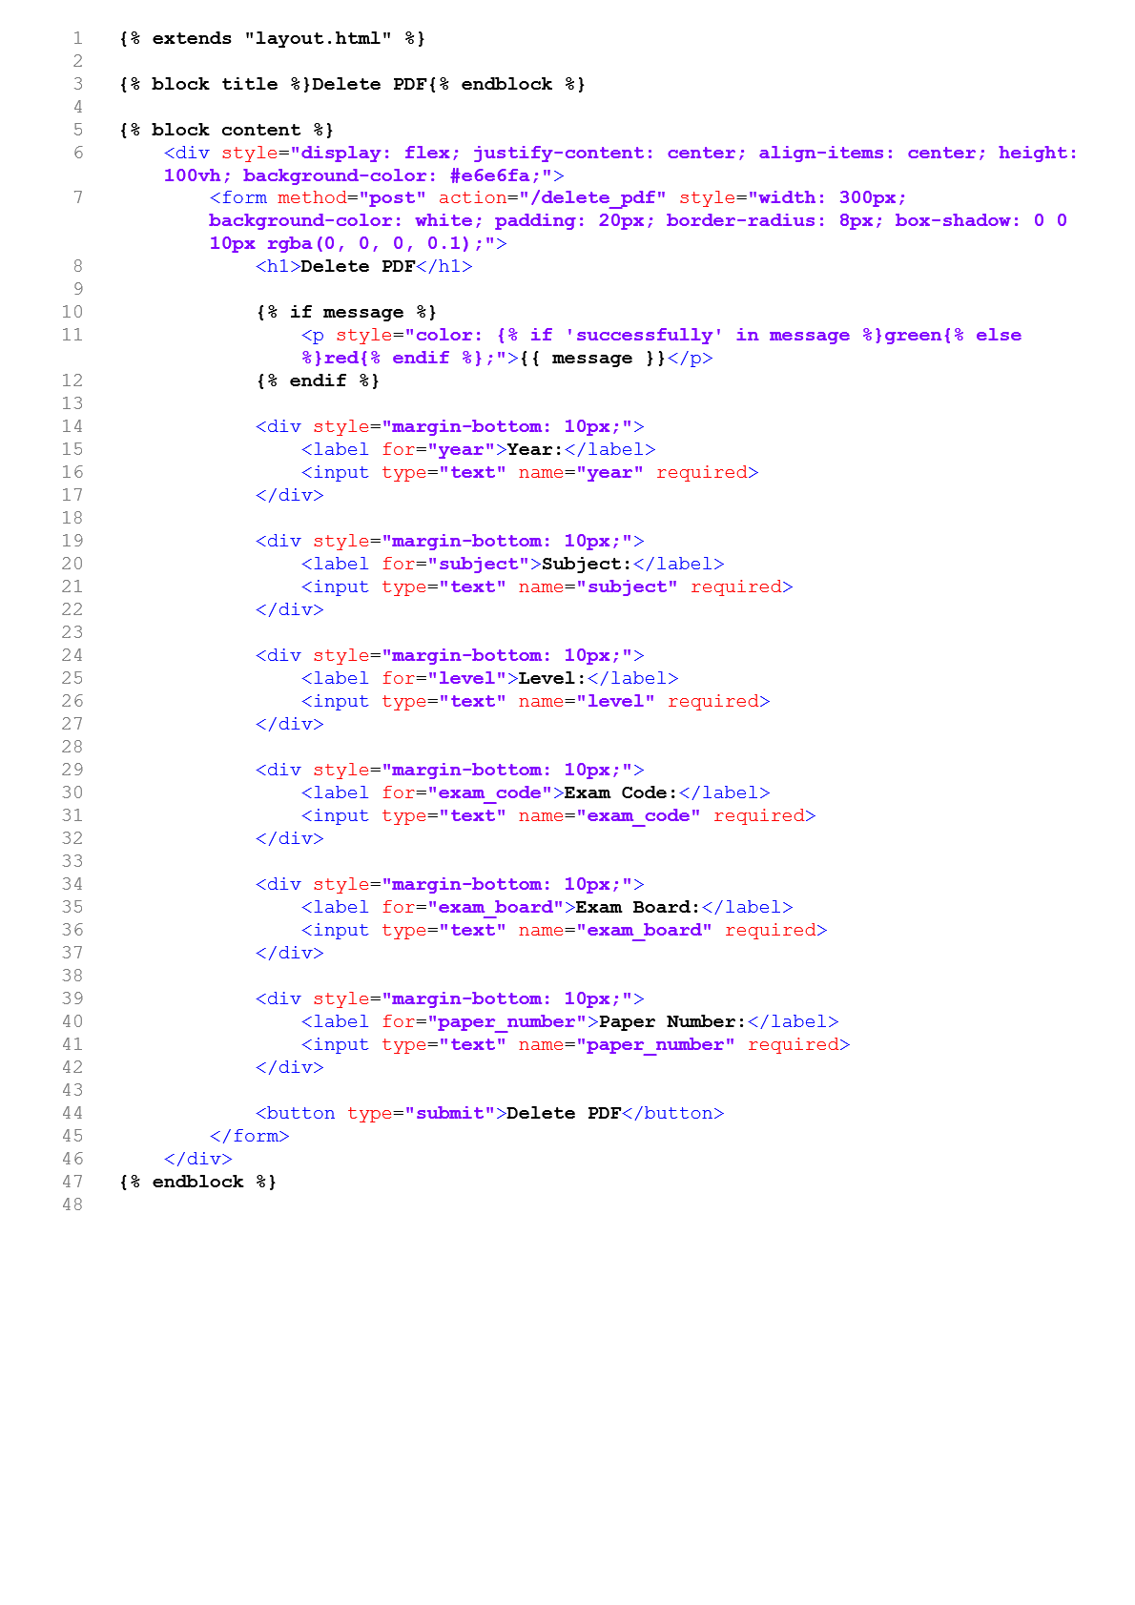

Question Analytics

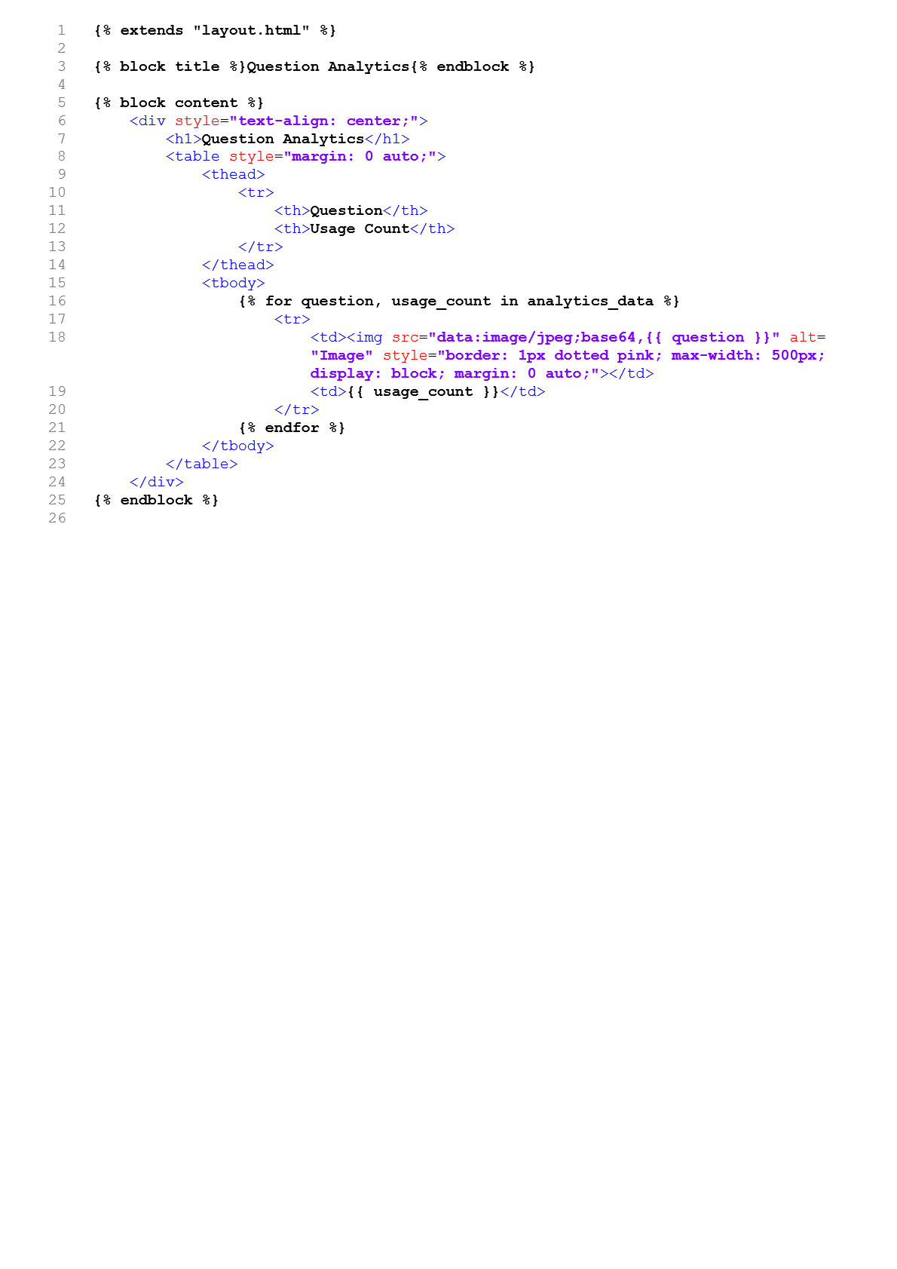

## Evaluation

I have successfully completed all the outlined objectives. The user interface has been designed to cater to both students and teachers, incorporating user authentication and intuitive buttons for various features. The PDF processing functions, utilizing fitz and IRect, effectively extract question images and text based on a provided regex pattern. User uploading features include pages displaying extracted text and regex pattern examples for refinement. The database design includes tables for question information, metadata, and user details, ensuring secure storage and retrieval. Retrieving and displaying questions, user management for admin users, and additional features like a to-do list have been implemented successfully. The system now offers a comprehensive solution for managing and analysing educational materials. However, I was unable to implement the feature that would validate that all file uploads are pdfs due to time restrictions.

## Final Interview with Client

Me: After reviewing my application, how do you feel about the finished product?

LT: Thank you, you have met all the original objectives and delivered a complete product that can be used immediately.

Me: Are there any improvements you would like after using the product for a while?

LT: I have thought about the system, and it is crucial to ensure that students cannot see the answers during the question compilation process. We want to maintain the integrity of the assessment process.

Me: Absolutely. I completely agree. Students should only see the questions they select for compilation, not the corresponding answers. We want to maintain the educational value of the platform while allowing students to engage with the material.

LT: Great to hear that we are on the same page.

Me: Now, as the database grows with more questions becoming available, I have considered the idea of allowing teachers to store custom booklets. What are your opinions about this? This could be a handy feature as it provides a way to organize and reuse selected questions efficiently.

LT: That is an interesting concept. Storing custom booklets could indeed enhance the usability of the system, especially for teachers who frequently use specific sets of questions. It could save them time and effort in recreating compilations for different classes or topics.

Me: It would also contribute to a more personalized and streamlined user experience. Teachers could build a repository of their preferred questions, making it easy to access and compile booklets tailored to their teaching needs. Plus, as the question database continues to expand, having a system that allows for efficient management of these questions becomes increasingly valuable.

LT: I see the potential benefits. It not only simplifies the process for teachers but also adds a layer of customization that can enhance their teaching methods. Let us explore the possibility of implementing this feature and how it aligns with the overall goals of the platform.

## Improvements

1. **User Interface (UI):**
   1. Design a user-friendly interface for students, admins and teachers.
   2. Implement user authentication to distinguish between students and teachers.
   3. Create a page that displays the top 10 used questions
   4. Add buttons that will redirect the user to the correct feature: search, delete pdf, upload pdf and question analytics.
   5. Limit the access that students have to certain features.
   6. Integrate features for admin users.

**I have met all the criteria as the website interface is easy to use and the text boxes are labelled so that the user has a clear understanding what needs to be inputted. The navigation is clear as the navigation bar is present to allow for fast redirection. Students have no way to access teacher/admin features preventing any confusion and mishandling of the database. Users are able to see the question analytics in a concise format – portraying the most popular questions easily.**  **It is visually pleasing which makes it easier for the users to interact with it.**

The current analysis of question usage focuses on tracking the frequency of questions selected for compilation. This provides valuable insights into the popularity of individual questions, offering a general overview of their usage patterns. However, to enhance the analytics further, I will consider separation based on subject and level would be a valuable addition. By categorizing and analysing popular questions within specific subjects and levels, a more granular understanding of question popularity can be obtained. This would enable teachers to identify trends and preferences within different academic domains.

Additionally, a potential improvement to the analytics system could involve pre-making booklets based on the popularity of questions. This proactive approach could streamline the preparation process for educators, as they could have ready-made booklets comprising the most frequently selected questions. The system could automatically generate booklets based on subject, level, and popularity criteria. This feature could significantly save time for educators and facilitate the efficient creation of study materials aligned with student preferences. In the future, implementing more advanced analytics features, such as user-specific question recommendations or detailed usage trend reports, could provide a comprehensive understanding of user behaviour.

A dedicated tab within the interface, labelled "Popular Questions," could provide educators with quick access to a dynamic list of the most frequently selected questions across all subjects and levels. This tab would serve as a centralized hub for real-time insights into question popularity, enabling teachers to stay informed about the evolving preferences of students. A collaborative feature, named "Question Booklet Collaboration," could allow educators to work together in curating question booklets. Teachers could share insights, discuss effective teaching strategies, and collectively decide on the selection of questions for specific booklets. This collaborative space would facilitate the exchange of best practices and the creation of well-rounded study materials.

A visual representation of question popularity could be integrated directly alongside each question. This graphical element, a bar chart or heatmap, would provide an immediate and intuitive understanding of a question's usage frequency. The size or colour intensity of the graphic could correlate with the question's popularity, allowing teachers to quickly identify trending questions.

Moreover, this graphic representation could dynamically update in real-time as more users select the question for compilation. Teachers could instantly gauge the popularity trends, helping them make informed decisions about the relevance and impact of specific questions on their teaching materials.

To ensure clarity and accessibility, the graphical representation could be accompanied by a numerical indicator displaying the exact count or percentage of times the question has been compiled. These changes would improve the analysis of question usage from a numerical list to an interactive experience.

1. **PDF Processing:**
   1. Implement a function that accepts the PDF file path and regex pattern and extracts images and text of individual questions and returns this as a list.
   2. This will use fitz (PyMuPDF) and IRect.
   3. The data structure used for storing question information in the provided code is a list of lists. Each inner list will contain two elements:
      1. The question text (extracted from the PDF).
      2. The question image, represented as a base64-encoded string.
   4. Implement logic to identify if the next image is a part of the previous question.
   5. Implement skip and stop phrases to decrease processing time by skipping certain pages in a pdf.

This works very well and I am able to retrieve images with exact questions on in their separate parts when the appropriate regex is inputted. It works well for both mark schemes and exam papers. I have noticed that the results are marginally better for exam papers due to the table like structure making it hard to form more accurate regex patterns. In considering the optimization of the extraction program, one improvement lies in refining the regex patterns used for parsing questions. Currently, the program may encounter challenges when questions exhibit complex structures or formatting that the existing regex patterns might not fully capture. To address this, a more nuanced and adaptive regex strategy could be implemented. This could involve fine-tuning existing patterns and incorporating additional rules to better handle diverse question formats. By enhancing the program's ability to accurately identify and extract individual questions, I can ensure that the integrity of each question is maintained, preventing the inadvertent splitting of questions into multiple images.

Furthermore, a key aspect of the extraction process involves saving the images associated with each question. In cases where a single question is broken into multiple images, it becomes crucial to associate these images with the same question number. An improved extraction program would include logic to recognize and link fragmented images belonging to the same question. This could involve implementing a mechanism to group images based on contextual clues or unique identifiers within the question content. By addressing this fragmentation issue, I could deliver a more cohesive and accurate representation of questions, providing a better compilation process for users.

1. **User Uploading:**
   1. Include a page of extracted text from the first ten page of the pdf to allow the user to form the regex pattern.
   2. Include a page that will allow the user to enter a regex pattern and see example images to allow the user to refine their regex pattern.
   3. Include a page that will allow the user to enter the question numbers and approve the metadata of the PDF

In my opinion, the user uploading mechanism stands out as it provides users with a user-friendly interface for forming regex patterns. The pages displaying extracted text and allowing regex input with visual examples enhance the user's understanding and refining of patterns. As the text and experiment pages open in a new tab it is easy to navigate back to the upload page and it is easy to form regex patterns as the web pages can be used in split screen. The fact that the regex pattern used is displayed along with the example images makes it really easy to track how well a certain regex pattern worked. Acknowledging the current limitation where users are required to manually input question numbers, a potential improvement involves automating this aspect to enhance user convenience and streamline the compilation process. By introducing automated mechanisms for identifying and associating question numbers, users would be relieved of the manual input burden, resulting in a more user-friendly and efficient system.

The PyMuPDF (fitz) library could be utilised to load an image, and the text content of the image is extracted. The regex pattern would then be applied to the extracted text to identify and capture the question numbers. The regex pattern is designed to recognize and extract question numbers based on their expected format within the image. For example, if question numbers are formatted as numeric sequences, the regex pattern can be tailored to match this structure.

Once the regex pattern successfully identifies question numbers, the code associates these numbers with their corresponding image paths or other relevant metadata. This linkage allows for the automated extraction of question numbers from images, providing a more streamlined and efficient process. It is important to fine-tune the regex pattern based on the specific characteristics of the question numbers in the images to ensure accurate extraction.

1. **Database Design:**
   1. Design a database to store the extracted question information, along with the question image.
   2. Design a function to extract the subject, level, years, exam board and exam code by analysing the metadata of the pdf using PDFMiner library.
   3. Create a metadata table to represent the subject, level, years, exam board and exam code with the pdf id.
   4. Add a function that encrypts the image in base64.
   5. Design tables to store the question and mark scheme details, including the text, image, question number, pdf id and question id and a flag to see if the question is hidden.
   6. Design table to store user details.

The database design, in my view, is a strong suit of the system. The comprehensive structure, including tables for question information, encrypted images, and metadata analysis, demonstrates a well-thought-out approach. The use of base64 encryption enhances security, while the systematic representation of metadata ensures effective organization. This design ensures robust data management and retrieval capabilities.

My current implementation utilizes SQLite for storing base64 strings representing question and answer images. This system works well and it is easy to retrieve/update/delete/add to the database due to the well-defined database . While SQLite is suitable for many applications, its performance might be challenged by the sheer size of inputs, especially in scenarios where a large volume of images is being handled. The decision to use SQLite was based on getting the system working at a base level before optimising. To address scalability concerns, I would adopt a more robust and scalable database solution. Options like PostgreSQL or MongoDB offer enhanced capabilities to handle large datasets efficiently. Migrating to a database with better scalability would ensure that the system can effortlessly manage the increasing volume of image data, providing a reliable and responsive foundation for the overall application.

The extraction program and database optimization are crucial components for ensuring a smooth and efficient user experience. By automating the question numbering process and enhancing the database infrastructure, I can significantly improve the overall functionality and scalability of the system.

1. **Database Integration:**
   1. Connect the application to a suitable database system (SQLite).
   2. Implement functions to insert the exam paper details and question details into the database.
   3. Implement logic to update the hidden status of questions by teachers.

I find the database integration to be well employed for its seamless connection with an SQLite database. The implemented functions for inserting exam paper and question details, along with logic for updating the hidden status of questions by teachers, showcase a well-integrated system. It also ensures that administrative tasks related to data management are efficient and reliable.

1. **Retrieving and Displaying Questions:**
   1. Implement a search feature to retrieve questions based on various criteria like subject, topic, year, and exam board.
   2. Write a generalised database queries to fetch questions and their associated information from the database.
   3. Display the retrieved questions to the user.
   4. Ensure that students can only view non-hidden questions.
   5. Add checkboxes to allow the user to select the questions they want to compile.
   6. Add radios to show the hidden status of each question.

In my assessment, the retrieval and display of questions exhibit a user-friendly and efficient design. The search feature allows users to locate questions based on various criteria, contributing to a positive user experience. The implementation ensures that students can only view non-hidden questions, promoting data integrity and security. The introduction of checkboxes and radios adds to the user's ability to interact with the displayed information. I have completed all of the criteria for my search function and the program is able to return queries based on year/ (multiple) exam board/ (multiple) keyword / subject/ paper number / level. I have exceeded the objective as I have expanded the SQL query to handle multiple exam boards and keywords. The results are displayed in a meaningful manner and it is easy to see which question are hidden.

There are improvements to be made, for example, as the database grows, the potential for the SQL queries to return an increasing number of results also grows. The SQL queries are designed to fetch distinct sets of attributes based on specified conditions, and as the volume of data in the database increases, the likelihood of obtaining a larger result becomes more prominent. To manage user experience and prevent overwhelming outcomes, a conditional statement or mechanism should be implemented to check the size of the result set. If the number of results exceeds a predefined threshold, such as one hundred records, the application could prompt the user to refine their search criteria for more specific and targeted results. This approach ensures that the user is aware of the potentially large dataset and encourages them to narrow down their search to obtain more meaningful and manageable outcomes, promoting a better user experience and efficient use of the application.

Adding a "Select All" button to my search function can significantly optimize the user experience by streamlining the selection process. This feature would allow users to select all available results quickly and effortlessly with a single click, eliminating the need to individually check each checkbox. It becomes particularly advantageous when dealing with many search results, saving users valuable time and effort.

1. **User Management (Admin):**
   1. Allow admin users to add new users with appropriate permissions.
   2. Enable admin users to delete existing users from the system.
   3. Implement the ability for admin users to update user information.
   4. Provide a feature for admin users to view the list of all users in the system.

Regarding user management, I think the system excels by providing admins with essential functionalities. The ability to add, delete, and update user information, coupled with the option to view a comprehensive list of all users, reflects a user management system that is both robust and user-friendly. The admin home page is succinct and works well and the buttons are labelled so the admin can easily navigate and it is clear where the inputs should go and what is expected by the system to be entered.

1. **Additional Features:**
   1. Add a to do list which displays question papers that have mark scheme that are yet to be uploaded and vice versa.
   2. Implement file validation to ensure that only PDF files, the standard format for exam papers, are accepted

I have been able to add a to do list which displays the exam papers/ mark scheme. Whilst testing, I found this incredibly useful for tracking my next steps to uploading pdfs. This has worked well and the colour coordination are helpful to differentiate and as the colour only appears when the user hovers over the row, it is not distracting nor does it become the central focus of the teacher home page. I have gone beyond the objective so currently I do not believe this feature can be further improved. Whilst I have been unable to implement file validation to ensure that only PDF files are accepted, this is not crucial to the program and will not produce crashes if other file formats are uploaded , the output would simply vary for data types. In addition, pdfs are the most common file type available to teachers so there is a high probability that a high percentage of uploads are pdfs.

Reflecting on the client feedback in the interview, storing custom booklets would be an additional feature I would like to include in the feature. To implement a system for storing custom booklets in the database, certain changes and additions would be necessary to accommodate this new feature. The existing database structure primarily focuses on storing base64 strings representing question and answer images, and it may need to be extended to handle the complexities of storing custom booklets. One potential approach is to introduce a new table dedicated to storing information related to custom booklets. This table could include fields such as a unique identifier for each booklet, the user ID of the creator, a list of question IDs or references included in the booklet, and any additional metadata associated with the booklet.

The linkage between questions and booklets could be established through foreign key relationships. This way, each entry in the custom booklet table would be associated with specific questions stored in the existing question table. Moreover, to facilitate collaboration among teachers, the database could support relationships between booklets and user accounts, allowing multiple educators to collaborate on the creation and modification of booklets.

Implementation-wise, modifying the backend code to handle the creation, retrieval, and modification of custom booklets would be necessary. The frontend interface would also require updates to provide users with intuitive controls for managing custom booklets, such as creating, editing, and sharing booklets.